******The British College**

**KATHMANDU**

**Coursework Submission Coversheet**(individual coursework only)

**Faculty of Arts, Environment and Technology LBU Student Id:**

77227253

**For checking by the student:**

Please ensure all information is complete and correct and attach this form securely to the front of your work before posting it in a coursework collection box.

Award name: Bsc Hons in Computing

Module code: 15781-AUT-202110

Module name: Advance Database System (ADS)

Module run: 2021

Coursework title: Data warehouse Design and Development

Due Date: 2021/22/12

Module leader: (In LBU): Jackie Campbell, Sanela Lazarevski

Module tutor: (In TBC): Dibya Tara Shakya

**TURNITIN** Checked: YES NO ***(please circle)***

Submission date& time: Date: Time: Before noon

**Total Word Count: 14811 Total Number of Pages (including this front sheet): 168**

**In submitting this form with your assignment, you make the following declaration:**  
I declare, that the coursework submitted is my own work and has not (either in whole or part) been submitted towards the award of any other qualification either at LBU or elsewhere. I have fully attributed/referenced all sources of information used during the completion of my assignment, and I am aware that failure to do so constitutes an assessment offence.

Signed: Akshobhya Sharma Date: 2021/22/12

**You are strongly advised to retain a second copy of your work in case of any query about the assignment.**

**For completion by the faculty:**

**This mark is provisional and subject to moderation and approval by the relevant examining board**

**Teacher's Feedback**

**Teacher's Signature: __________________________________ Date: _________________**

Contents

OLTP and OLAP

OLTP System

OLAP System

Differences between OLAP and OLTP

Data Warehouse

Precursor to Data Warehouse

What is Data Warehouse?

Features of Datawarehouse

Types of Data Warehouse

Process of data warehousing

Approaches to data warehouse design

Dimension Modeling

Components of Dimensional Model

Schemas

Difference between snow flake and star

Project Overview

Aims & Objectives

Task 1: Star schema design

Reports

Star Schema

Granularity

Data Dictionary

Business Intelligence Report

Task 2 Star Schema Set up

Setting up source database

Star Schema set up

Task 3: Extract Transform and Load

Extraction

Cleaning

Transform

Loading

Appendix

Bibliography

# OLTP and OLAP

## OLTP System

OLTP systems are systems designed to fulfill the daily transactional needs of an organization. They aid in business process of an organization. This system enables a real-time operation of huge number of small transactions with the clients without compromising the integrity of the data. The transactions and their results are almost instantaneous. Most of the OLTP System rely on the internet to carry out these transactions.

The OLTP system relies on a normalized relational database to carry out these transactions and minimize the redundancy in data stored. Online transaction model of businesses like e-commerce, e-banking, online ticketing make use of OLTP systems.

## OLAP System

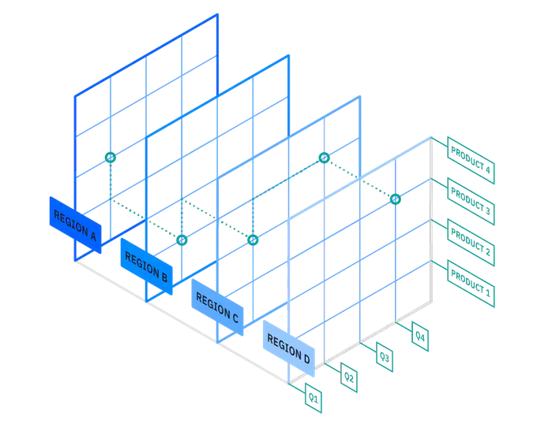“Online analytical processing is a system for conducting a multi-dimensional analysis at high speeds on large volume of data. “ (Sinha, 2021) This type of systems are well suited for the purpose of aiding in business decisions, data mining as well as performing complicated analytical computations.

The core concept of an OLAP system is a cube database. The OLAP cube makes it easier to perform a multidimensional analysis on a particular dataset. For example, a dataset about a product could be analyzed differently from the lens of the products, from the lens of time interval or from the lens of regions.

The OLAP systems most often uses data from sources like data warehouse. The data stored in the data warehouses on the other hand is contributed by OLTP systems, legacy apps and various other sources.

Figure OLAP cube (Sinha, 2021)

## Differences between OLAP and OLTP

The OLAP and OLTP systems both fulfill different scopes. OLTP Is used to make the wheels of business turn whereas the use of OLAP is to observe the turning of the said wheel (Ponniah, 2001). Since the scope as well as the purpose of the two systems are different, there are a lot of differences between them. The differences are listed below:

|  |  |  |
| --- | --- | --- |
| Criteria | OLTP Systems | OLAP Systems |
| Process | It is an online transactional system. It manages database modification. | OLAP is an online analysis and data retrieving process. |
| Method | It uses traditional DBMS. | It uses data warehouse architecture. |
| Transactions | It allows all of the insert, select, update and delete operations. | It mostly allows select statements. |
| Tables | The tables in OLTP systems are normalized to minimize redundancy. | The tables in OLAP Systems are left denormalized to maximize query performance on huge volume of data. |
| Source | The transactions carried out in the OLTP systems are the sources of the data. | Different OLTP systems as well as legacy applications, spreadsheets can be the source of data for OLAP. |
| Data volume | Generally, data volume of OLTP systems aren’t that high as it stores data on relevant for current operations. | Data volume is larger compared to OLTP as OLAP Systems tend to store historical data as well. |
| Queries | Queries are relatively simple in nature, returning few results. | Queries are complicated involving the use of aggregation. |
| Response Time | The simple queries make response time very fast, in millisecond. | The complex queries tend to make response time a bit higher, in seconds to minutes. |
| Access | Can be accessed by a lot of clients. | Can be accessed by peoples involved in the Decision Support System. |
| Purpose | Designed to fulfill the real time business needs. | Designed to fulfill analytical needs for business decisions. |
| Design | DB design is application oriented. | DB design in subject oriented. |
| Performance metric | Transaction throughput is used as the performance metric. | Query throughput is used as the performance metric. |
| Style | It is designed to have fast response time, low data redundancy as well as data integrity. | It is designed to integrate data from different sources; it has fast query performance with flexibility. |
| Reports | It can be used to produce informational report. | It can be used to produce analytical reports. |

(Taylor, 2021)

# Data Warehouse

## Precursor to Data Warehouse

Following the emergence of huge OLTP systems, the use of extract programs became very common. An extract program is a program that uses certain parameters to select and transfer the data to another database. (Inmon, 1992)

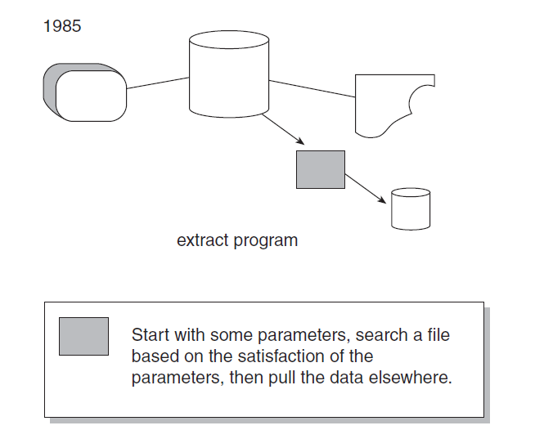

Figure Extract Processing (Inmon,1992)

The use of extracts became very prevalent in big corporations, often forming chain of extracts. This would result in the formation of “naturally evolving architecture”, which was basically a pattern of uncontrolled extract processing.

The naturally evolving architecture however led to some problems, which were:

1. **Lack of data credibility**

The uncoordinated extraction of data often produced conflicting reports from different departments of the same company. This maybe because:

* The time period from which the data was extracted could be different.
* The process or code for data extraction could be focusing on different data sets.
* The chain or levels of extraction would further exacerbate the above problems.
* The dataset used could be brought from an external source.
* The origin of dataset used could be different.

1. **Productivity**

The productivity issue arises because of the need to analyze the data across the company which may be stored in various formats. The process of retrieving data to generate reports would be very taxing. The fact that one generated report wouldn’t help in generation of future reports further exacerbated this issue.

1. **Inability to transform data into information**

The systems found within naturally evolving architecture lacked integration. Due to this, information was extracted from legacy systems which is hard to decipher. Apart from this, the systems weren’t designed to store historical data for future analysis, with different systems having data discrepancy between them. Therefore, these systems were insufficient for fulfilling the informational demands.

All these drawbacks of naturally evolving architectures required a more deliberately architected approach to decision support system which is where the concept of data warehouses comes in.

## What is Data Warehouse?

Father of data warehouse Bill Inmon defined data warehouse as “a subject-oriented, integrated, nonvolatile, and time-variant collection of data in support of management’s decisions. (Inmon, 1992)”. The data warehouses serve as a bedrock for a DSS (Decision Support System) of a company and makes the work of a DSS analyst considerably easier. This is because the data warehouse relies on a single integrated source of data while at the same time making those data easily accessible.

## Features of Datawarehouse

The definition of data warehouse by Bill Inmon outlines the main features of Data warehouses. However, we can look at each of those features in a more comprehensive manner. The features of Data Warehouses include:

1. **Subject Oriented**

Data stored in data warehouse are subject oriented. It means that data which relevant to a company’s DSS or data relevant to the analysis are stored in an ordered manner. For example, a school may choose to store data on student, address, subject and scores if their analysis requirement pertains to students only. The subject of the data warehouse changes based on the interest area of the company in question and the warehouse is built around those subjects of interests.

1. **Integrated**

Integration is one of the most crucial aspect of data warehouse. A company relies on multiple transactional databases to function; however, the design of those databases with regards to attributes used, naming used, placeholders used as well as design elements may not be consistent. The data is fed into data warehouse in a manner that negates these inconsistencies at application level. The integration aspect is crucial to ensure that the data in data warehouse is consistent.

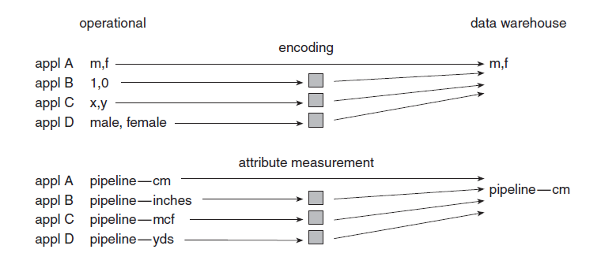

Figure Data Integration (Inmon, 1992)

1. **Non-volatile**

Another defining characteristic of data warehouse is the non-volatility of the data. In a transactional database, the data is inserted and updated on a constant time interval based on the functionalities. Contrary to that, the data in data warehouse are inserted in bulk; the operation in data is also limited to access only with some cases of updates. In doing so, the data warehouse preserves the history of the data.

1. **Time-variant**

Lastly, the data warehouse is time-variant. Each unit of data in data warehouse has some form of time stamp or time value associated with it. All the units of data are therefore true in the given time. However, data warehouses tend to store data from a large period of time, in a way providing historical context to the data. This is in contrast to the operational databases where there is mostly one data which is accurate and useful in the present context.

## Types of Data Warehouse

Considering the scale of warehousing and its purpose data warehouse can be classified into 3 types (Efraim, et al., 2014). They are:

**Data Mart**

Data warehouses serve as centralized aggregation of data from all the databases of an enterprise; however, data marts are in a way, a subset of data warehouses, storing data related to a single subject matter within the company. There are 2 types of data marts:

1. Dependent data mart

Dependent data marts are derived from data warehouses. This ensures that the data used across multiple departments of the company is consistent to the data warehouse. This of course means that this type of data mart is dependent on the construction of data warehouses first.

1. Independent data mart

Independent data marts have sources other than data warehouses and focuses on a singular area of interest. They are easy to set up for short term but may cause a lot of hassle in the long term if the analytical need of an organization increases.

**Operational Data Stores**

Operational Data Store consolidates data from multiple source systems and provides a near-real-time, integrated view of volatile, current data (Efraim, et al., 2014). It is commonly used as a staging area for a data warehouse. Due to the absence of historical data, it is only used to make short-term operational decision making.

**Enterprise Data Warehouse**

Enterprise Data Warehouse congregates multiple sources of data from various sources and application of an enterprise to a singular centralized database. It can be used across the entire enterprise as a decision support system. The centralized data from all the sources gives a holistic insight on running the organization.

## Process of data warehousing

The data warehousing process has following main components (Efraim, et al., 2014):

1. **Data Sources**: Data sources can be a variety of things including legacy applications, external data source or OLTP systems. Data are collected from all these sources for the data warehouse.
2. **Data Extraction and transformation**: The source data are extracted and transformed using a commercial ETL software or a software is custom-written as suitable for the data warehouse being designed.
3. **Data Loading**: The successfully transformed data are then loaded into the data warehouse or data marts.
4. **Comprehensive database**: A comprehensive database requires the creation of an Enterprise Data Warehouse which aggregates data originating from diverse source and can provide decision support to all departments of the company.
5. **Metadata**: Metadata basically means data about data. They describe the data and their structure making their use effective. Software tools may be used to maintain meta data so that they are easy to search and use for developers as well as users.
6. **Middleware tools**: These tools enable the access to the data warehouse. It includes variety of tools like reporting tools, data visualization tools, mining tools that the end user can use to access and interact with the stored data.

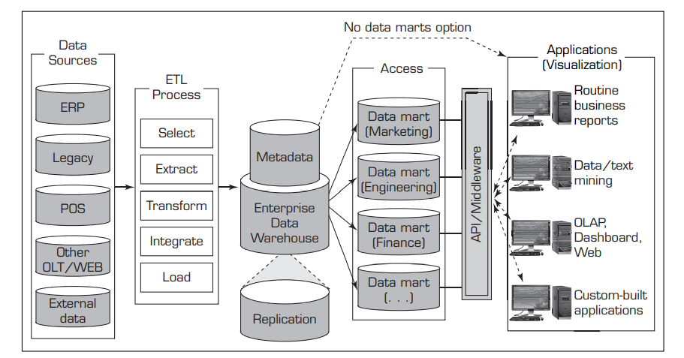The following diagram illustrates the data ware house framework encompassing all these components:

Figure Data Warehouse Framework (Efraim, et al., 2014)

## Approaches to data warehouse design

There are two major approaches to designing data warehouses, a top-down approach and a bottom-up approach. The advocate of the top-down approach is Bill Inmon, the father of data warehouse where as the bottom-up approach is advocated by Ralph Kimball, two very prominent figures in the field of data warehouse. The choice on which approach to use usually depends on the organization undertaking the development of the data warehouse as well as their analytical requirements.

1. **Bill Inmon’s Top-Down Approach**

Bill Inmon’s Top-Down Approach starts with creation of corporate data warehouse model. To do that the subject areas as well as the entities that the business is involved with are properly identified. Then a comprehensive logical model that maps the relationship between the entities is created. Each of these entities are built in a normalized way to avoid redundancy. There is a single fact table connected to various entities. The physical model is then derived from this logical model and a necessary ETL process is used to extract the data and fill into the physical data model. Dependent data marts are then derived from a centralized warehouse for various departments. (Naeem, 2020)

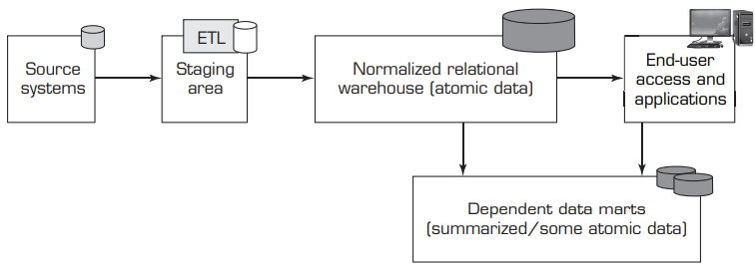

Figure Bill Inmon's approach (Efraim, et al., 2014)

Advantages of Top-Down Approach:

1. The centralized database acts as a single source of truth, incorporating all the sources; there is consistency in the reports across the enterprise as they are drawn from the same data warehouse.
2. The redundancy of data in reduced due to normalization. This reduces the update anomalies and makes the process of ETL easier.
3. Since the data sources cover the entirety of an enterprise all kinds of analytical needs can be met through this system.
4. The logical model clearly represents all the detailed business entities; therefore, the business process is easy to understand.
5. It reacts well to change in business requirements and modifications to the data sources. A number of normalized tables are modified, and the change permeates through the system.

Disadvantages of Top-Down Approach:

1. The model can become very convoluted overtime as a lot of relationships and tables need to be added.
2. The personals needed have to be highly skilled and which comes with higher expense.
3. The initial set up and maintenance is costly in terms of time as well as investment.
4. Additional ETL processes are necessary for the dependent data marts which are derived from data warehouse.
5. Although it fulfills all the reporting requirements of an organization, the complex joins required because of the complex entity relationships may result in bad query performance.
6. **Ralf Kimball’s Bottom-Up Approach**

Ralf Kimball’s approach of data warehouse aims on fulfilling the immediate analysis requirements of the business with data marts. More data marts are constructed as the requirement of an organization grows. First of all, a logical dimensional model is made. The data sources are then evaluated and loaded into the staging area. The data is than transformed and loaded into a denormalized physical dimensional model. The dimensional model is either built as a star schema or a snowflake schema. Ralf Kimball’s architecture keeps a one-way relationship between dimension and fact table. The dimension table doesn’t have relationship with other entities.

To integrate the data, the confirmed dimension tables are used to connect the data marts. The confirmed dimension tables are the common dimension tables across multiple data marts. These confirmed dimension tables provide consistent descriptive attributes across dimensional models and combine together to form a bus architecture (Ralph & Margy, 2002).

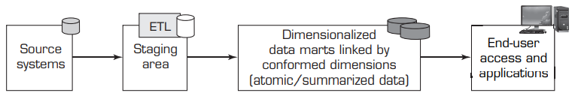

Figure Ralf Kimball's approach (Efraim, et al., 2014)

Advantage of Bottom-Up approach:

1. The initial set up of this architecture is much simpler and be delivered in a shorter amount of time.
2. The structure of star schema is simple; It is easier to understand for layman and produce reports with it.
3. It makes good use of resources as only the data marts of subject area that the business is interested in are made.
4. The query performance of this type of data warehouse is very good as complex joins are not required.
5. It requires fewer number of less specialized technical manpower to set up and maintain.
6. The data marts constructed can be very useful for department level reporting.

Disadvantages of Bottom-Up approach:

1. Data in the data warehouse is sorted and designed with data marts in mind. The data is not fully integrated so a ‘single source of truth’ is lost.
2. The redundancy of data in fact tables can cause update anomalies.
3. Addition of a column in fact table can cause significant degradation in performance as fact tables have huge number of denormalized rows to store an in-depth data.
4. This approach takes into consideration critical business processes but doesn’t give a holistic view of the enterprise data.

# Dimension Modeling

Dimension Modelling was a concept of structuring data developed by Ralf Kimball. The purpose of this technique was to optimize the data retrieval in data warehouses. These dimensional models define the database structure to maximize query performance.

## Components of Dimensional Model

The Dimensional model consists of following components:

1. **Fact Table**

Fact Table are the central tables in a dimensional data model. Their attributes consist of number of foreign keys linking them to dimension tables and numerical values called measures. The measures/facts help us to perform various analysis based on the grain of the fact table.

1. **Dimension Table**

Dimension Tables provide descriptive characteristics of each entry in the fact table, data are stored in textual form in the dimension tables. There can be multiple dimension tables in a DDM and have one-to-many relationship with the fact tables.

## Schemas

Dimensional data modelling is done in form of schemas. “A schema is a collection of database objects, including tables, views, indexes, and synonyms.” (oracle, n.d.) There are two popular schemas for the purpose of dimensional data modelling, they are:

1. **Star Schema**

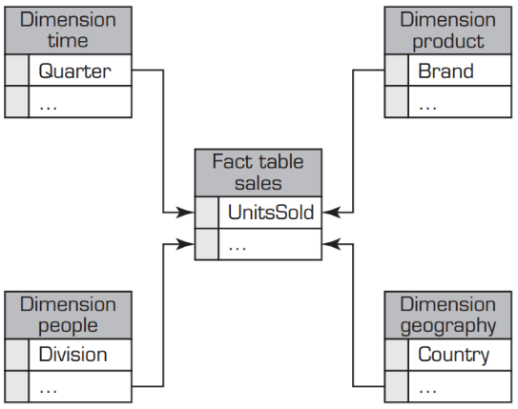Star schema is the simplest schema used in dimension modelling. It consists of a single fact table surrounded by multiple dimensional tables. The fact table maintains one-to-many relationships with all the dimension tables with the help of foreign keys. The dimension tables are purposefully denormalized do not have relationship with any other table apart from the fact table.

Figure Star Schema (Efraim, et al., 2014)

1. **Snowflake Schema**

Snowflake schema builds on the concept of star schema. Similar to star schema, one fact table is surrounded by multiple dimension tables; however, in the case of star schema, the dimension tables are further broken down into multiple tables. This is done until the model is normalized and ends up creating a snowflake pattern. The normalization however causes a rise in complexity of the schema.

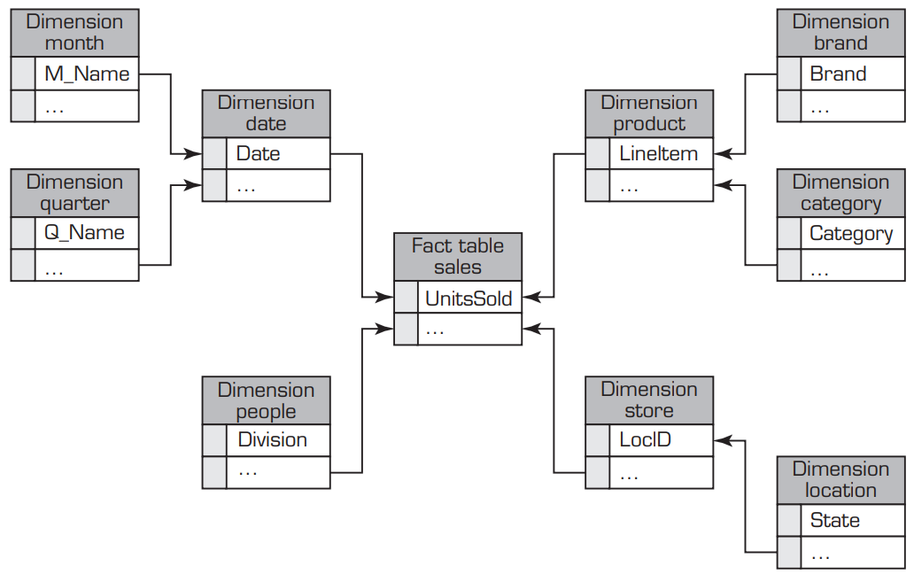

Figure Snowflake Schema (Efraim, et al., 2014)

## Difference between snowflake and stare schema

The differences between snow flake and star schemas are as follows (Taylor, 2021):

|  |  |  |
| --- | --- | --- |
| Criteria | Star Schema | Snowflake Schema |
| Structure | Fact tables surrounded by denormalized dimension tables. | Fact tables surrounded by normalized dimension tables. |
| Complexity | The database design is very simple. | The complexity of the design increases with normalization. |
| Redundancy | The redundancy of values is high. | The redundancy of values is relatively lower. |
| Query | The structure makes use of simple joins to access data, requiring one join between any dimension table and fact table. | Requires multiple joins to join data from multiple dimension tables. |
| Query Performance | The simple join results in fast query performance. | The complex joins result in slower query performance. |
| Hierarchies | The dimensional hierarchies are represented in a single dimensional table. | The dimensional hierarchies are split into separate tables. |
| Disk Space | The redundancy results in more disk space being used. | The normalization reduces the disk space used. |

# Project Overview

The project revolves around the police force of England and Wales. The police force uses multiple systems to facilitate their operation by keeping track of the crime cases. The systems help them keep track of crime based on regional area, leading officer and status of the case.

There are 2 systems and a spreadsheet that are being used to aid them in their task. The aim of the project is to design a Data Mart for the purpose of collecting and analyzing the data obtained from these sources. The police have considered following key performance indicators (KPI) for analysis:

1. Reduce crime
2. Close crime
3. Identify areas with crime hotspots

This project focuses on the KPI of **reduce crime** which focuses on generating reports for the police with aim of reducing the total no. of crime.

# Aims & Objectives

This project aims to provide decision support to the police of England to aid them in reducing crime. The project aims to fulfill this task with the help of data warehouse technology. Following are the key objectives of this project:

1. Analyze the source data to find what kind of reports can be generated to aid the police in reducing crimes.
2. Design a star schema of a data mart from which these reports can be obtained.
3. Make a data dictionary to aid the understanding of the data stored in a physically implemented data marts as well as their sources.
4. Forward engineer the data warehouse that fulfills the star schema designed.
5. Perform the ETL process to collect data from 3 sources provided into the data mart. The ETL process deals with the issue of data quality that can be observed in the source data as well as possible issues.

# Task 1: Star schema design

The star schema of the design will be based on the KPI of **reduce crime**. Before designing the star schema however, it is important to identify the types of reports that can help the police in reducing the crime.

For the purpose of designing the reports that can aid the police in reducing the crime, it is essential to understand what police practices help in reducing the crime. According to an article from police quarterly, following are the evidence-based policing practices that help in reducing the crime (Cody & David, 2012):

1. **Hotspot Policing**: Increasing police presence in the areas where crime rate is high as well as crime prone.
2. **Problem-Oriented Policing**: This involves police proactively solving the crime by identifying the underlying problem specific to the place, analyzing them, implementing the intervention and accessing them.
3. **Focused deterrence strategy**: This involves police utilizing all available legal options to deter the crime by analyzing the ties of the crime and focusing this effort on them.
4. **Directed patrol to prevent gun violence**: This approach is similar to hotspot policing but on greater scale in the areas prone to gun violence.
5. **Using DNA evidence in Property crime cases**: The use of DNA evidence is shown to lead to a greater number of identified suspect and is a more economical approach in doing so. Criminals identified by DNA based evidence had twice as many prior felony arrests compared to criminals identified by standard method. This leads to the arrest of high-rate offenders which could also help in curbing down the crime.

Looking at the above practices, there can be numerous reports that can be built to reduce crime. Some approaches will not be possible due to the depth of data in the source. Therefore, the reports below will be focused on aiding the practices with reports that can be generated from the available data in the source.

## Reports

1. 5 regions with the highest no. of crime last year compared to this year.
2. Highest crime type per station in first quarter of this year compared to last year.
3. Total no. of officers working for each crime type in open cases this month compared to last month.
4. Average no. of crime per station for each region in the 2nd quarter of last year.
5. Highest witness type in closed cases in Yorkshire per year for all the years.
6. No. of crimes per crime type in Leeds per area last year.

## Star Schema

Looking at the above report following star schema has been constructed with the aim of maximizing the types of reports.

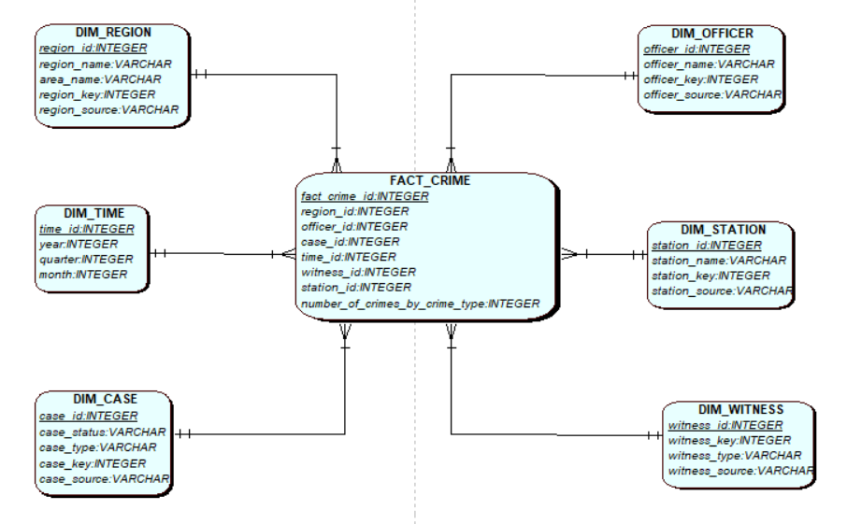

## Granularity

Granularity represents the lowest level of detail for the data in the data warehouse. Higher level of granularity can produce more detailed report at the cost of query performance.

For the Time table, the granularity of year, quarter and month was chosen to get meaningful reports based on the spread of time in the data. For the purpose of policing, the use of month as the lowest level of granularity maybe more useful to see the crime trends more clearly.

The fact table is granularized based on region, officer, case, time, witness and station to allow for a much more variety in terms of report as well as produce more detailed type of reports. Further drilled down reports based on the given dimensions could be produced using above data mart schema.

The region table also has an added level of granularity of area to utilize sub regions within a region if available in the data source.

## Data Dictionary

The following data dictionaries will help us better understand the dimensions and their attributes:

1. **DIM_REGION**

|  |  |  |  |  |  |  |
| --- | --- | --- | --- | --- | --- | --- |
| Column | Data type | Column type (SK, PK or FK) | Definition | Example | Source element and transformation | Transformation rule |
| Region_id | Integer | SK and PK | The unique identifier for dim_region. | ‘1’ | Generated from sequence dim_region_seq found in dimension_dll script. |  |
| Region_name | Varchar (40) |  | The name of the region relevant to region_id. | ‘YORKSHIRE’ | Taken from table region in PS-Wales system | Region name relevant to wales were taken and the unwanted symbols were cleaned. |
| Taken from table pl_area in PCRS system. | Area of higher orders were used as region_name. |
| Area_name | Varchar (40) |  | The name of sub-region inside of a region. | ‘Manchester’ | Taken from table region in PS-Wales system. | Unavailable areas were marked as ‘N/A’. |
| Taken from table pl_area in PCRS system. | Areas of lower order were used as area_name. |
| Region_key | Integer |  | The keys used in tables pl_area and region. | ‘1’ | Taken form pl_area. |  |
| Taken from pl_region. |
| Region_source | Varchar (40) |  | Description that tells from which system the data was taken from | ‘pcrs’ | Inserted by transformation procedures. |  |

1. **DIM_TIME**

|  |  |  |  |  |  |  |
| --- | --- | --- | --- | --- | --- | --- |
| Column | Data type | Column type (SK, PK or FK) | Definition | Example | Source element and transformation | Transformation rule |
| Time_id | Integer | SK and PK | The unique identifier for dim_time. | ‘1’ | Generated from sequence dim_time_seq in dimension ddl script. |  |
| Year | Integer |  | The value of a year for the data. | ‘1992’ | Split from year value from date_reported in pl_reported_crime table in PRCS system. | Current time was selected if the date was greater than current date. |
| Split from year value from reported_date in crime_register in PS-Wales system. |
| Quarter | Integer |  | The value of a quarter for the data. | ‘3’ | Generated from date_reported in pl_reported_crime table in PRCS system. | Current time was selected if the date was greater than current date. |
| Generated from reported_date in crime_register in PS-Wales system. |
| Month | Integer |  | The value of a month for the data. | ‘12’ | Split from day value from date_reported in pl_reported_crime table in PRCS system. | Current time was selected if the date was greater than current date. |
| Split from day value from reported_date in crime_register in PS-Wales system. |

1. **DIM_CASE**

|  |  |  |  |  |  |  |
| --- | --- | --- | --- | --- | --- | --- |
| Column | Data type | Column type (SK, PK or FK) | Definition | Example | Source element and transformation | Transformation rule |
| Case_id | Integer | SK and PK | The unique identifier for dim_case. | ‘1’ | Generated from sequence dim_case_seq in ddl. |  |
| Case_status | Varchar (40) |  | Describes the status of the case. | ‘CLOSED’ | Taken from crime_status column in crime_register for pl_wales. | All the values were changed to uppercase before insertion. |
| Taken from crime_status column in pl_reported_crime for prcs. |
| Case_type | Varchar (40) |  | Describes the case type or crime type. | ‘DRUNK DRIVING’ | Taken from crime_name column from crime_register table in ps_wales system. | The null values were changed to ‘UNKNOWN’ and the available values were changed to upper case. |
| Taken from crime_type_desc column from pl_crime_type for PRCS system. | The case was changed to upper case. |
| Case_key | Integer |  | The key in original tables used to insert data to fact table. | ‘2’ | Taken from crime_id column from crime_register table in ps_wales system. |  |
| Taken from reported_crime_id column in pl_reported_crime for prcs. |
| Case_source | Varchar (40) |  | Description that tells us which system the data is from. | ‘pcrs’ | Inserted by procedures during transformation. |  |

1. **DIM_OFFICER**

|  |  |  |  |  |  |  |
| --- | --- | --- | --- | --- | --- | --- |
| Column | Data type | Column type (SK, PK or FK) | Definition | Example | Source element and transformation | Transformation rule |
| Officer_id | Integer | SK and PK | The unique identifier for dim_officer | ‘1’ | Generated by sequence dim_officer_seq in dimension ddl script. |  |
| Officer_name | Varchar (40) |  | The full name description for each officer. | ‘HARRY REDKNAPP’ | Combined from first_name, middle_name and last_name coloumns from officer table in ps_wales. | All the names were changed to upper case. |
| Taken from emp_name coloumn in pl_police_employee table in prcs system. | Names were changed to upper case. |
| Officer_key | Integer |  | The primary key in the original tables used for insertion in Fact table. | ‘52’ | Taken from officer_id coloumn in officer table in ps_wales. |  |
| Taken from emp_id coloumn in pl_police_employee table in prcs system. |
| Officer_source | Varchar (40) |  | Identifier for which system the data is taken from. | ‘prcs’ | Inserted by transformation procedures. |  |

1. **DIM_STATION**

|  |  |  |  |  |  |  |
| --- | --- | --- | --- | --- | --- | --- |
| Column | Data type | Column type (SK, PK or FK) | Definition | Example | Source element and transformation | Transformation rule |
| Station_id | Integer | SK and PK | Unique identifier of dim_station. | ‘20’ | Generated by dim_station_seq in dimension ddl script. |  |
| Station_name | Varchar (40) |  | Named description of station. | ‘Kings Cross’ | Station name not available for ps_wales system. | The null station names were changed to ‘N/A’. |
| Taken from station_name column in pl_station table for prcs. | The repeating station names referencing the same regions were considered as one. |
| Station_key | Integer |  | The unique identifiers in original table required for data insertion in fact tables. | ‘45’ | Taken from Location_ID column in Location table in ps_wales. The repeating locations in same region was assumed as multiple stations. |  |
| Taken from station_id column in pl_station for prcs system. |
| Station_source | Varchar (40) |  | Identifier to inform which system the data was taken from. | ‘prcs’ | Inserted by transformation procedures. |  |

1. **DIM_WITNESS**

|  |  |  |  |  |  |  |
| --- | --- | --- | --- | --- | --- | --- |
| Column | Data type | Column type (SK, PK or FK) | Definition | Example | Source element and transformation | Transformation rule |
| Witness_id | Integer | PK and SK | The unique identifier for the witness dimension table | ‘4’ | Generated by dim_witness_seq in dimension ddl script. |  |
| Witness_key | Integer |  | The unique identifier in the original table used for insertion in Fact table. | ‘5’ | Taken from reporter_id in crime_reporter table for ps_wales system. |  |
| Taken from witness_id column in pl_witness for prcs system. |
| Witness_type | Varchar (40) |  |  |  | Witness_type data not available for ps_wales system. | The null values were replaced with ‘unknown’. |
| Taken from witness_type_desc column in pl_witness_type table from prcs system. | All the values were changed to upper case for consistency. |
| Witness_source | Varchar (40) |  | The identifier to inform which system the data was taken from. | ‘pcrs’ | Inserted by transformation procedures. |  |

1. **FACT_CRIME**

|  |  |  |  |  |  |  |
| --- | --- | --- | --- | --- | --- | --- |
| Column | Data type | Column type (SK, PK or FK) | Definition | Example | Source element and transformation | Transformation rule |
| Fact_crime_id | Integer | PK and SK | The identifier and the surrogate key for the fact table. | ‘1’ | Generated by fact_crime_seq in the dimension ddl script. | Cannot be null. |
| Region_id | Integer | FK | The foreign key of fact table with dim_region, which provides region description. | ‘2’ | Taken from primary key column of the region dimension table. | Cannot be null. |
| Officer_id | Integer | FK | The foreign key of fact table with dim_officer, which provides officer description. | ‘3’ | Taken from primary key column of the officer dimension table. | Cannot be null. |
| Case_id | Integer | FK | The foreign key of fact table with case dimension table, which provides case information. | ‘4’ | Taken from the primary key column of the case dimension table. | Cannot be null. |
| Time_id | Integer | FK | The foreign key of fact table with dim_time which provides temporal information. | ‘5’ | Taken from the primary key column of the time dimension table. | Cannot be null. |
| Witness_id | Integer | FK | The foreign of fact table with witness dimension which provides witness information. | ‘3’ | Taken from the primary key column of the witness dimension table. | Cannot be null. |
| Station_id | Integer | FK | Foreign key of fact table with station table which provides station information. | ‘2’ | Taken from the primary key column for the station dimension table. | Cannot be null. |
| Number_of_crimes_by_crime_type | Integer | Measure | Measure which indicates no. of crimes committed per crime type that this case belongs to. | ‘42’ | Generated in the ins_fact_table procedure while inserting data in the fact table. | Cannot be null. |

## Business Intelligence Report

The following is an example of an expected data from the star schema as well as the report derived from it using pivot chart in excel. The data warehouse can be used to produce such multidimensional analysis.

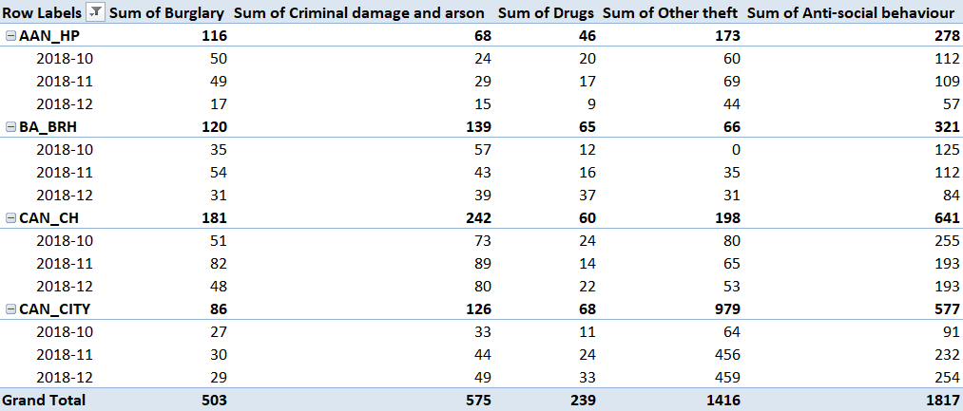

Figure Total no. of crime per area in Leeds in the last quarter of 2018

# Task 2 Star Schema Set up

## Setting up source database

Before forward engineering the above star schema, the 2 source databases provide to us were uploaded. The data sources provided were PRCS.sql, PRCS_insert_test_data.sql and PS_wales.sql.

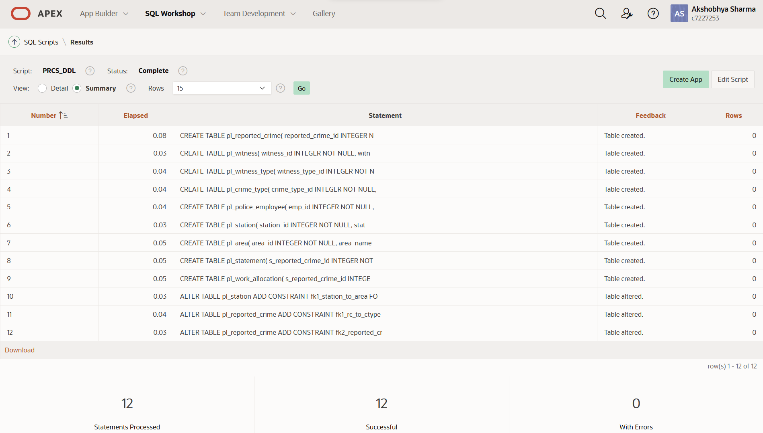

Figure Successful run of PRCS source

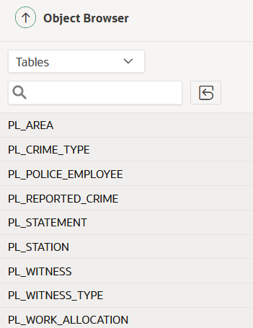

Figure All the tables of PRCS visible in object browser

The data provided for PRCS was also inserted.

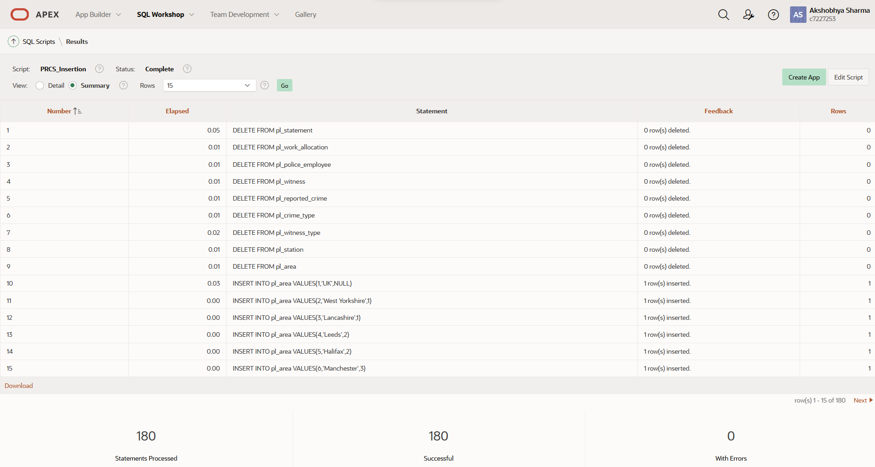

Figure Successful insertion in PRCS tables

The script for ps_wales system along with its insertion data was also run.

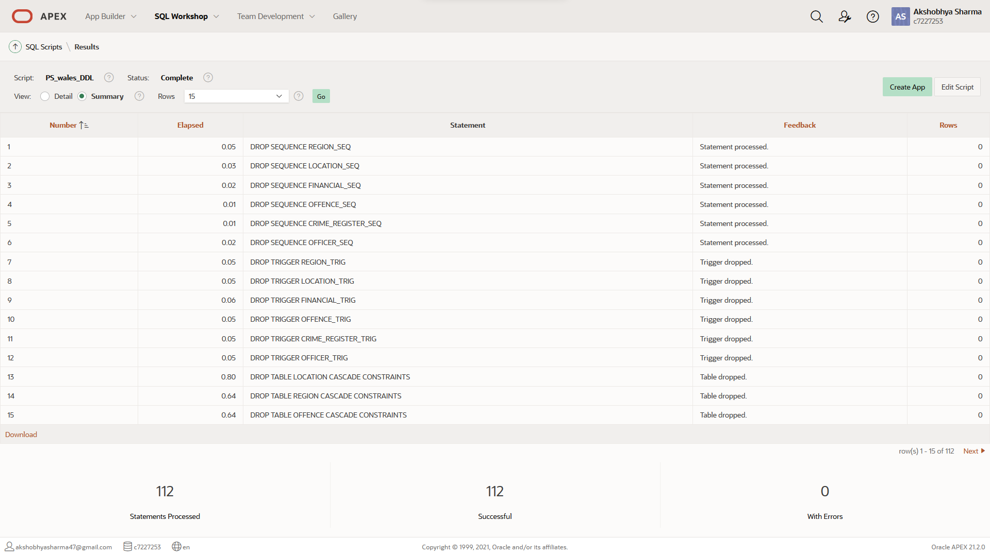

Figure Successful set up of PS_WALES DDL and insertion

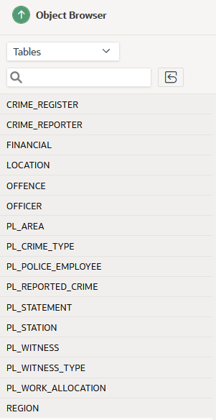

Figure All the required source data structures

Following are the tables with data from the above scripts run:

For **PRCS** we have:

1. **CRIME_REGISTER**

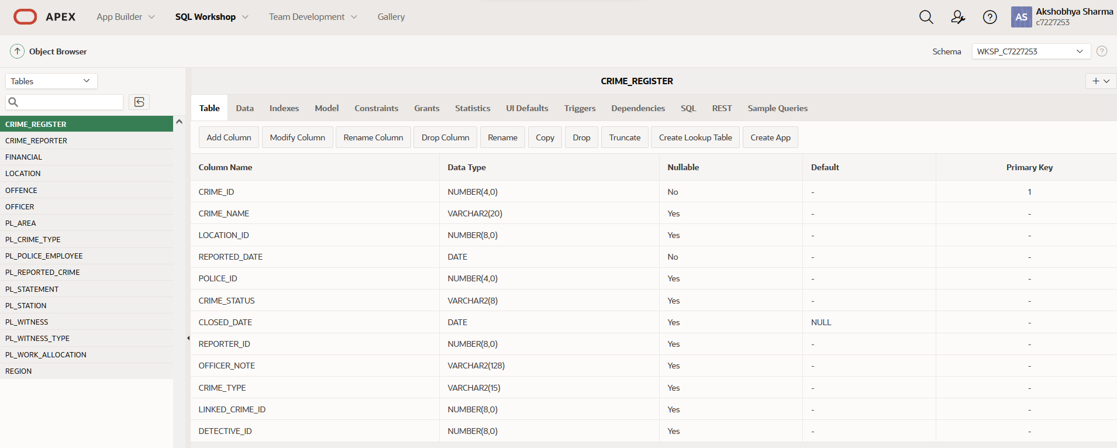

Figure Crime_register table

1. **CRIME_REPORTER**

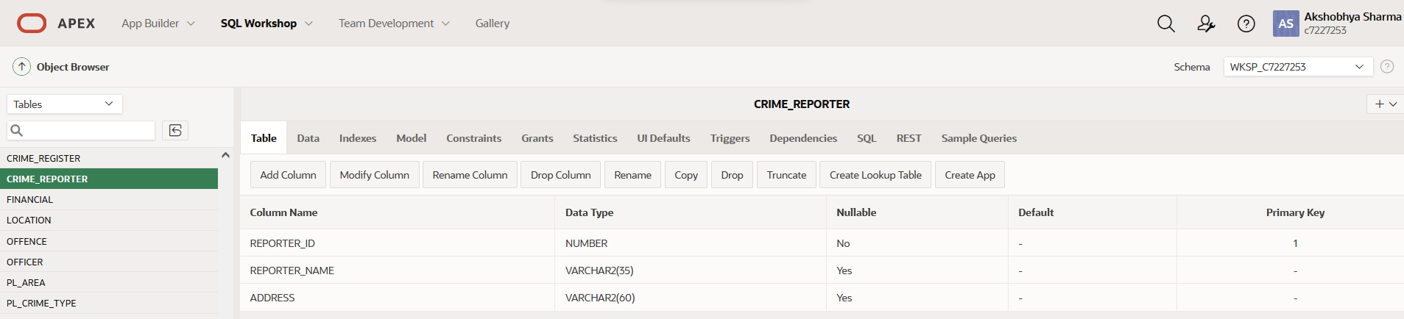

Figure Crime_reporter table

1. **FINANCIAL**

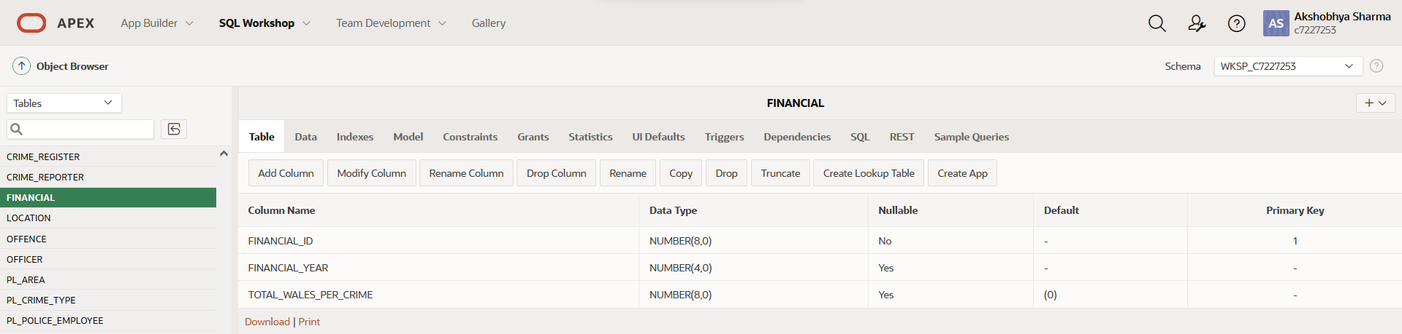

Figure Financial table

1. **LOCATION**

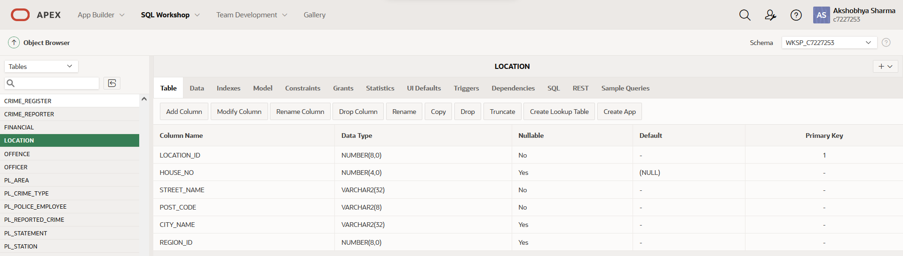

Figure Location table

1. **OFFENCE**

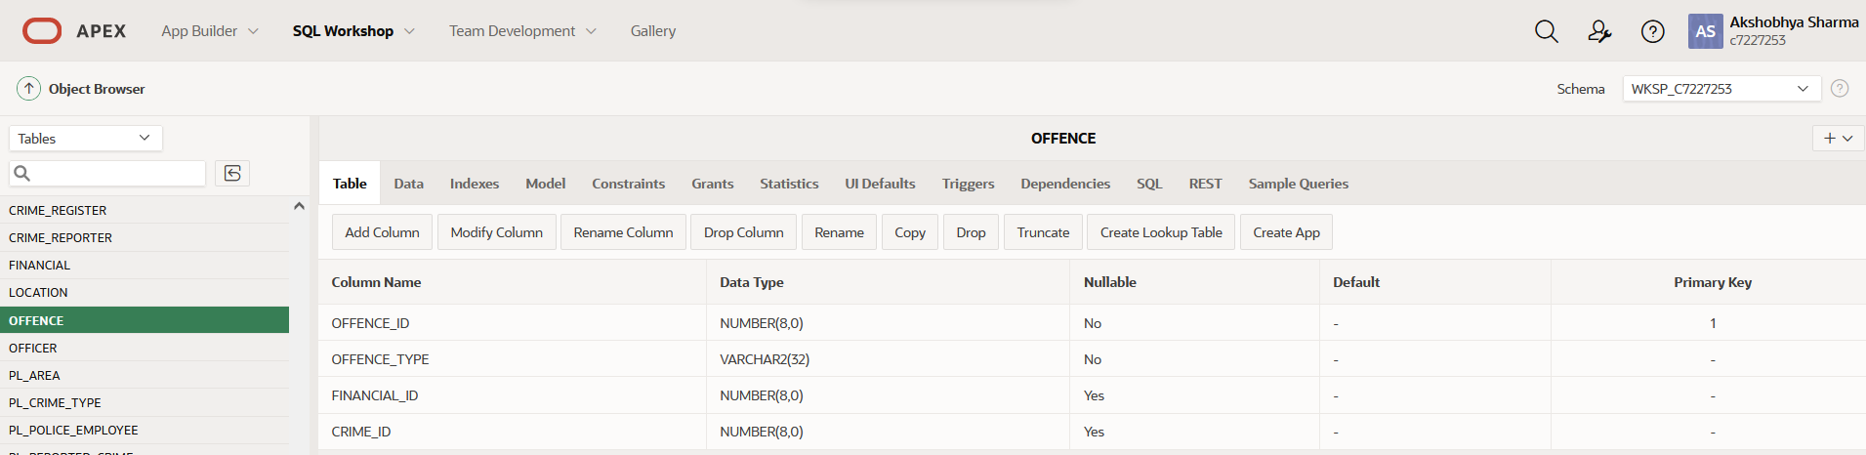

Figure Offence table

1. **OFFICER**

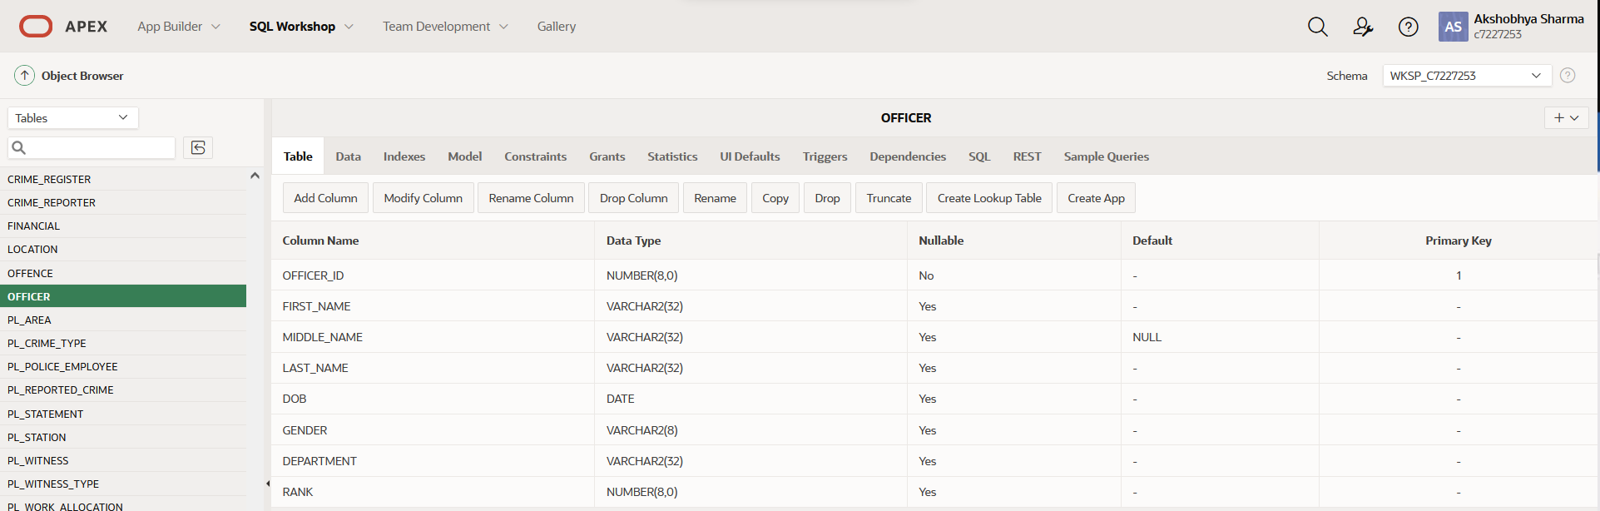

Figure Officer table

1. **REGION**

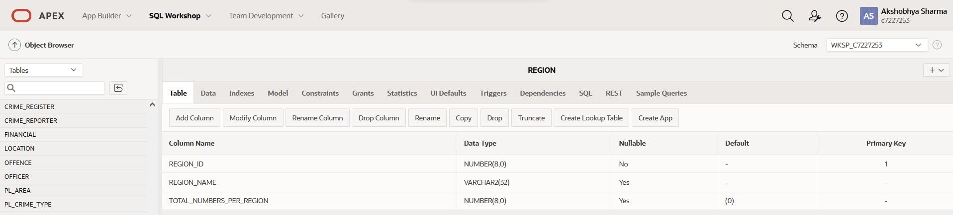

Figure Region table

For **PS_WALES** we have:

1. **PL_AREA**

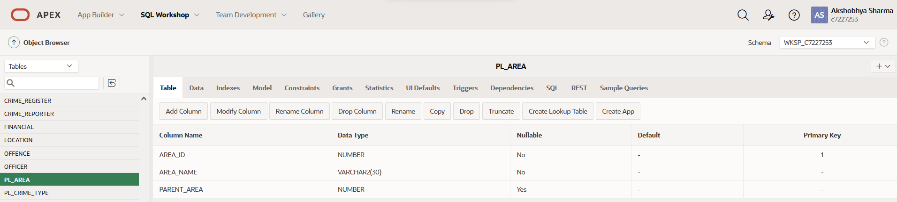

Figure PL_AREA table

1. **PL_CRIME_TYPE**

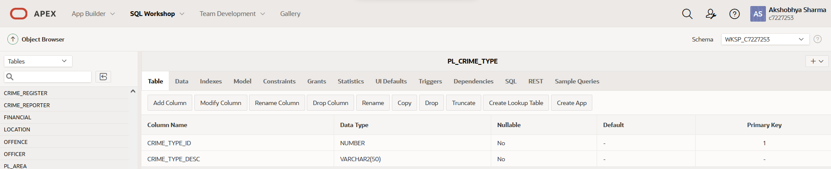

Figure PL_CRIME_TYPE table

1. **PL_POLICE_EMPLOYEE**

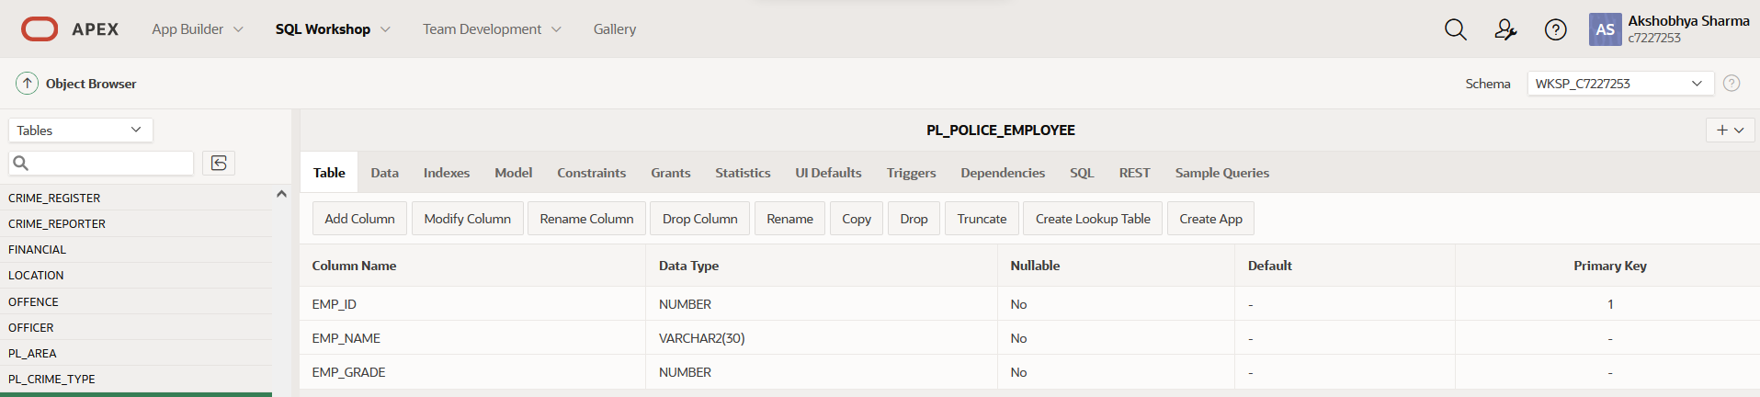

Figure PL_POLICE_EMPLOYEE table

1. **PL_REPORTED_CRIME**

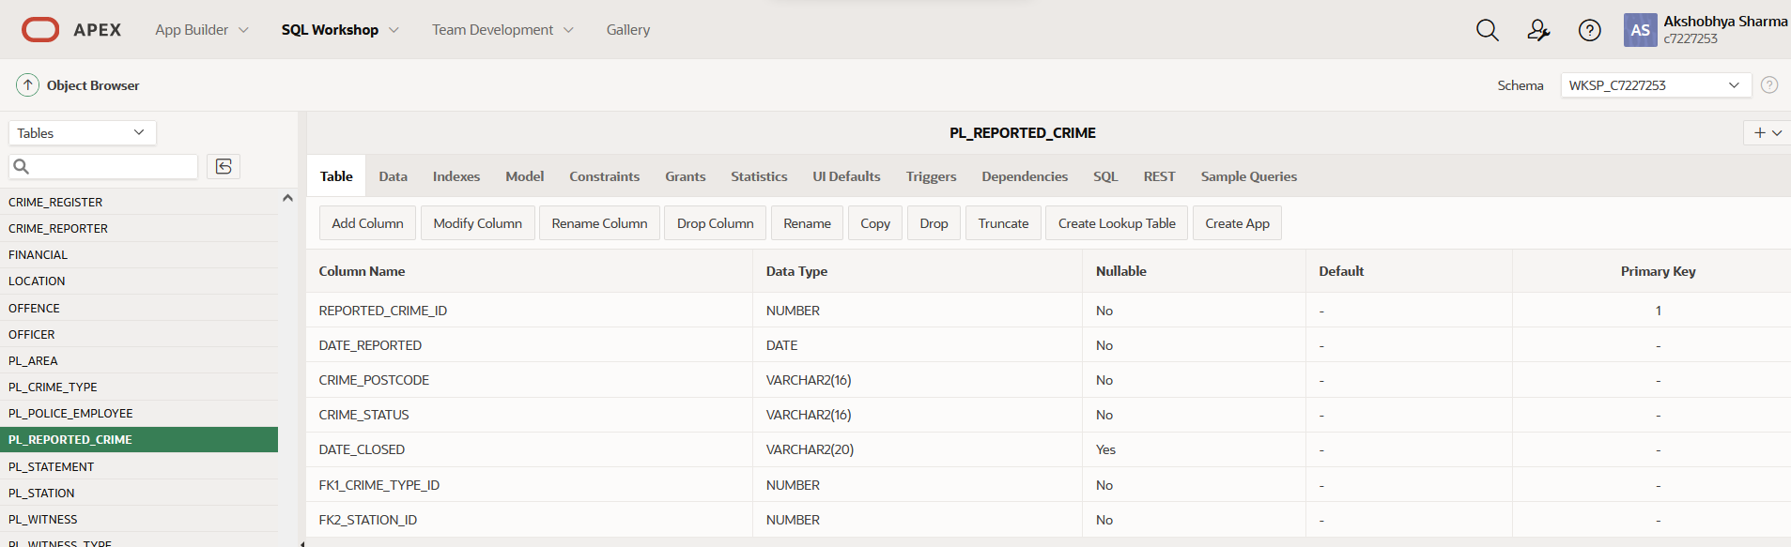

Figure PL_REPORTED_CRIME table

1. **PL_STATEMENT**

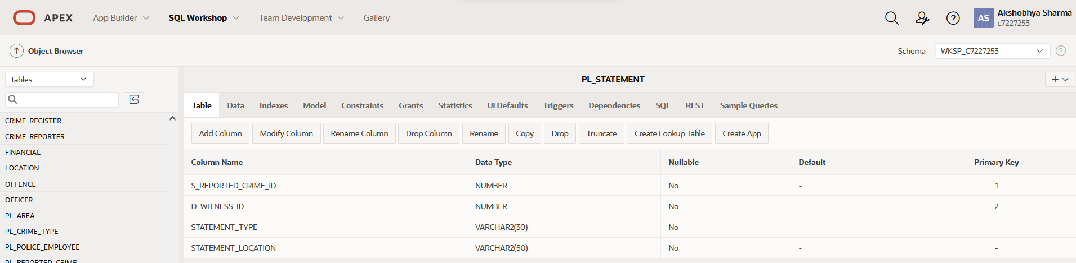

Figure PL_STATEMENT table

1. **PL_STATION**

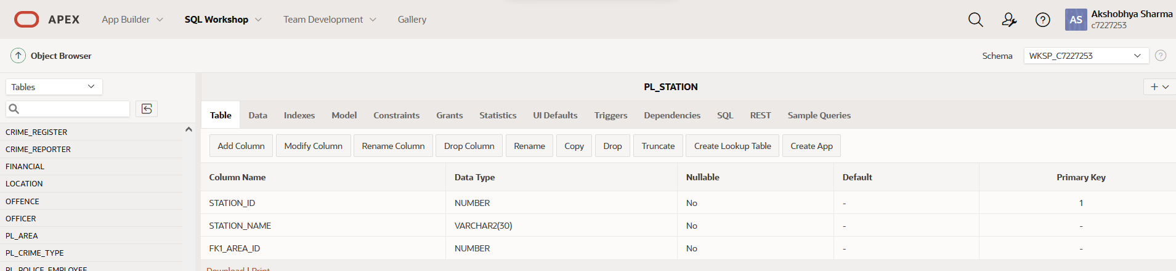

Figure Pl_STATION table

1. **PL_WITNESS**

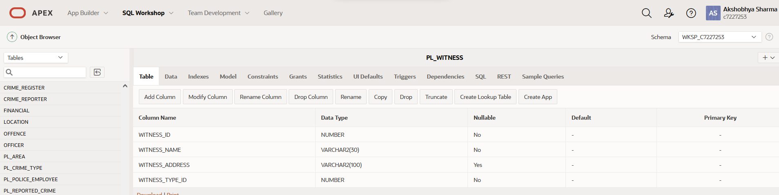

Figure PL_WITNESS table

1. **PL_WITNESS_TYPE**

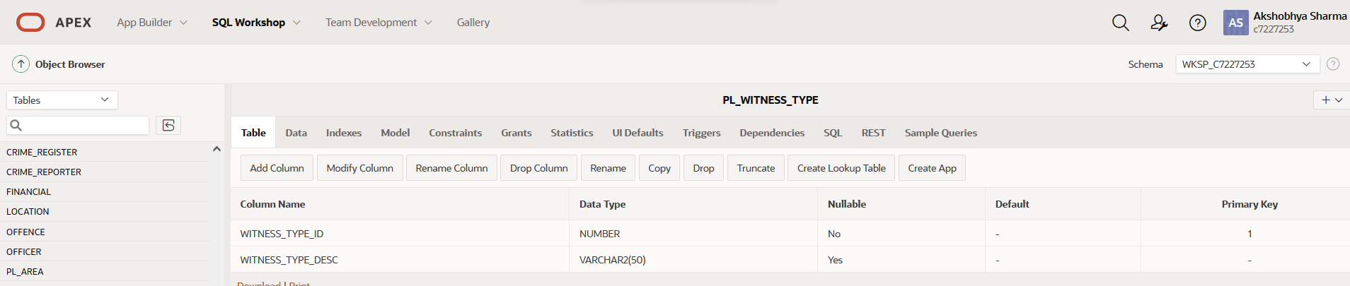

Figure PL_WITNESS_TYPE

1. **PL_WORK_ALLOCATION**

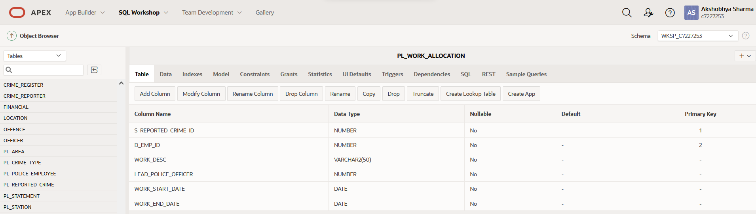

Figure PL_WORK_ALLOCATION table

## Star Schema set up

The QSEE tool was used to forward engineer the database. Two DDL files were generated from the QSEE one for dropping the structure and a DDL file for the structure. For the sake of convenience for testing purpose, both those files were combined into a single one. Following changes were further made to make the script more appropriate for the desired schema:

1. The CASCADE CONSTRAINT keywords were added to the DROP TABLE commands as the tables use foreign keys, which needs to be dropped as well.
2. The auto generated foreign keys like fk1_region_id, fk2_case_id was removed and the keys present in the fact table in the QSEE diagrams were altered as foreign keys.
3. The alter table constraints changed from ON DELETE RESTRICT ON UPDATE RESTRICT to ON DELETE CASCADE for testing, however the use of ON DELETE restrict would probably be suitable later on as data aren’t deleted from data warehouse.
4. Sequences were created for each of the table in the DDL.
5. Furthermore, triggers were created to insert primary keys for each of the sequences.

The following screenshots demonstrate a successful run of the script as well as evidences of database structures created.

Successful Execution of dimension_ddl script

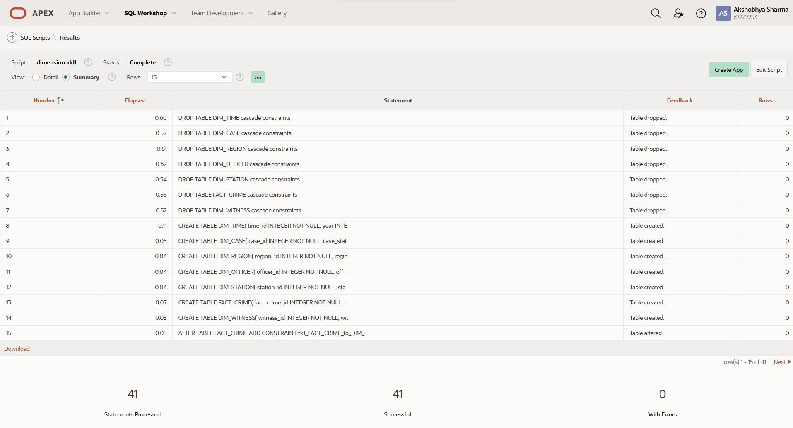

Figure Dimension DDL script

Following structures were created following the script execution:

1. **DIM_CASE**

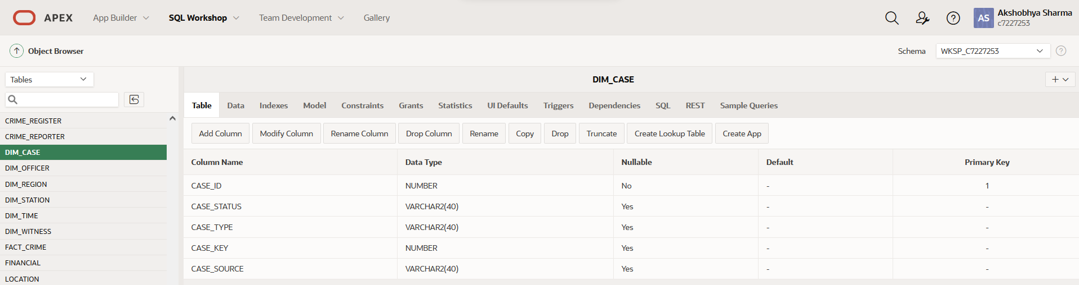

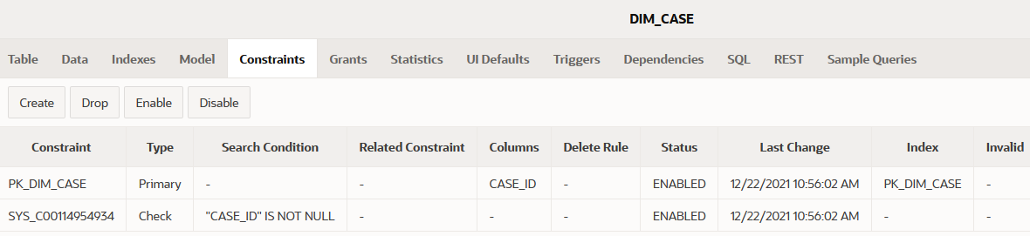Figure DIM_CASE table

Figure DIM_CASE constraints

1. **DIM_OFFICER**

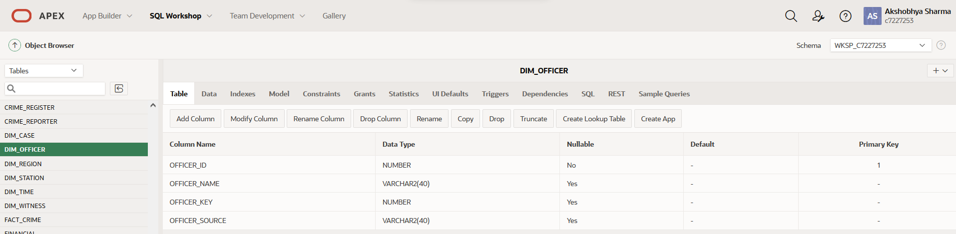

Figure DIM_OFFICER table

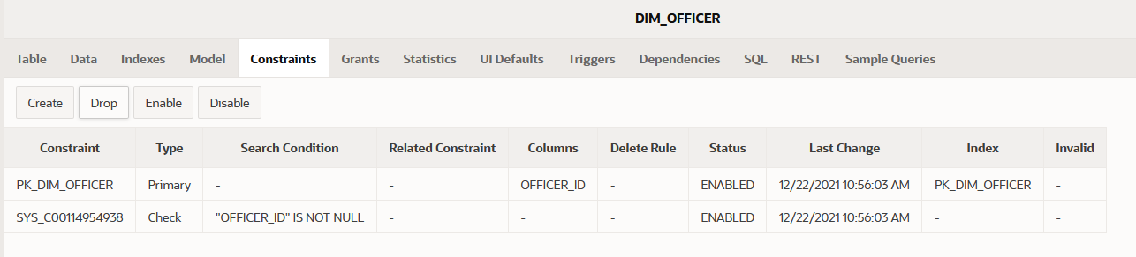

Figure DIM_OFFICER constraints

1. **DIM_REGION**

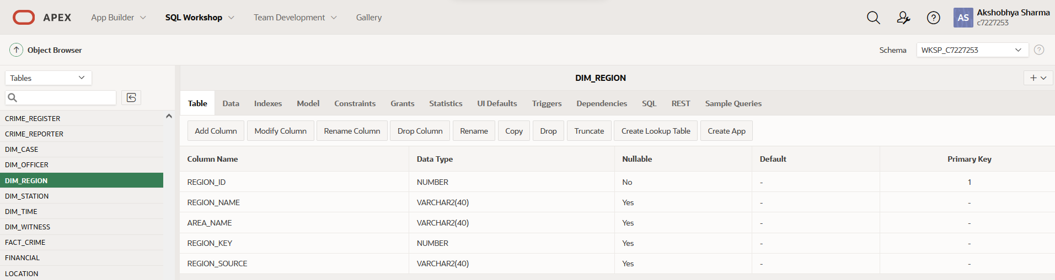

Figure DIM_REGION table

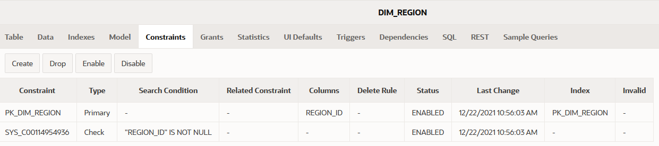

Figure DIM_REGION constraints

1. **DIM_STATION**

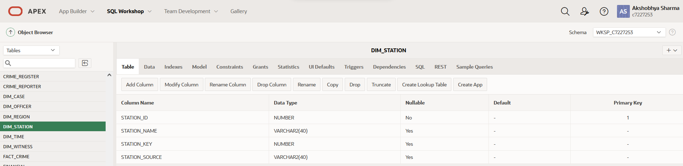

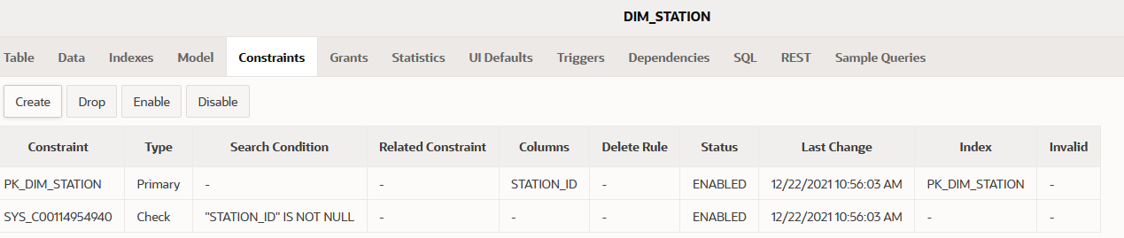Figure DIM_STATION table

Figure DIM_STATION constraints

1. **DIM_TIME**

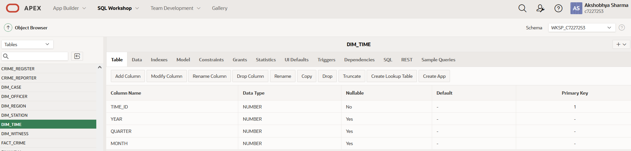

Figure DIM_TIME table

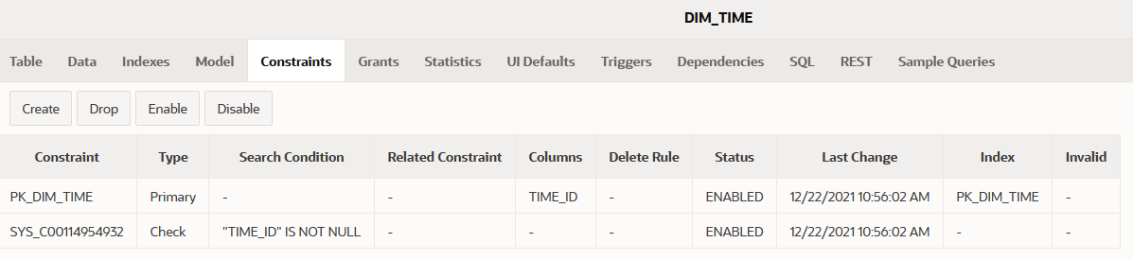

Figure DIM_TIME constraints

1. **DIM_WITNESS**

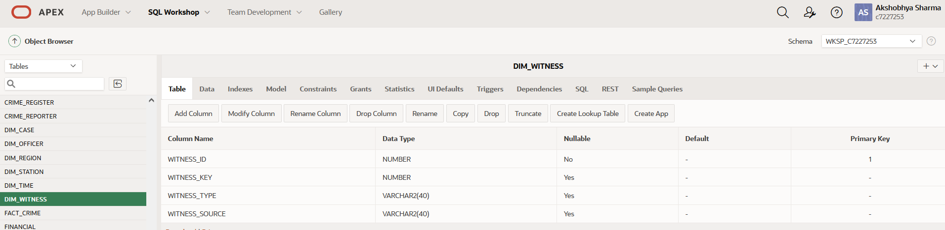

Figure TABLE DIM_WITNESS

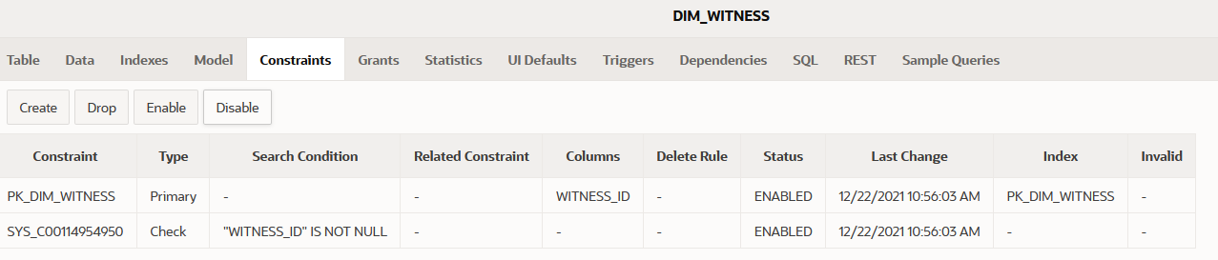

Figure DIM_WITNESS constraints

1. **FACT_CRIME**

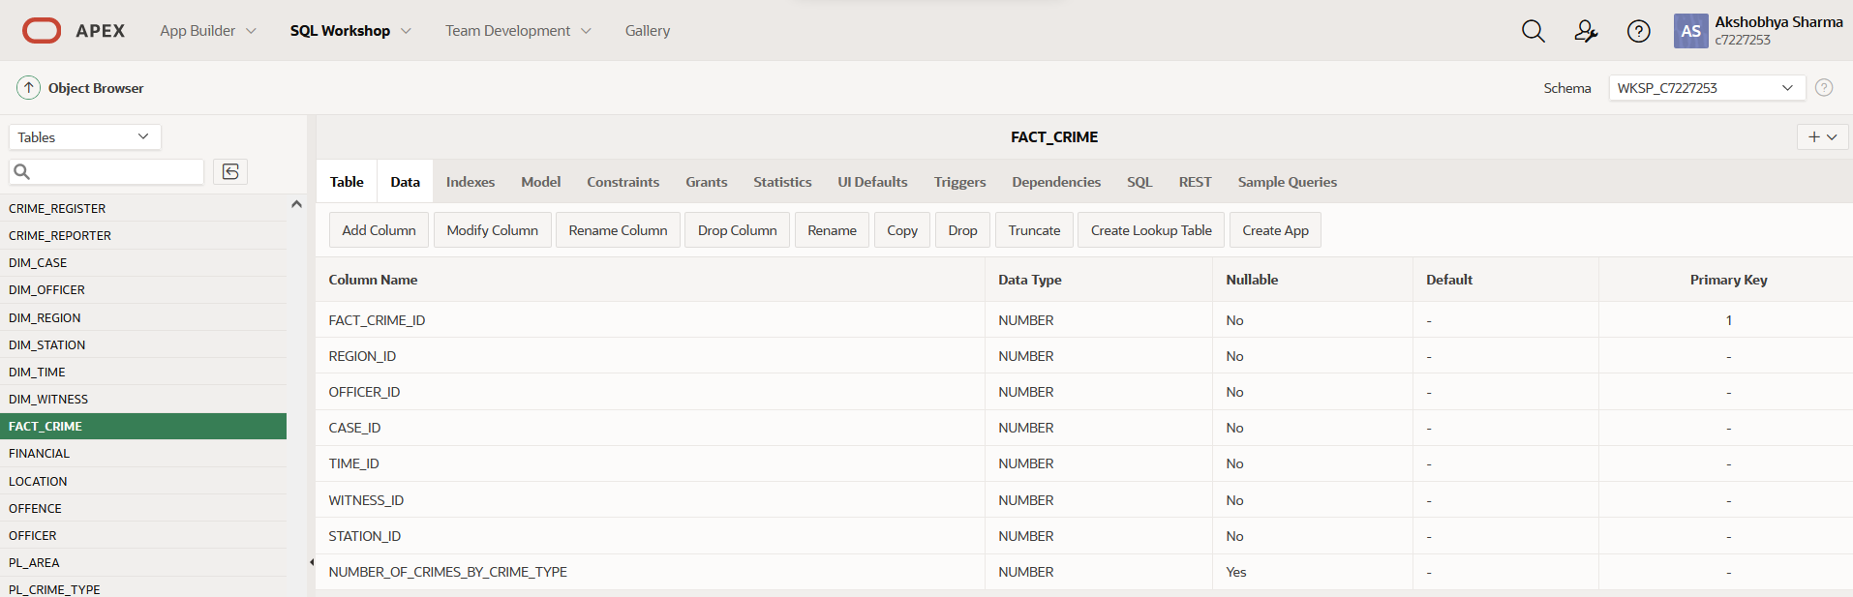

Figure FACT_CRIME table

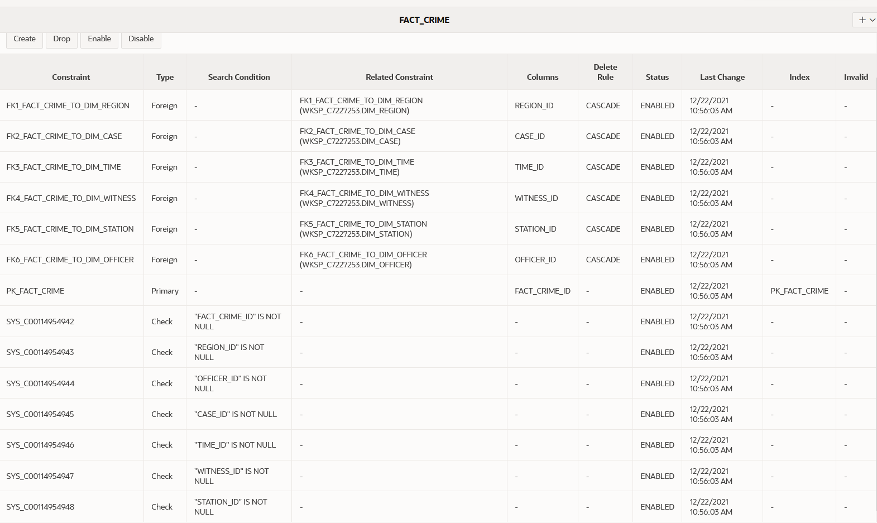

Figure FACT_CRIME constraints

The associated triggers and sequences have also been implemented:

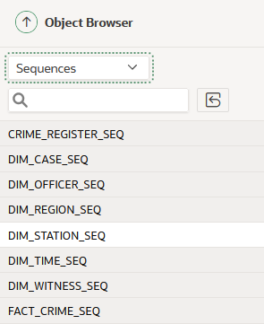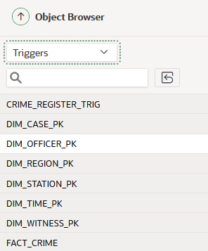

Figure Dimension model sequences

Figure Dimension model sequence triggers

# Task 3: Extract Transform and Load

The ETL process is the most essential part in designing the data warehouse. The following screenshots represent the ETL process being carried out to set up the data mart.

## Extraction

**Setting up the staging Area**

The first part of extraction is setting up the staging area, for that, the staging_DDL script.

The staging_DDL script includes all the triggers as well as sequences for the staging area.

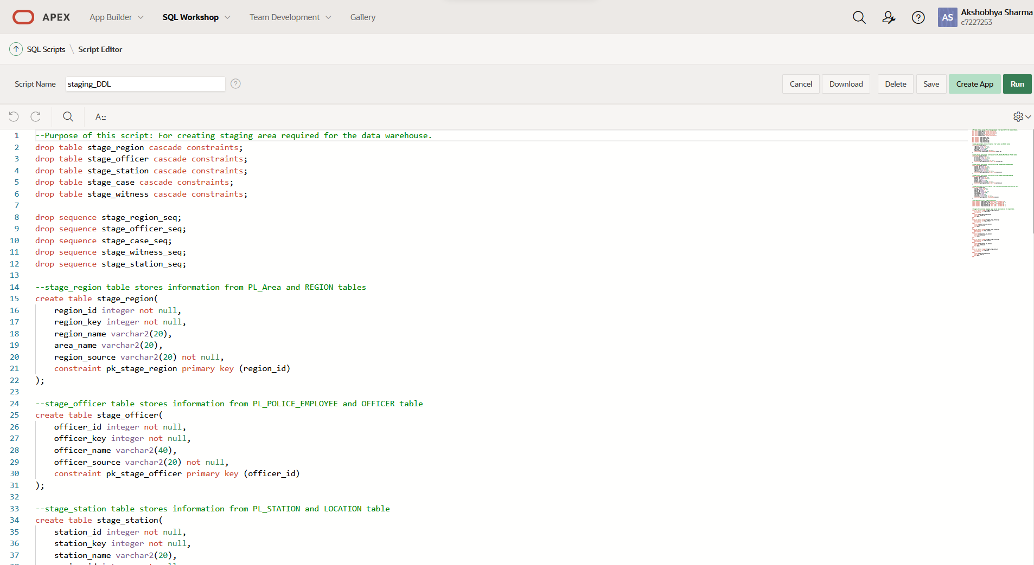

Figure Staging_DDL

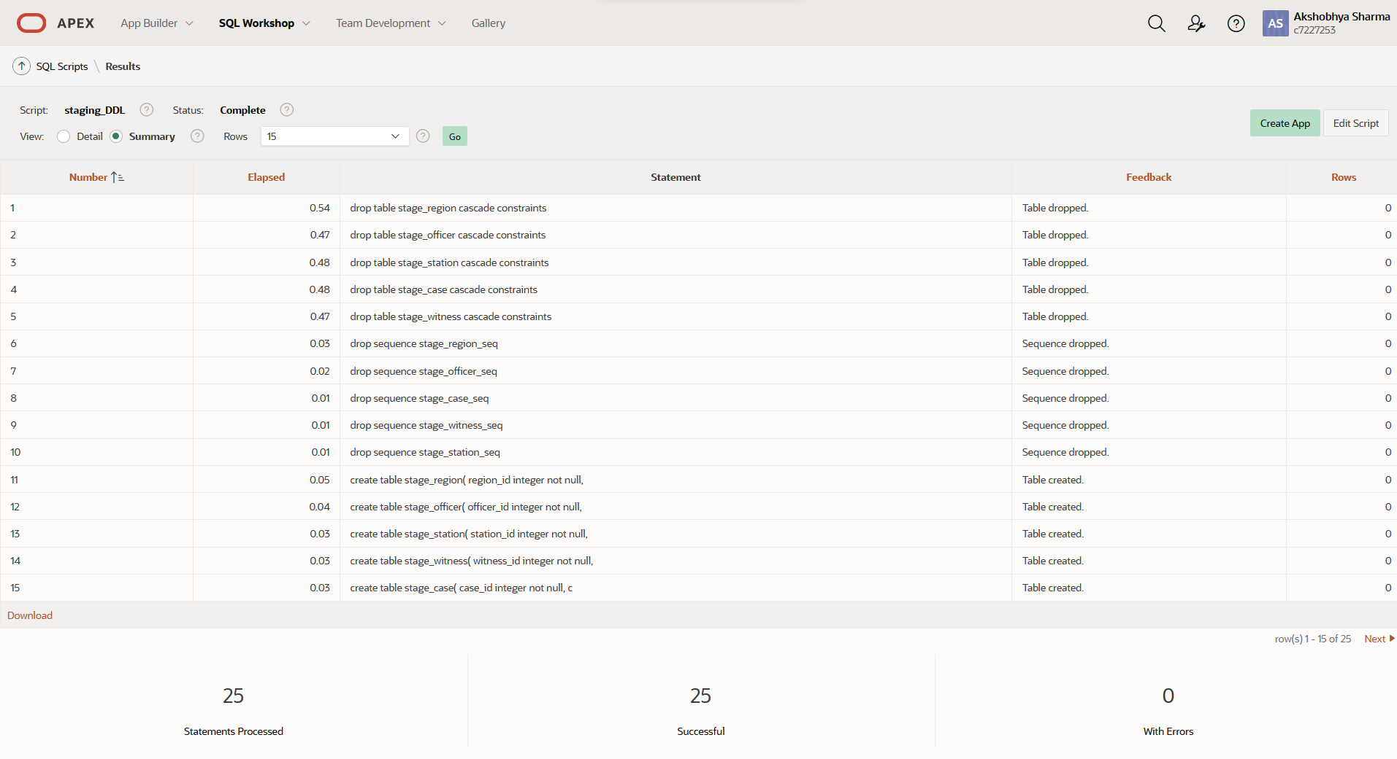

Figure Successful execution of staging_DDL

**Stage Case**

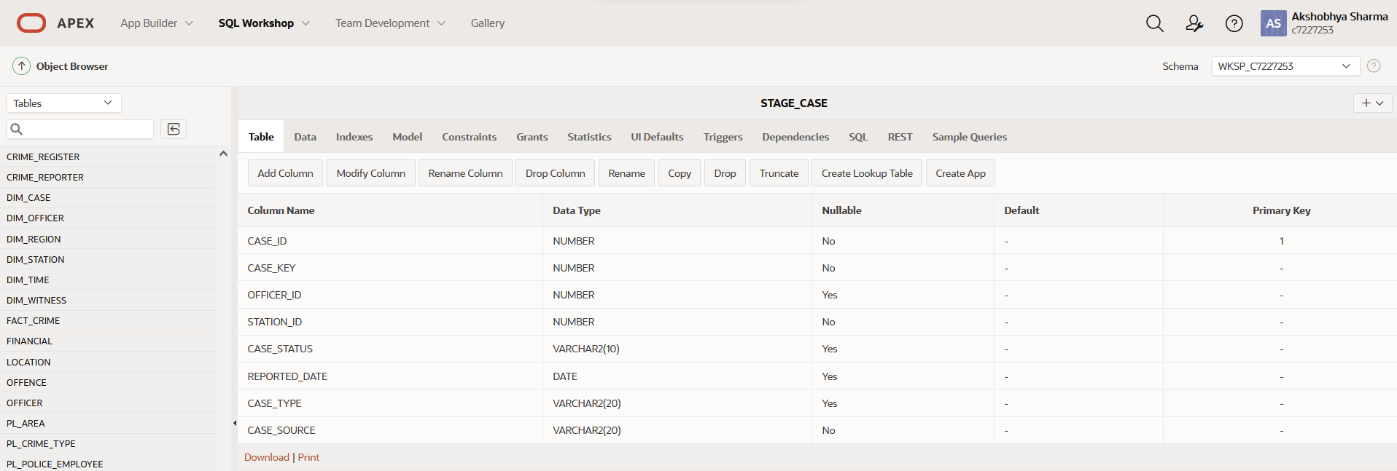

Figure Successful creation of stage case

**Stage Officer**

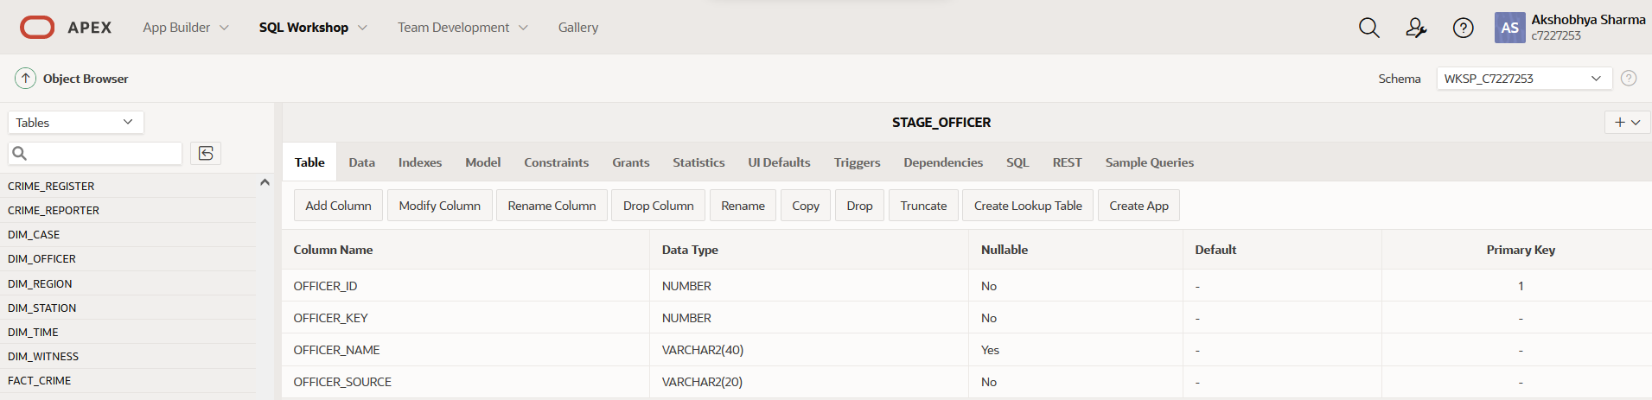

Figure successful creation of stage officer

**Stage Region**

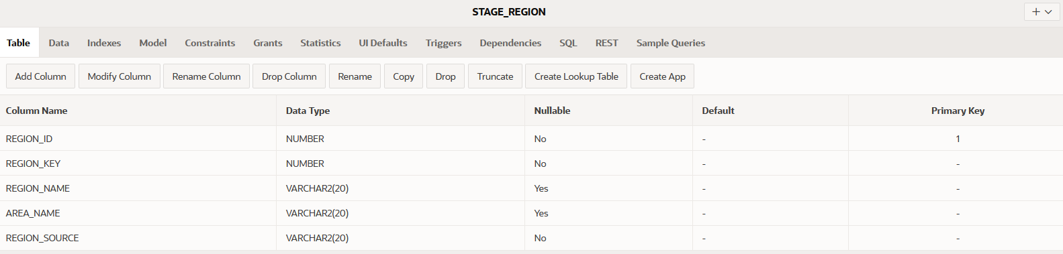

Figure Successful creation of Stage Region

**Stage Station**

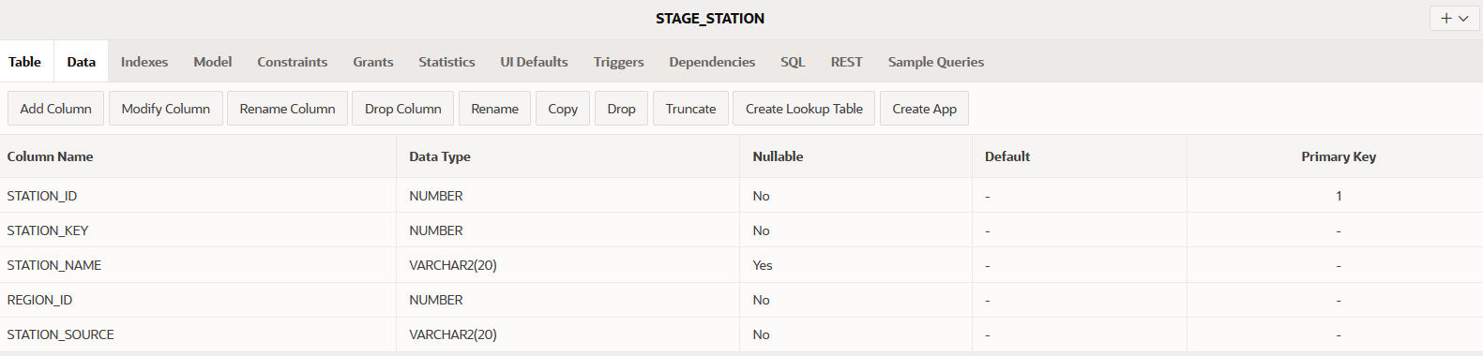

Figure Successful creation of stage station

**Stage Witness**

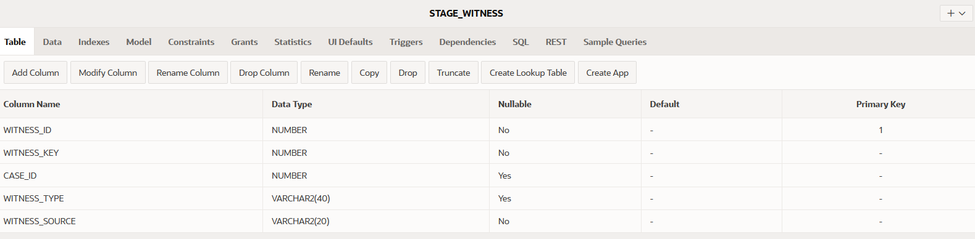

Figure Successful creation of stage_witness

**Extraction Procedures**

The next step for extraction is actually extracting the data, this is done with the help of couple of procedures which have been encoded in a package called staging_procedure_package. This package is declared along with the procedures in stage_insert_procedure package. Two merge statements are used for each source systems inside a procedure to accomplish the task.

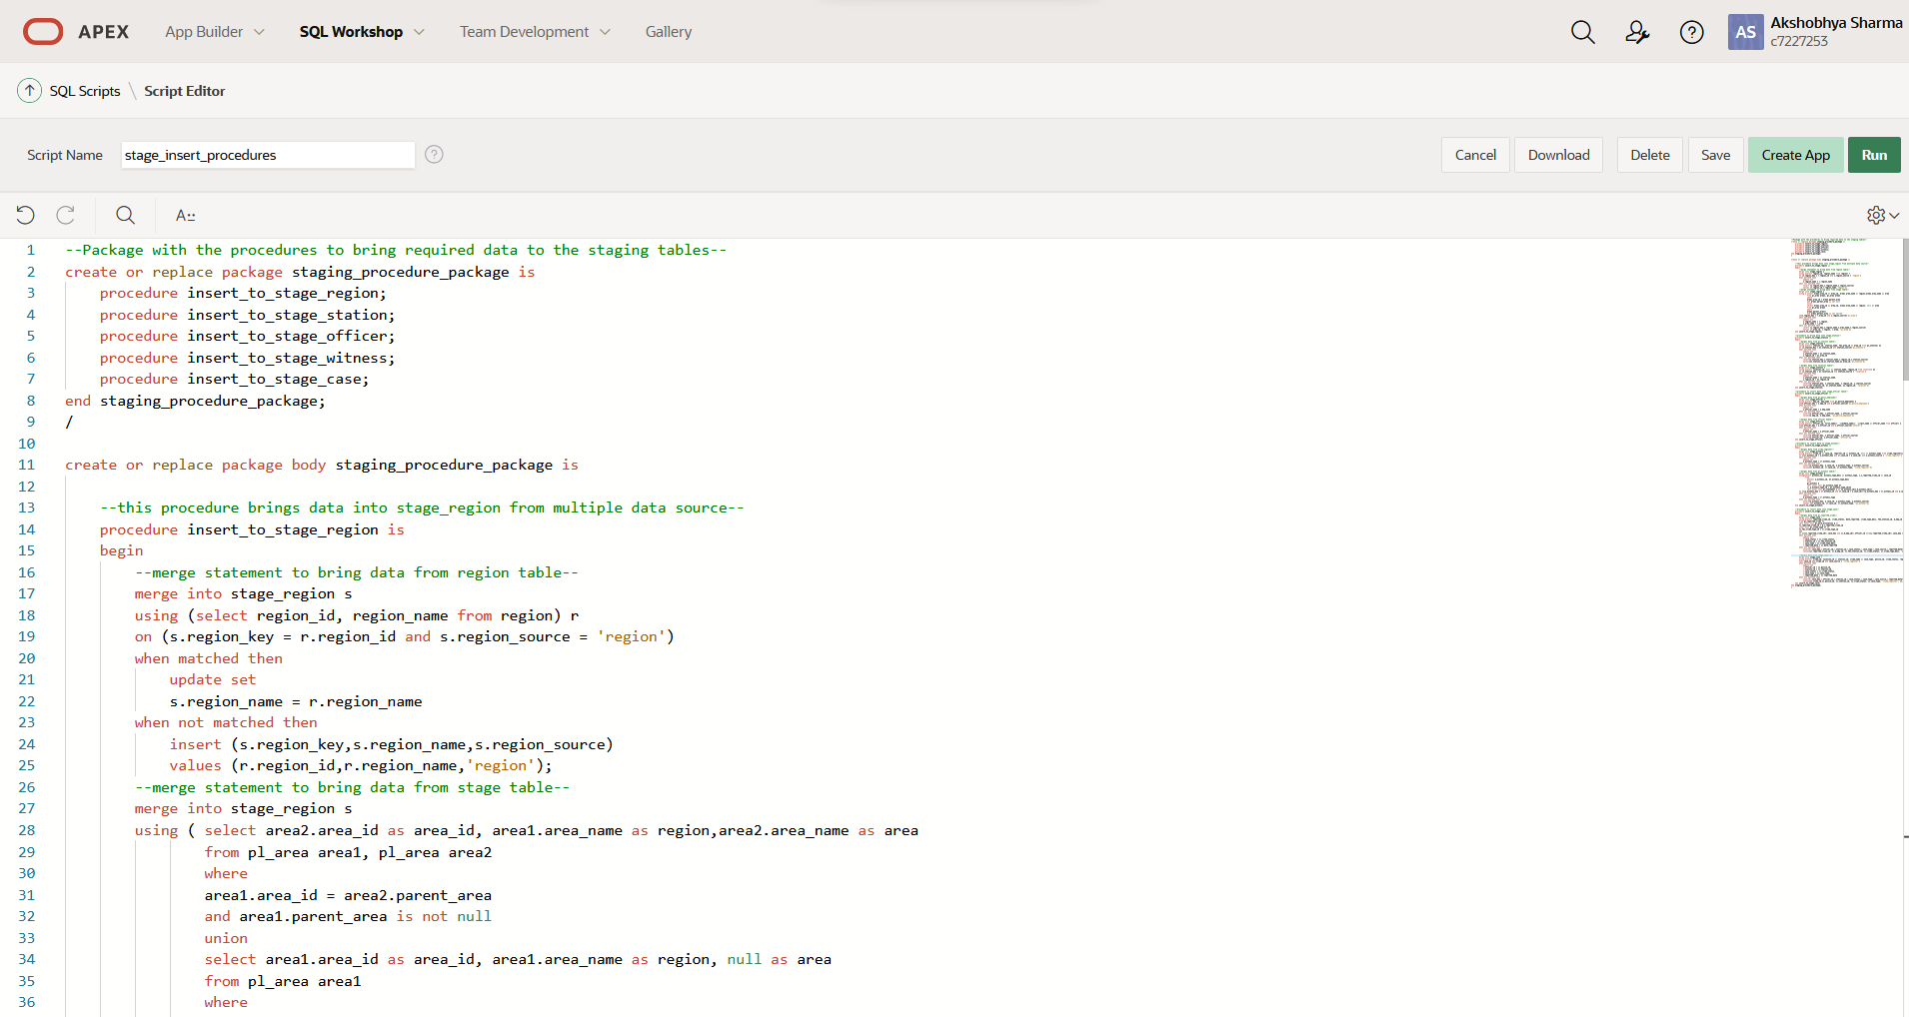

Figure Fig staging_procedure_package

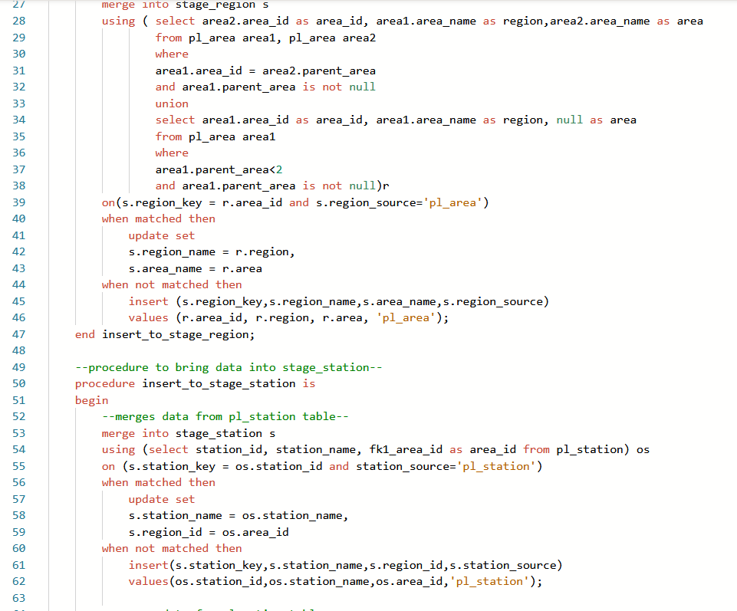

Figure Fig staging procedures

The detailed staging procedure codes can be found in the appendix at the end of the report. This code was successfully executed.

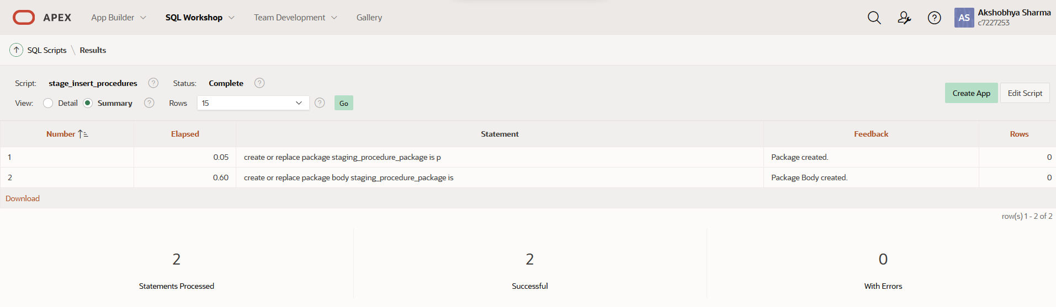

Figure Successful creation of staging package and procedures

The procedures were then executed using the following script to successfully bring data to the staging area.

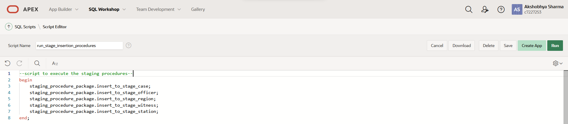

Figure Staging execution script

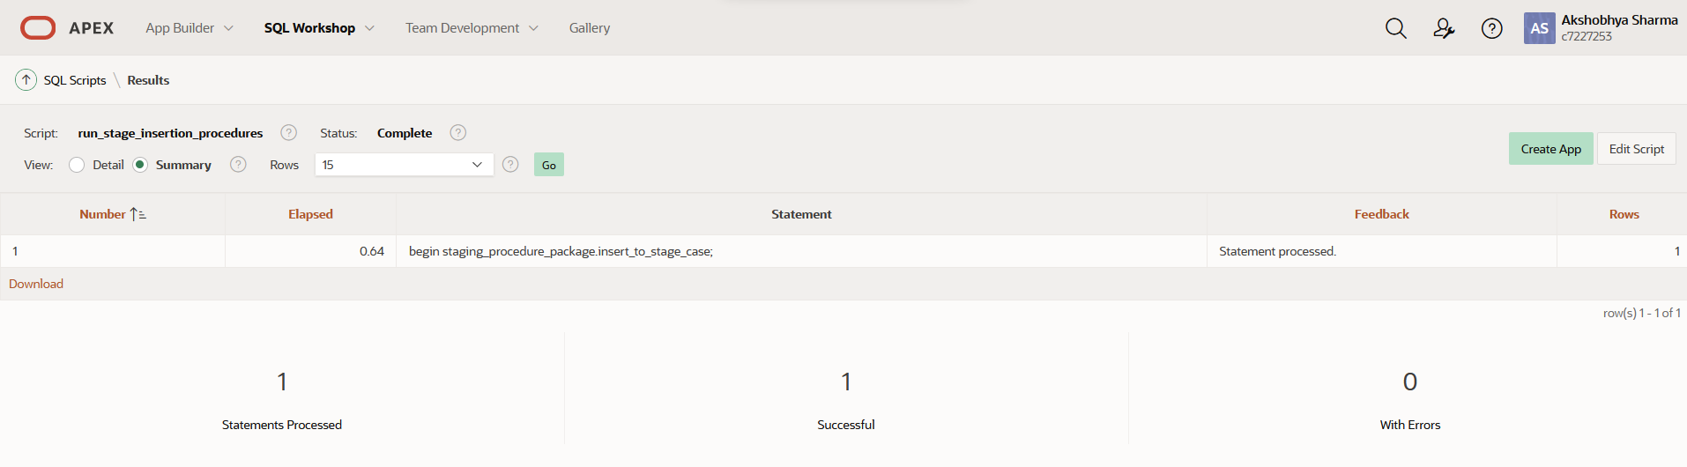

Figure Succesfull execution of stage insertion procedures

The execution of this statement has brought the data to our staging area.

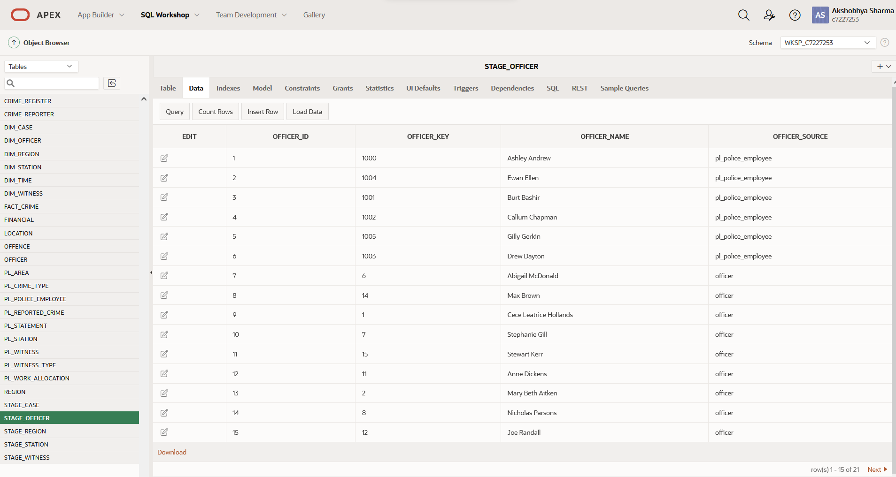

Figure Data in Staging Area

## Cleaning

Following the staging of the data, the data must now be filtered into clean and bad tables. This requires the creation of clean and bad tables to store those datas which is done by clean_and_bad_DDL script which also includes the sequences and triggers for those tables.

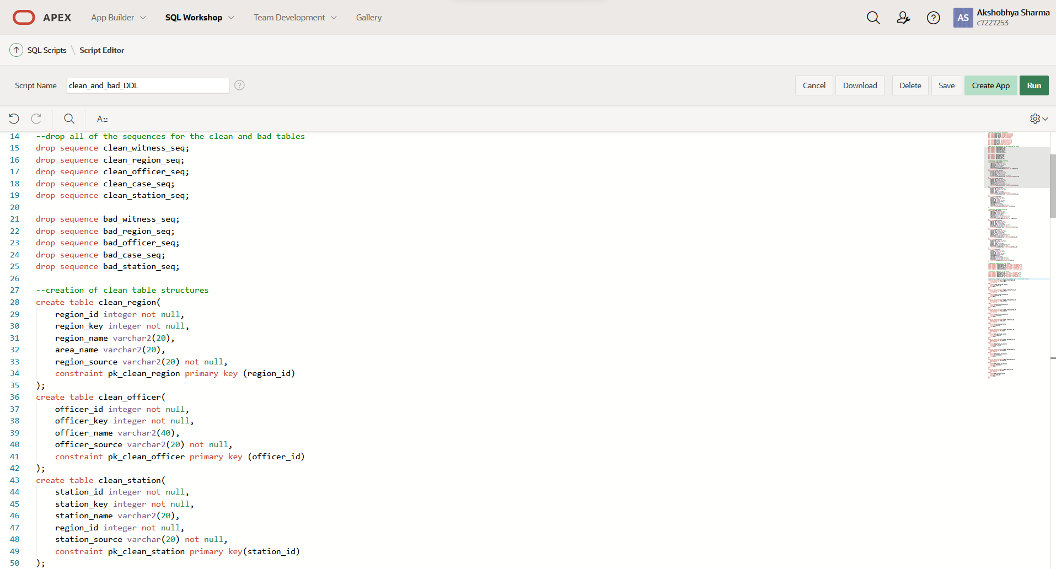

Figure clean_and_bad_DDL script

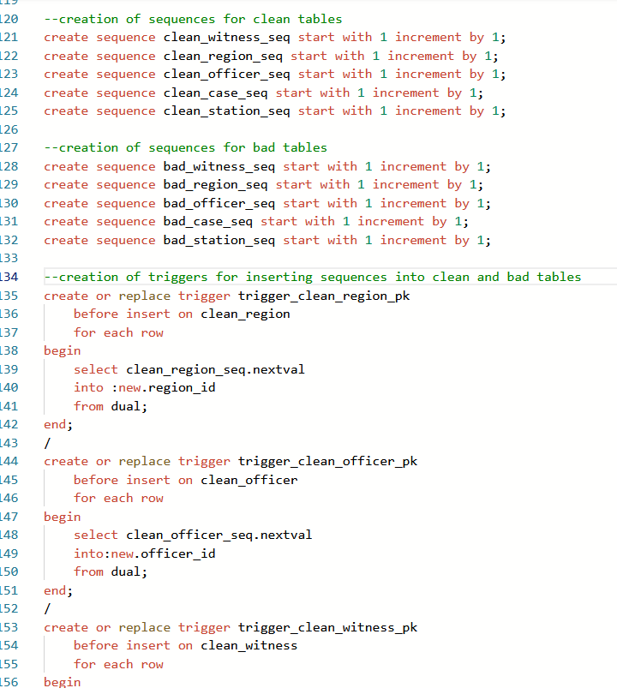

Figure sequences and triggers

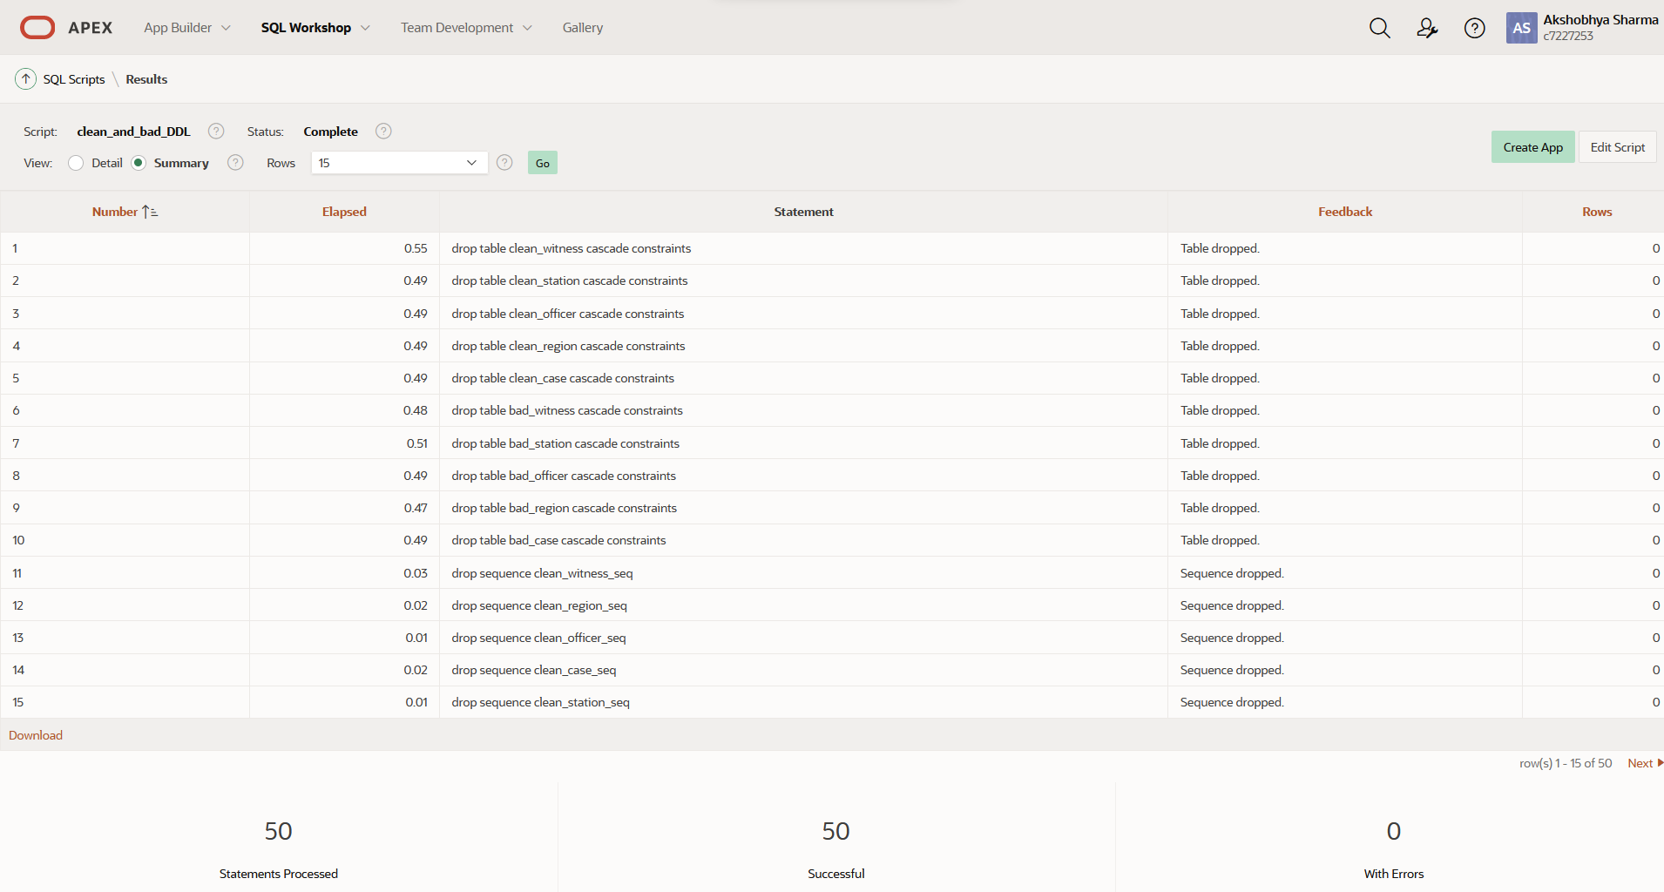

Figure clean_and_bad_DDL successfully executed

The execution of clean_and_bad_DDL has provided us with the structures required for cleaning the data.

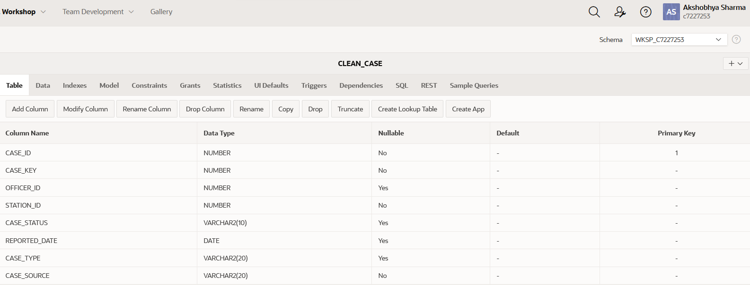

Figure Successful creation of clean_case

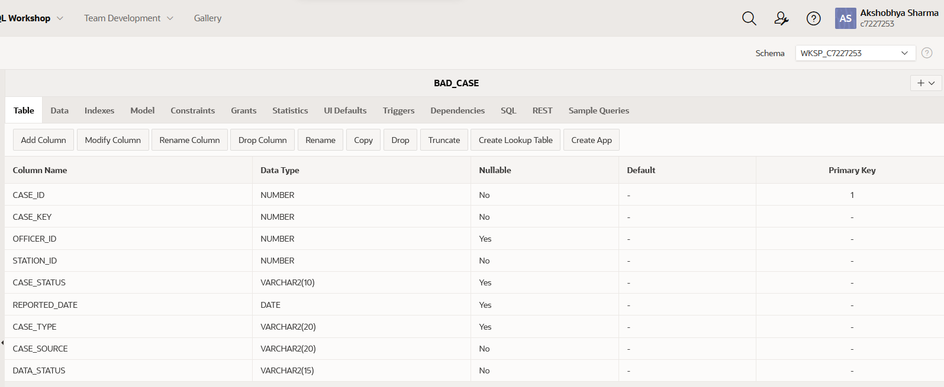

Figure Successful creation of bad_case

**Considerations**

The creation of clean and bad tables allows us to now filter data. The following are the considerations based on the source data for cleaning:

1. Null values were found in case_type attribute in stage_case.
2. Special character in region_name in stage_region as well as null area name.
3. Null station_name as well as repeated values in case of stage_station.
4. Lack of witness_type in stage_witness.

Apart from the bad data already found in the tables, further bad data were introduced with the procedures from create_bad_data_procedure script and executed with insert_bad_data script. It includes:

1. Changing the date value in stage_case to be after the current system date.
2. Changing the officer’s name to include symbols.
3. Changing the witness type to include symbols.
4. Inserting bad data in case table with invalid date as well as invalid crime type.

The following packages and scripts were run to infuse bad data into the stage tables:

The create_bad_data_package includes multiple procedures to manipulate the data which takes input and makes desired changes.

**Creation of procedures to insert bad data**

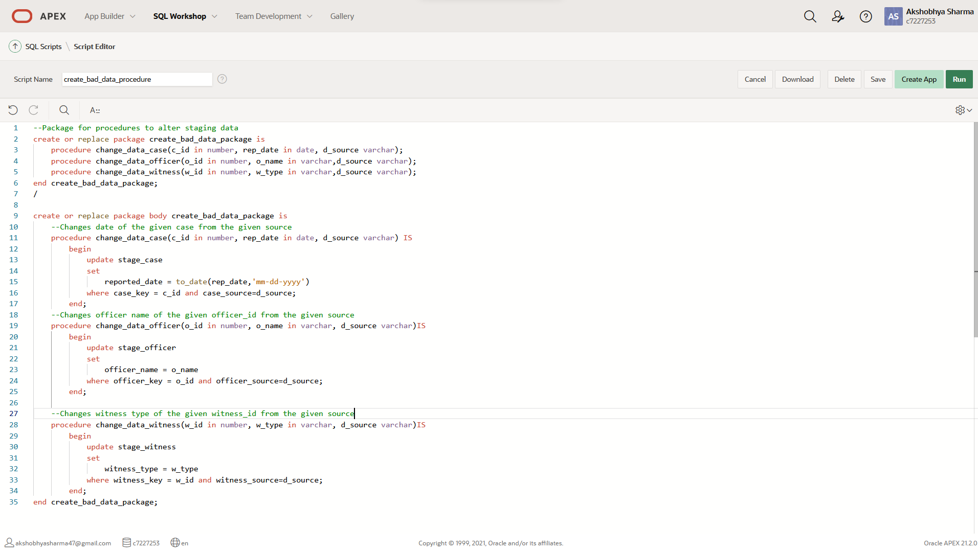Figure create_bad_data package

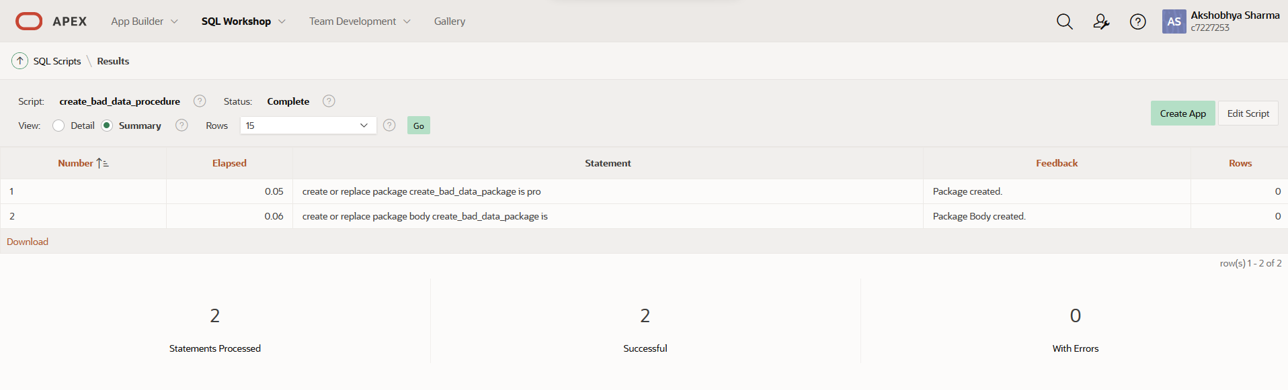

Figure Successful creation of procedures

**Execution of procedures to insert bad data**

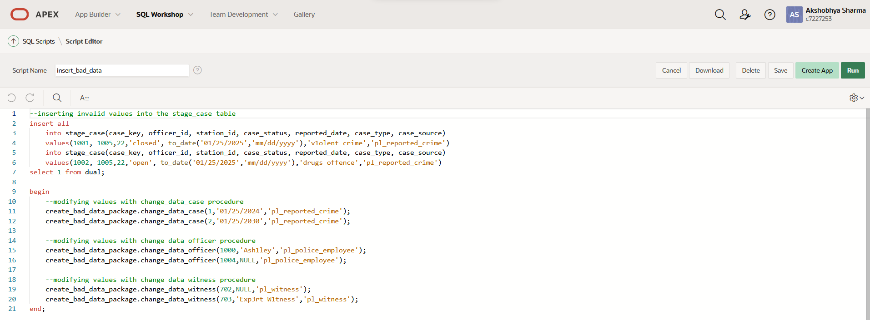

Figure script to insert and change data

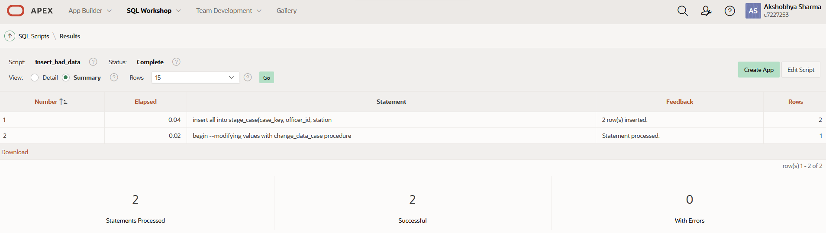

Figure Successful insertion and manipulation of data

**Filtering data**

After all the bad data has been inserted, the next process is separating the staged data into clean and bad tables. For this purpose, procedures in filter_procedure_package is used. The procedures make extensive use of cursors, parameterized cursors, user defined table types as well as record variables in addition with loops and control structures.

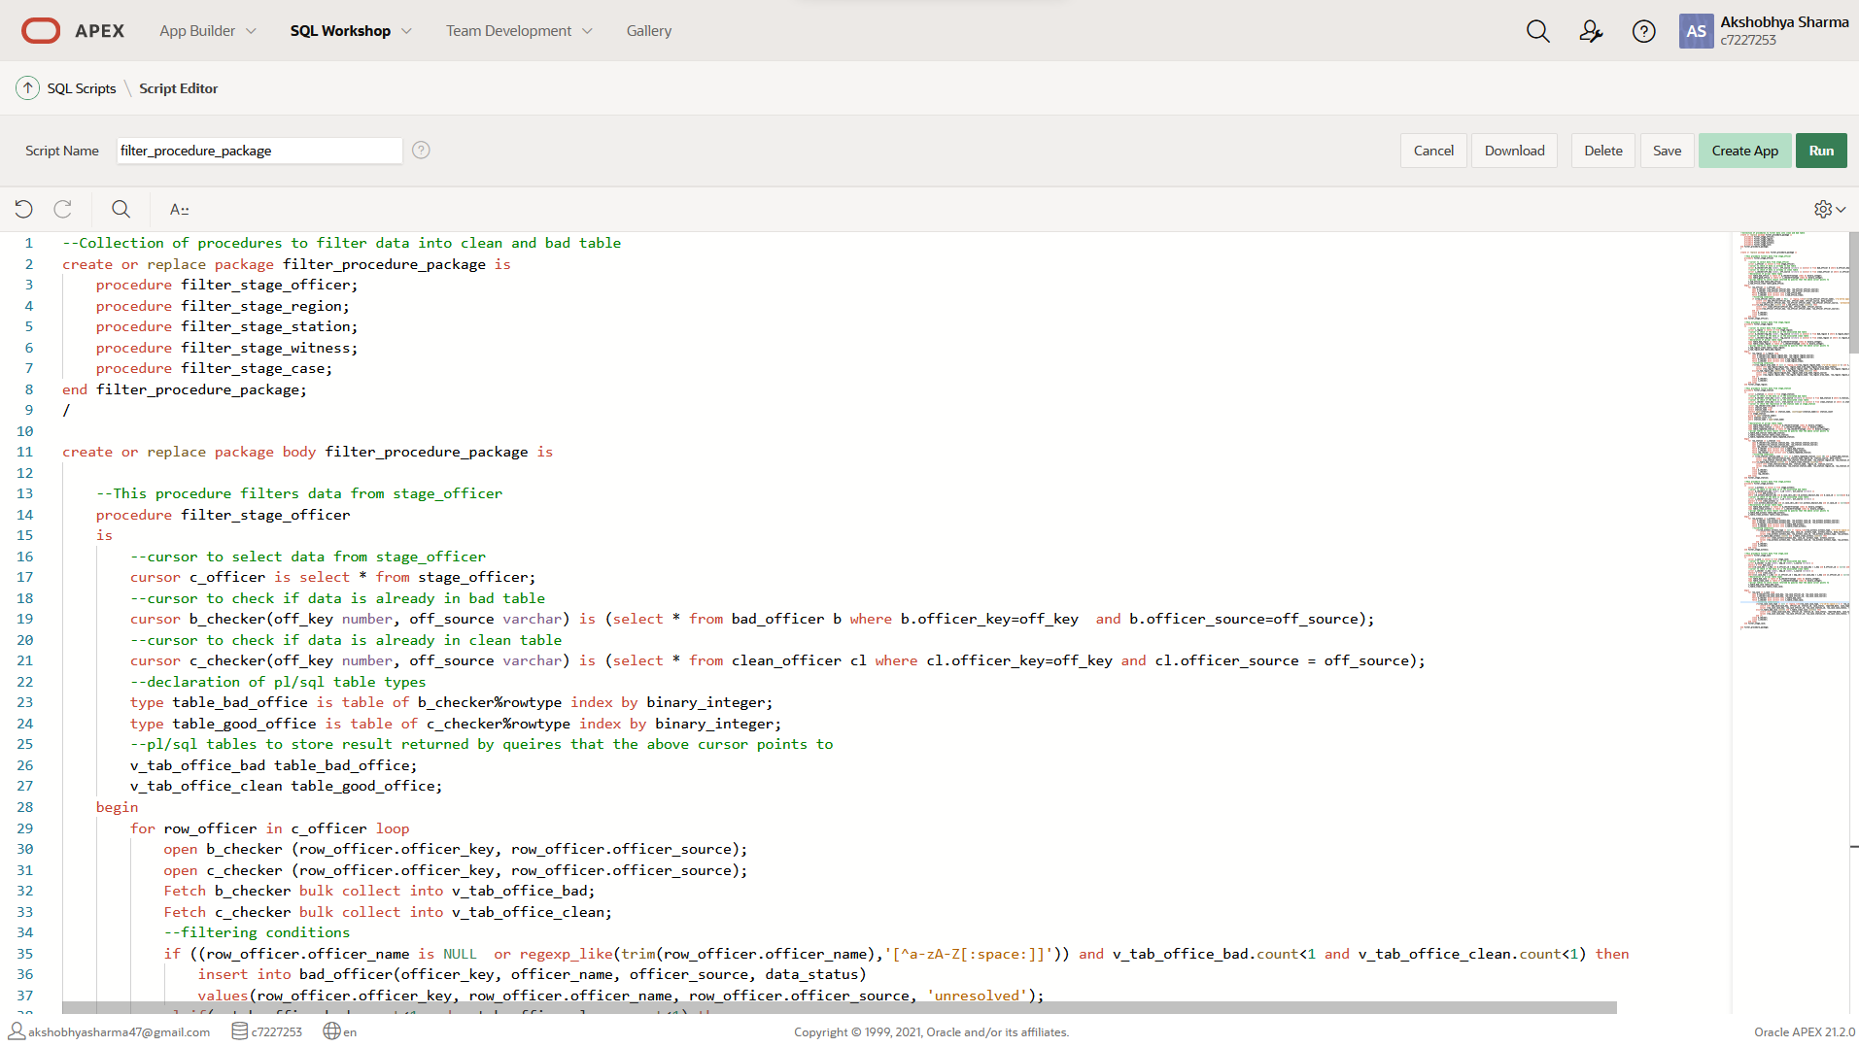

Figure Filter_procedure_package

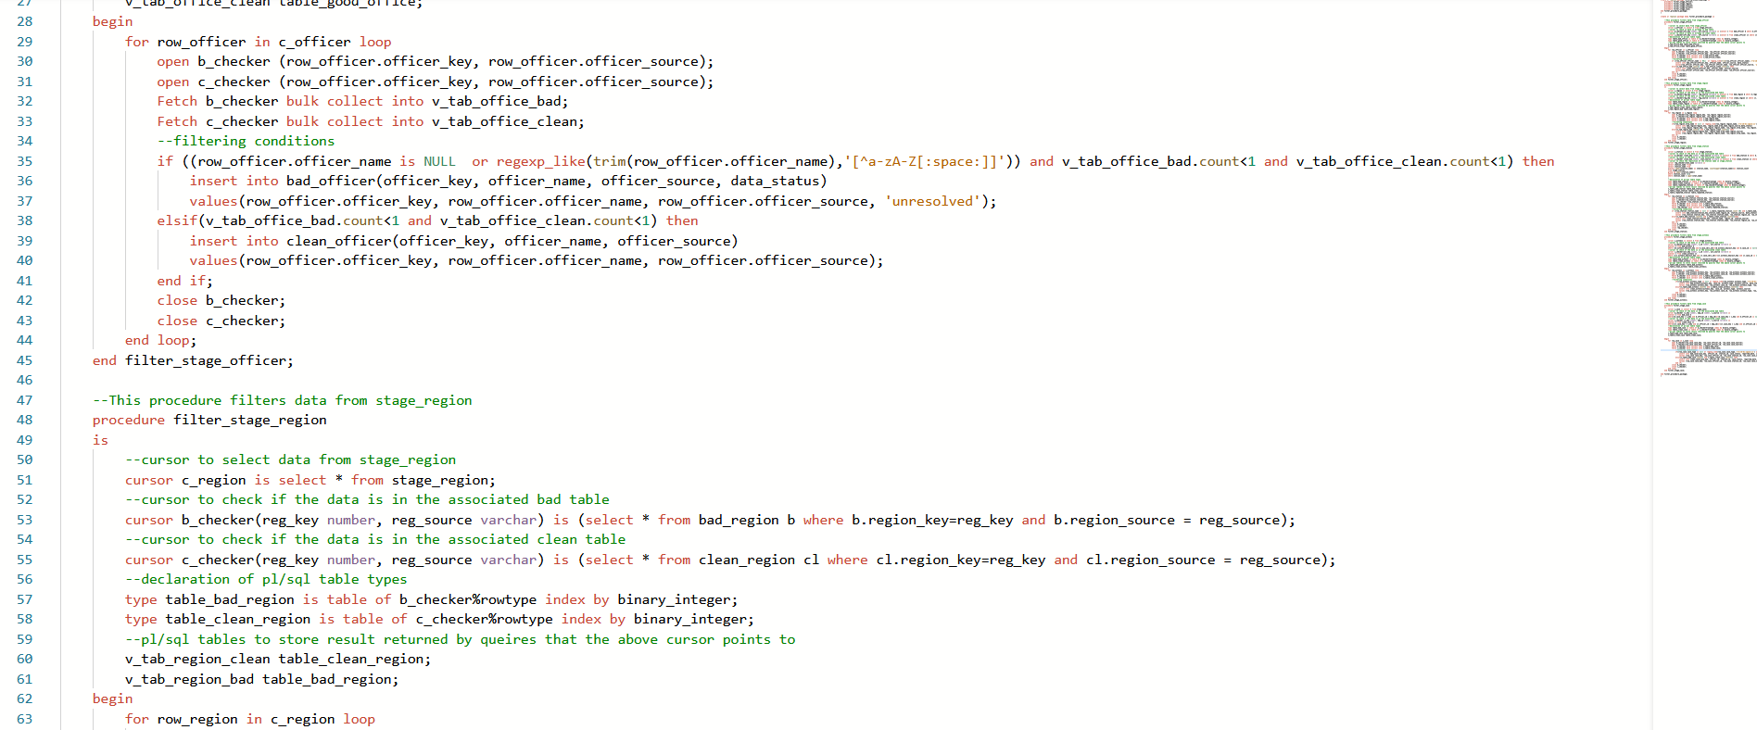

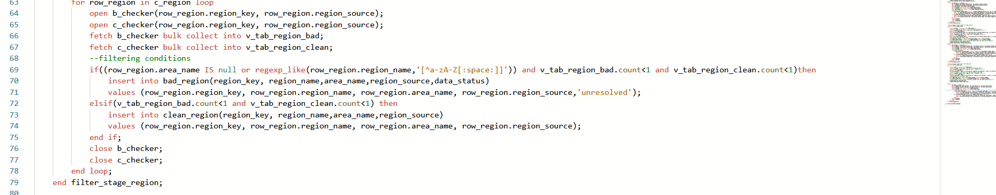

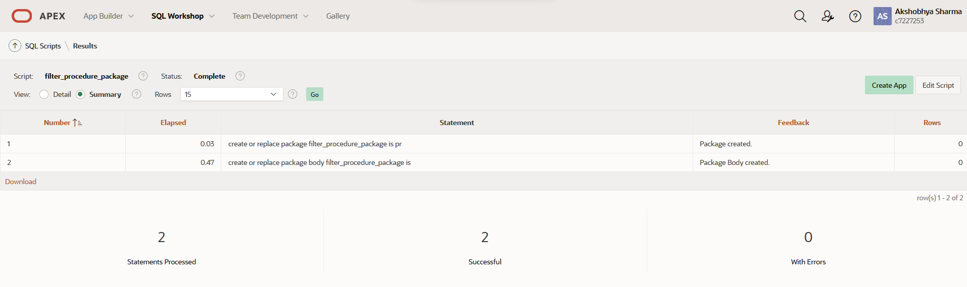

Figure Successful creation of above procedures

The run_filter_procedure script then runs these procedures.

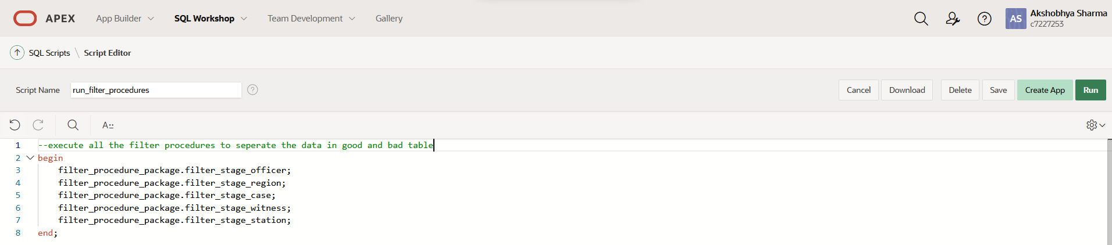

Figure run_filter_procedure

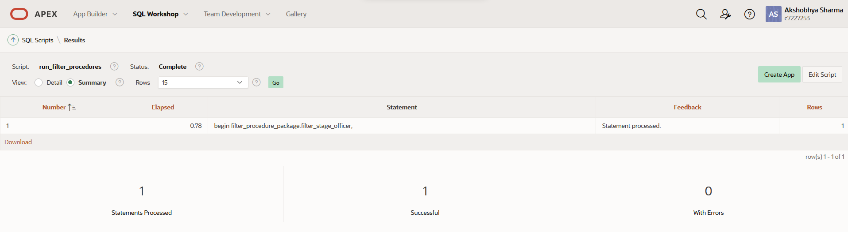

Figure successful execution of run_filter_procedure

The execution of these procedures has filtered the data to our clean and bad tables.

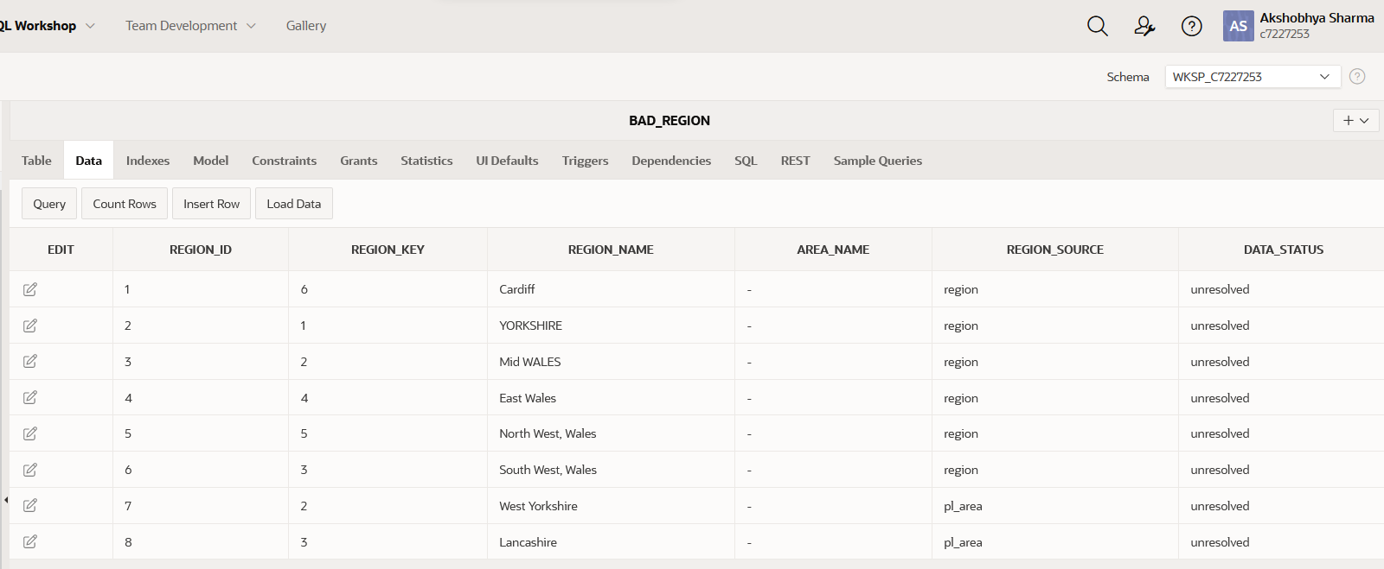

Figure Bad data separated

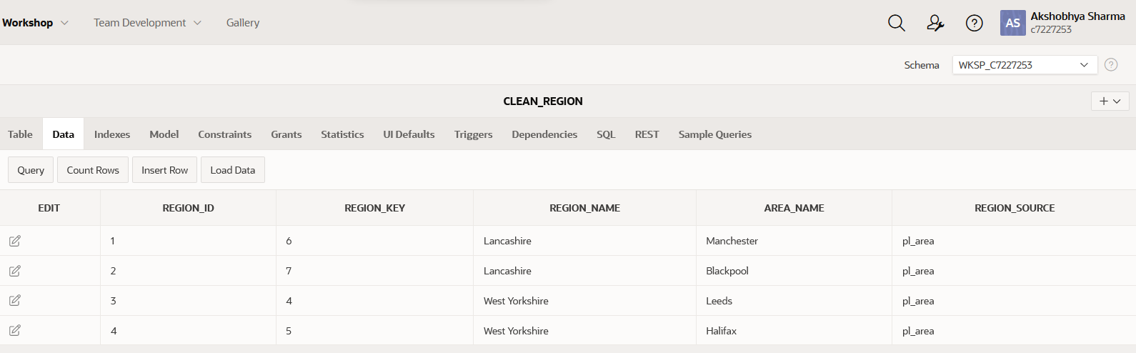

Figure Clean data also separated

**Cleaning bad data**

Following the filtration of the data to good and the bad table, the next process is to clean the bad data to good data. For cleaning the data following approach was taken:

1. For bad data altered in the staging area, the source tables were searched and the original data was retrieved **if** they were clean.
2. If the original data was also bad, values such an ‘unknown’, ‘n/a’ were given, this was also done in cases where the source table lacked the needed data as well.
3. For cleaning the dates, if the original date was also bad, current system date was taken.
4. In case of bad_region the symbols were replaced appropriately to create good data.
5. The process to check if the data has already been inserted in clean table was done through parameterized cursors.

For the purpose of cleaning the data, the procedures in cleaning_procedure_package was used. These procedures were run with run_cleaning_procedure script.

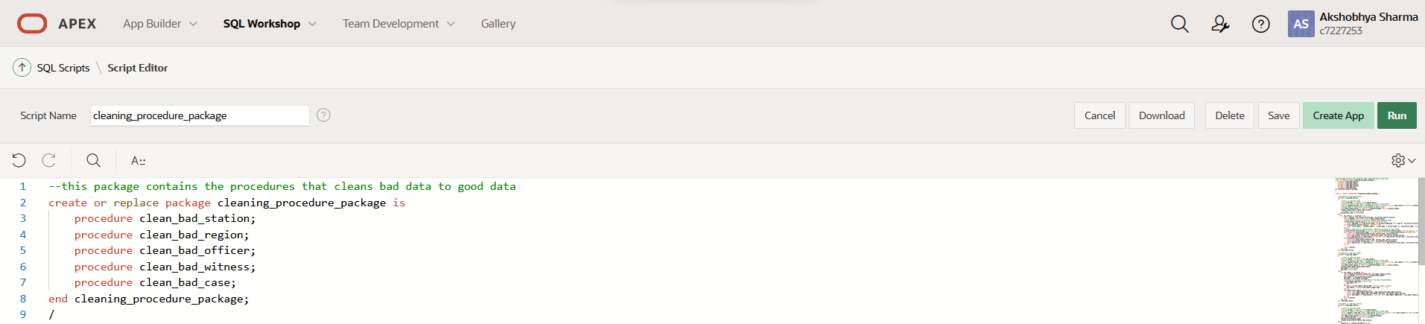

Figure Cleaning procedure Package

**Cleaning Procedures**

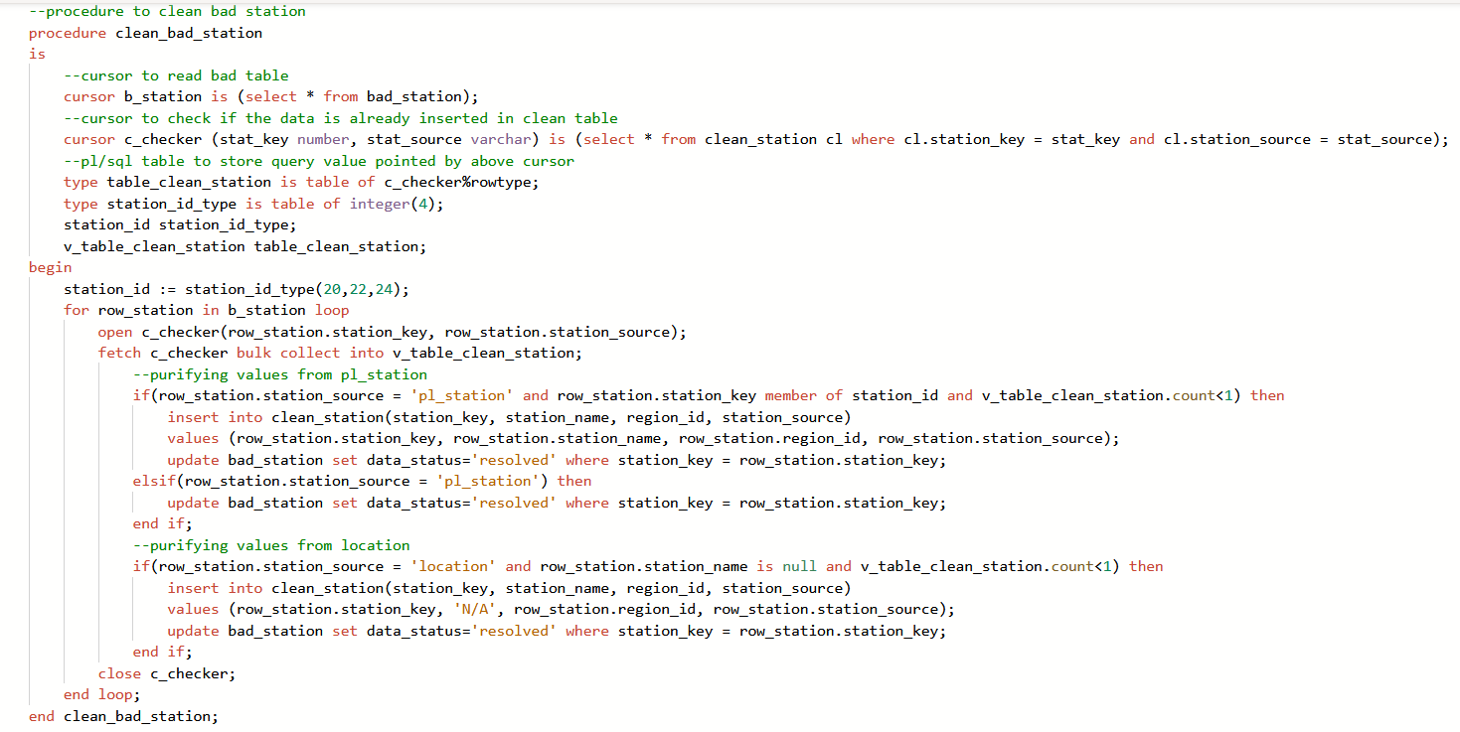

Figure clean_bad_station procedure

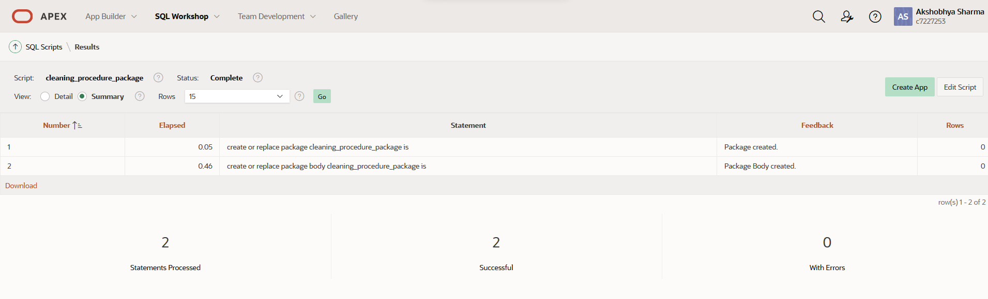

Figure Successful creation of the procedures

The package with the cleaning procedures was successfully run the create the package and its procedures.

Following the creation, the procedures were successfully executed with the following script.

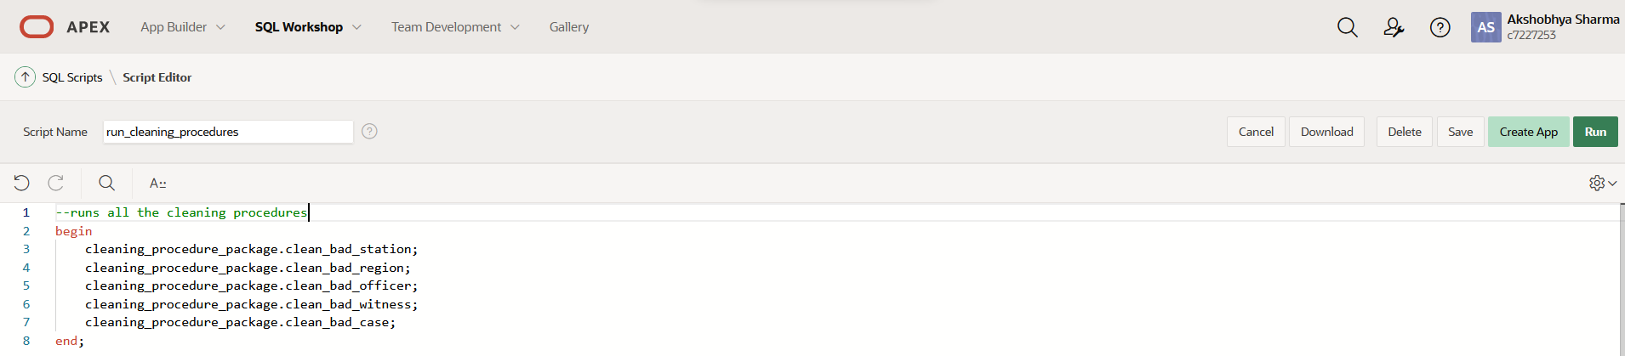

Figure Running the cleaning procedures

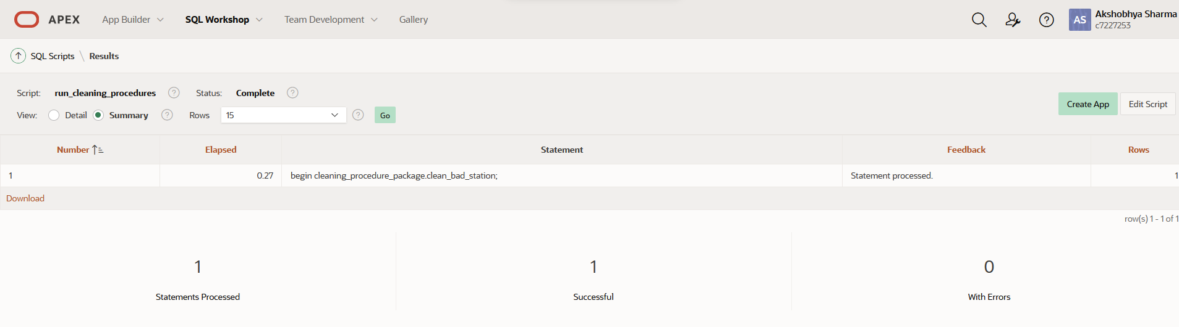

Figure Cleaning procedures successfully run

We can now see the result of the successful cleaning of bad_region and allocation of that data to clean_region below.

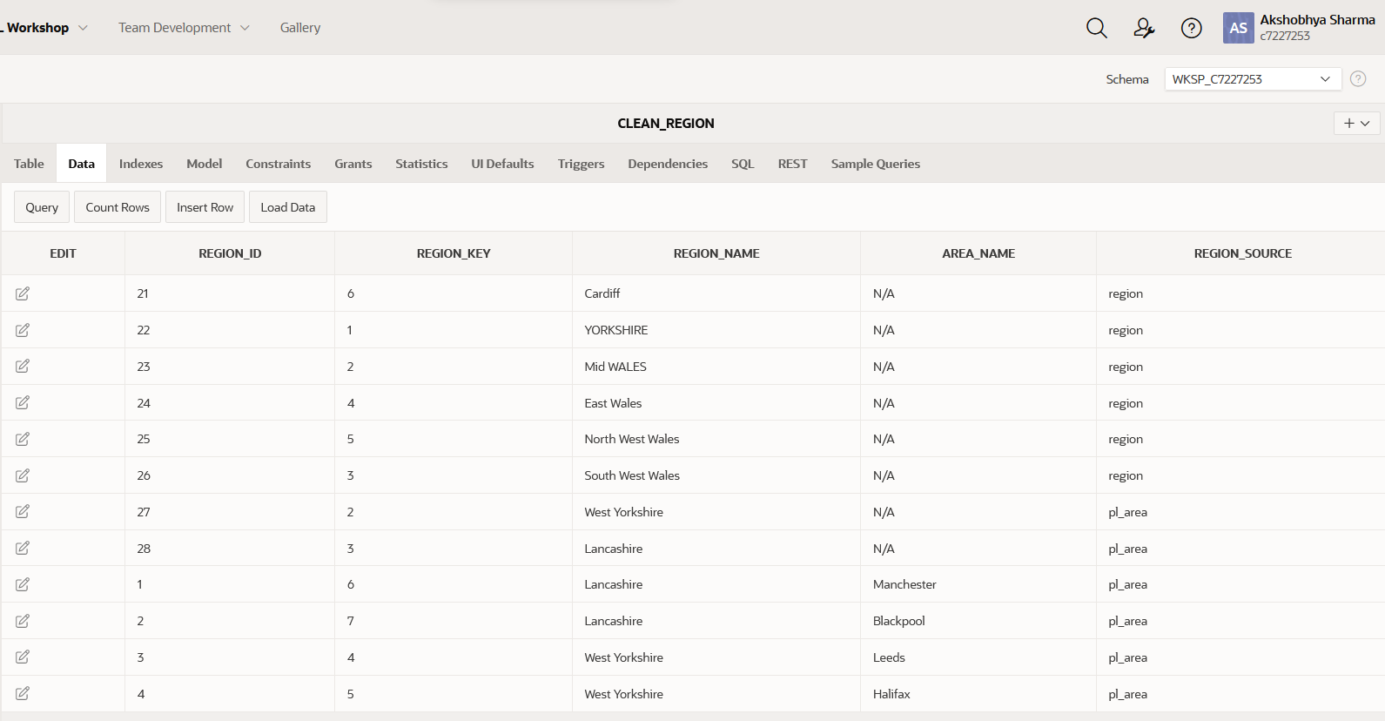

Figure Successfully cleaned data

Following the cleaning of this data the data_status of the bad table is marked as resolved to acknowledge this operation.

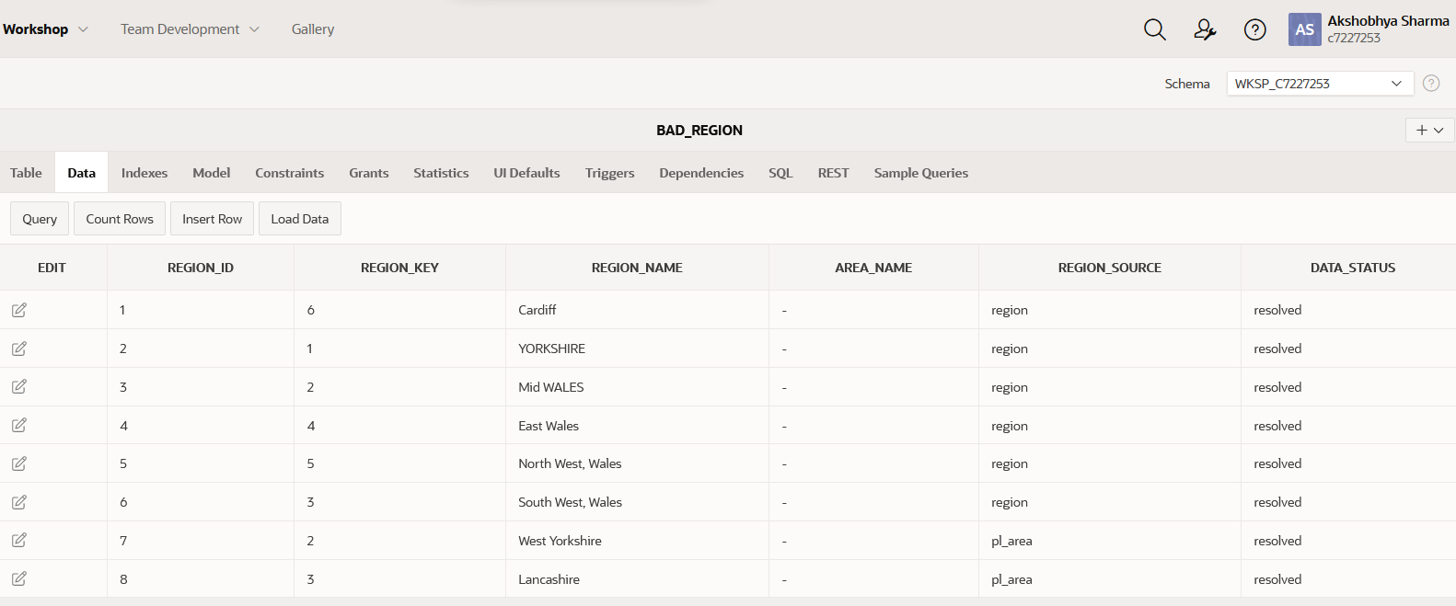

Figure data status changed to resolved

With the cleaning of the bad data, the cleaning stage of the ETL is officially over. The data is almost ready to load as the ETL structure was made with the dimension’s structure in mind since the beginning. The last few things left to be tweaked will be done in transformation stage.

## Transform

The cleaned data is now ready to be loaded into the transformation table. This process normally involves making data from multiple sources consistent with each other; however, we staged the data from multiple sources into the same structure as that of the dimension tables so, the transformation process is almost complete apart from few minor changes.

For data to be transformed we first need transformation structures. The transformation_ddl script creates all the necessary structures for transformation table.

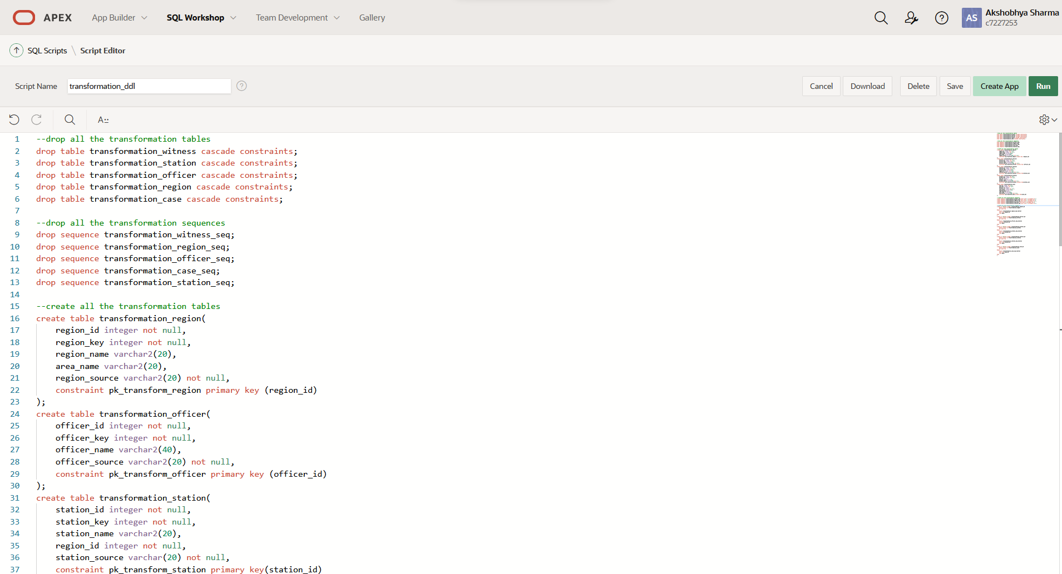

Figure transformation_ddl script

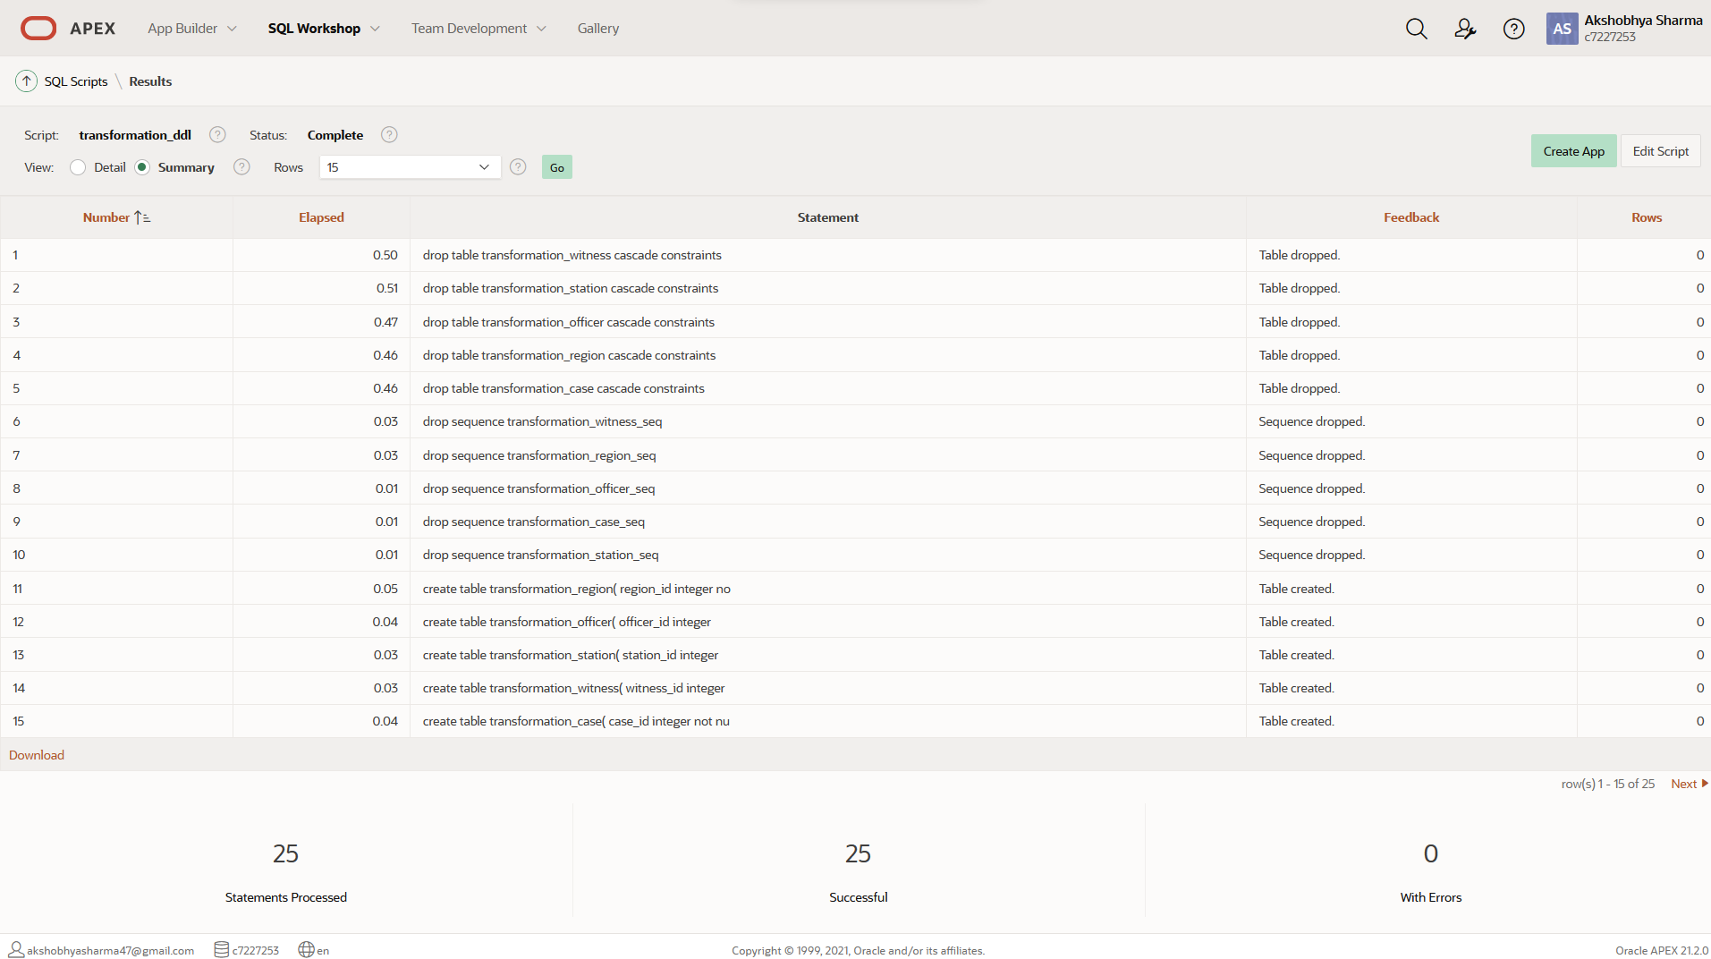

Figure Successful execution of transformation_ddl

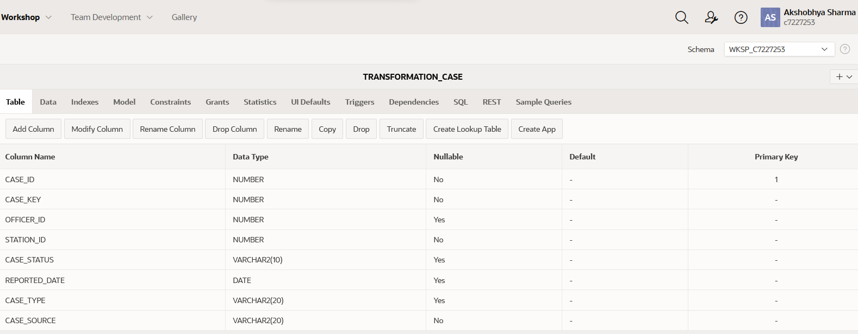

Figure Transformation_case successfully created

After the creation of transformation structures, following changes were made with the help of transformation procedures:

1. Changing all the varchar values to upper case.
2. Changing sources to represent which system the values were taken from like ‘PRCS’ or ‘PL_WALES’ instead of table sources in those systems.

The transformation_procedure_package script contains the script containing all the transformation procedures.

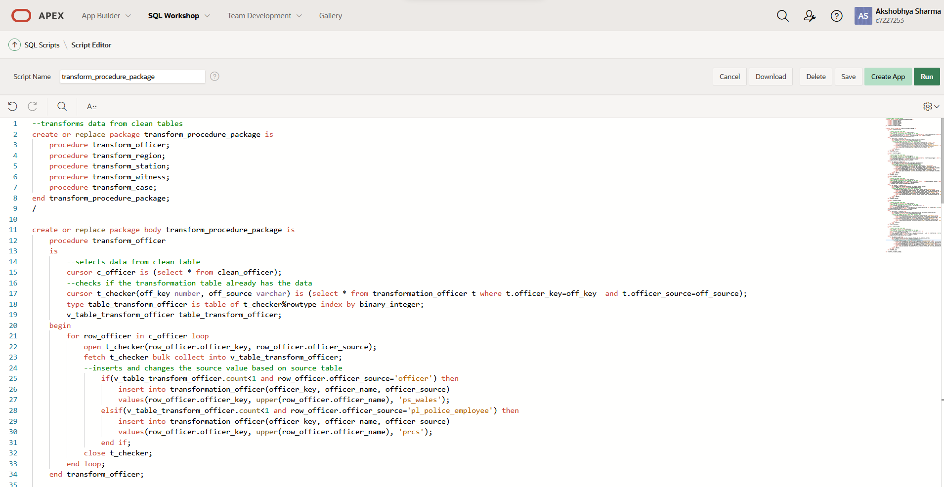

Figure transform_procedure_package

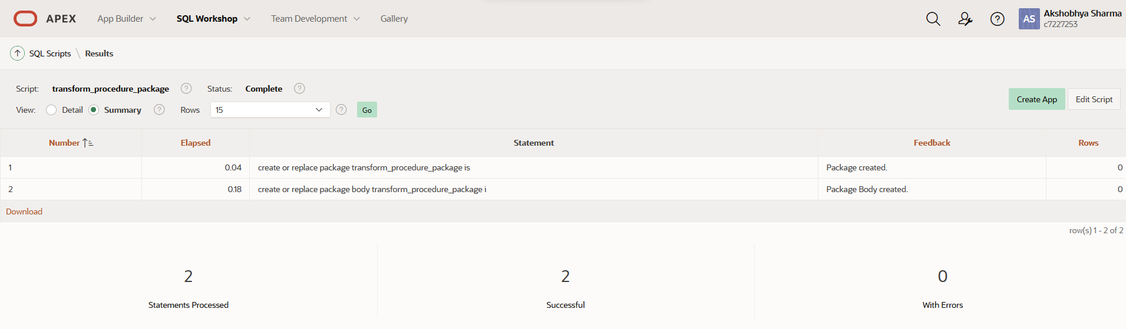

Figure Package successfully created

The following script successfully runs the transformation procedures.

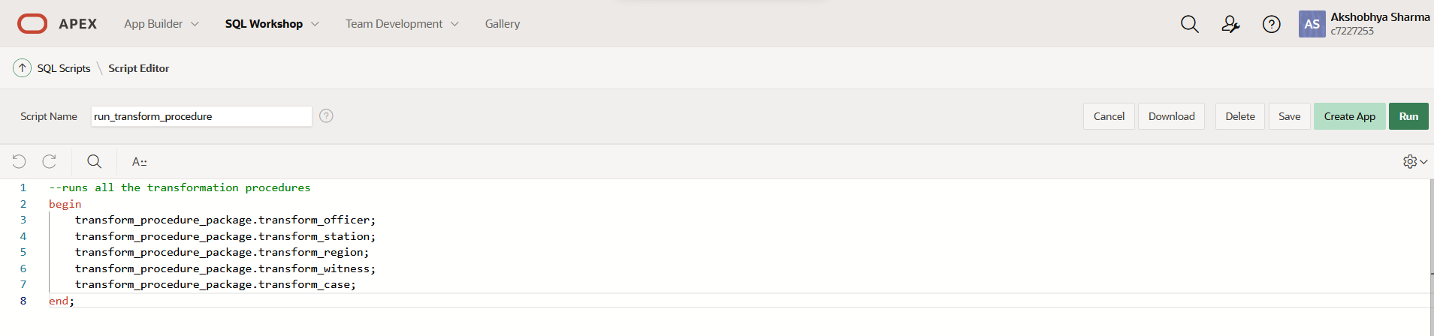

Figure run_transform_procedure script

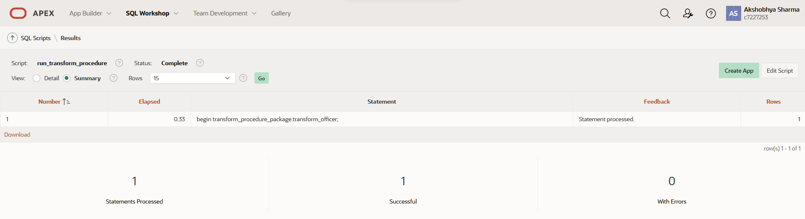

Figure Data successfully transformed

Following the execution of the procedure, the data has now been transformed into the transformation table.

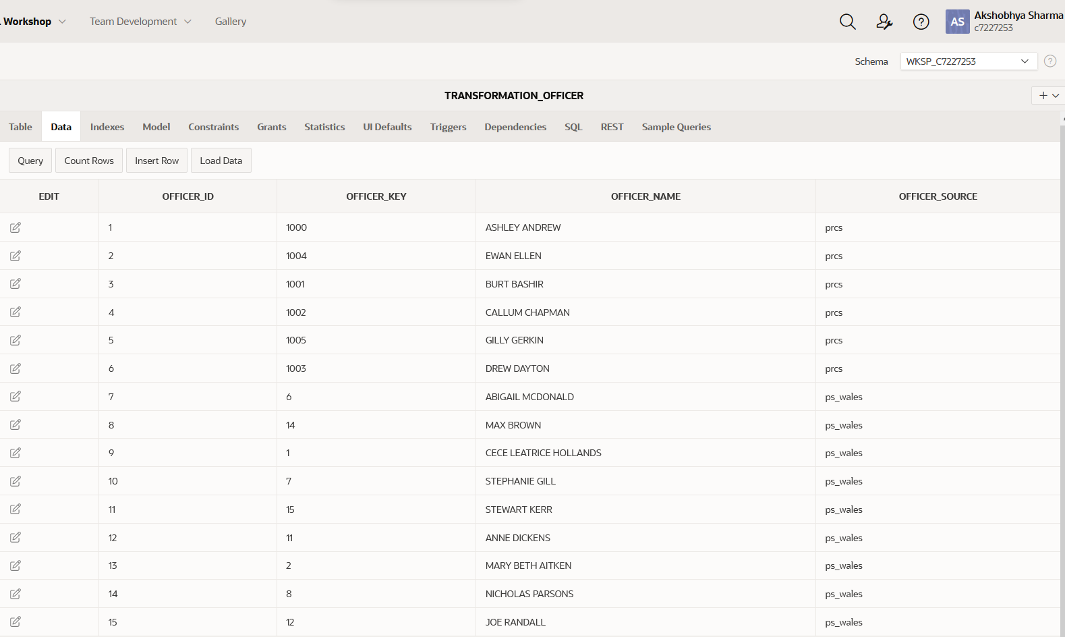

Figure Transformation_officer table

With this the transformation of data is complete and the data is now ready to be loaded into the data mart.

## Loading

The loading process imports all the data into the data mart in previously shown structure of dimension model. Here, the relationship is maintained between the fact tables and the dimension tables and reporting is possible. The dimensional structure for the loading stage has already been forward engineered using the QSEE with the required modifications. Therefore, the next thing to do will be to insert the data into those dimensions and fact tables. The inser_dimension_procedure script does this necessary task.

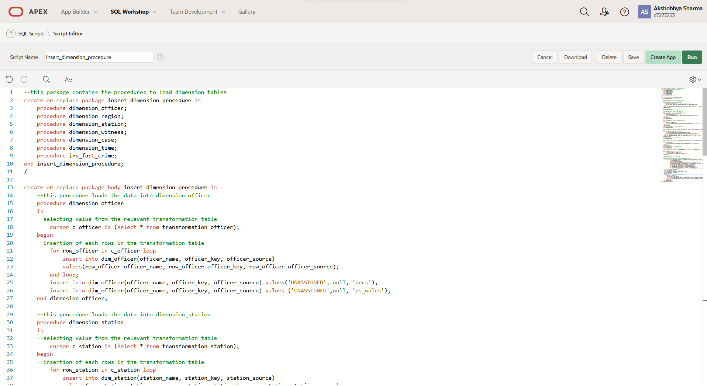

Figure insert_dimension_procedure

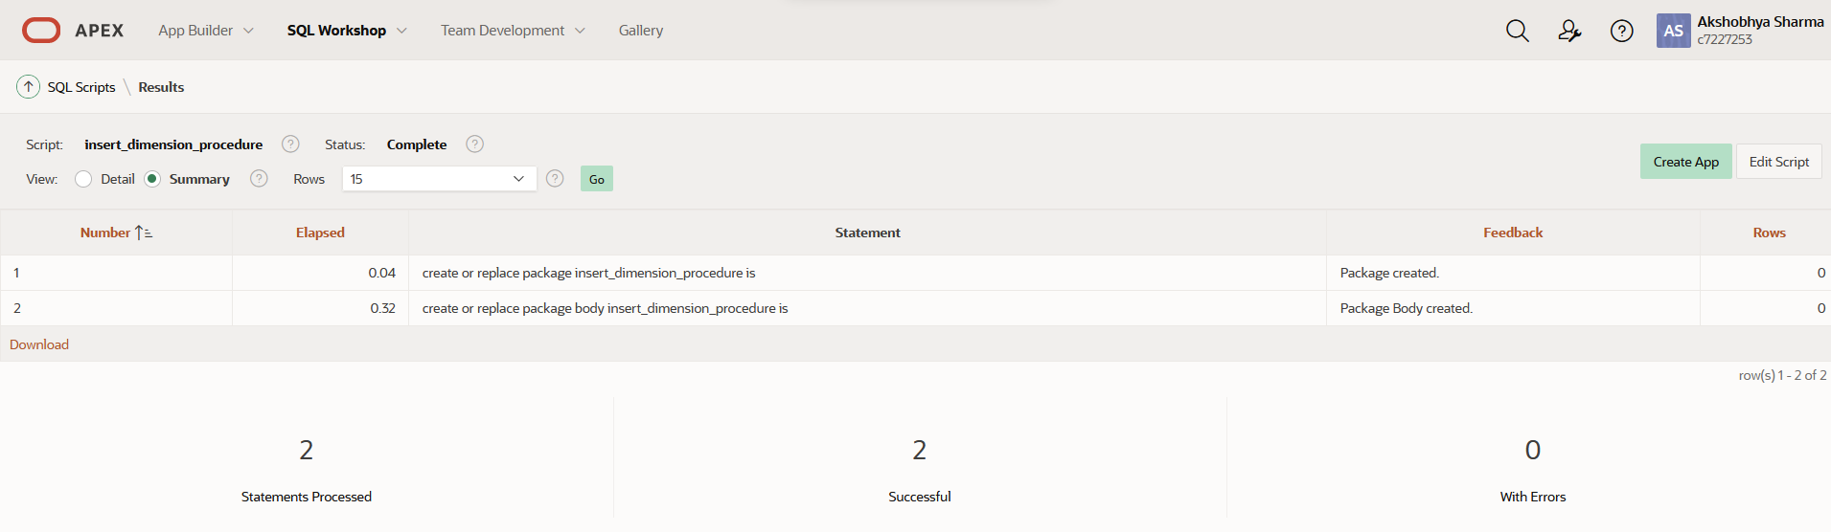

Figure Successful creation of those procedures

The run_dimension_procedure is then used to run these procedures to fill the dimension and the fact tables.

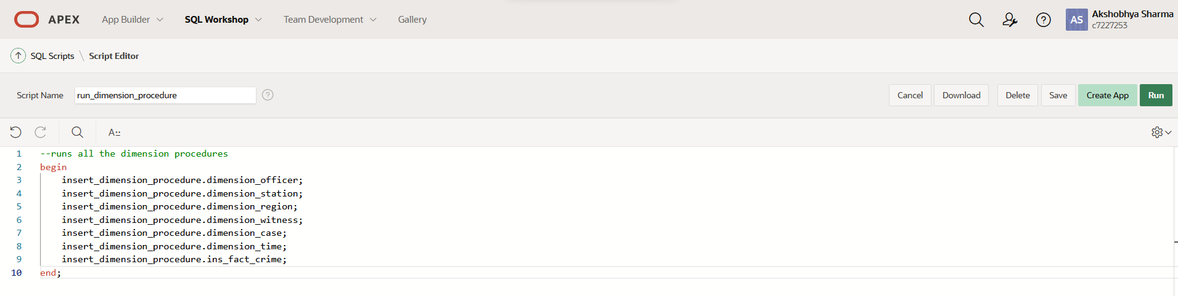

Figure run_dimension_procedure script

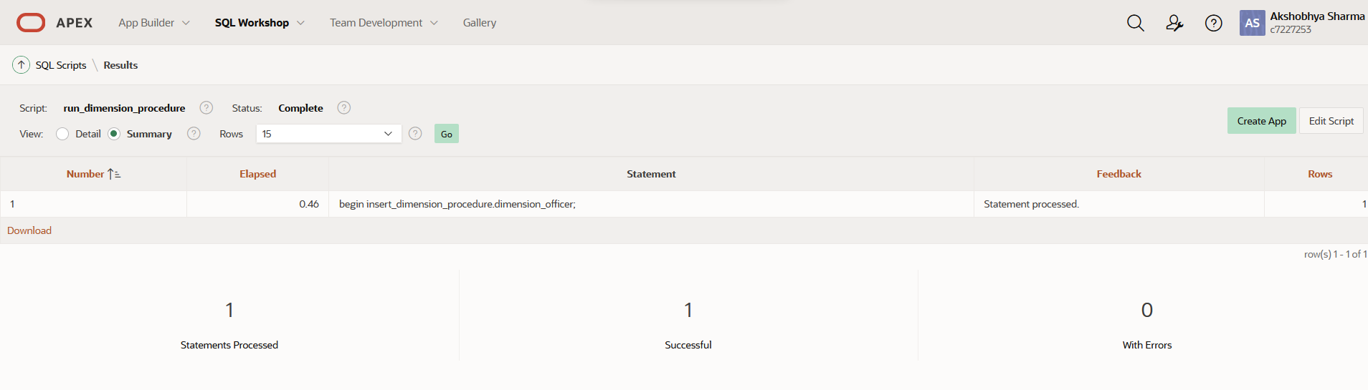

Figure dimension insertion successful

With this, we have successfully inserted the data in our dimension and fact tables.

Following are the evidences of data in all the dimension as well as fact tables.

**DIM_CASE**

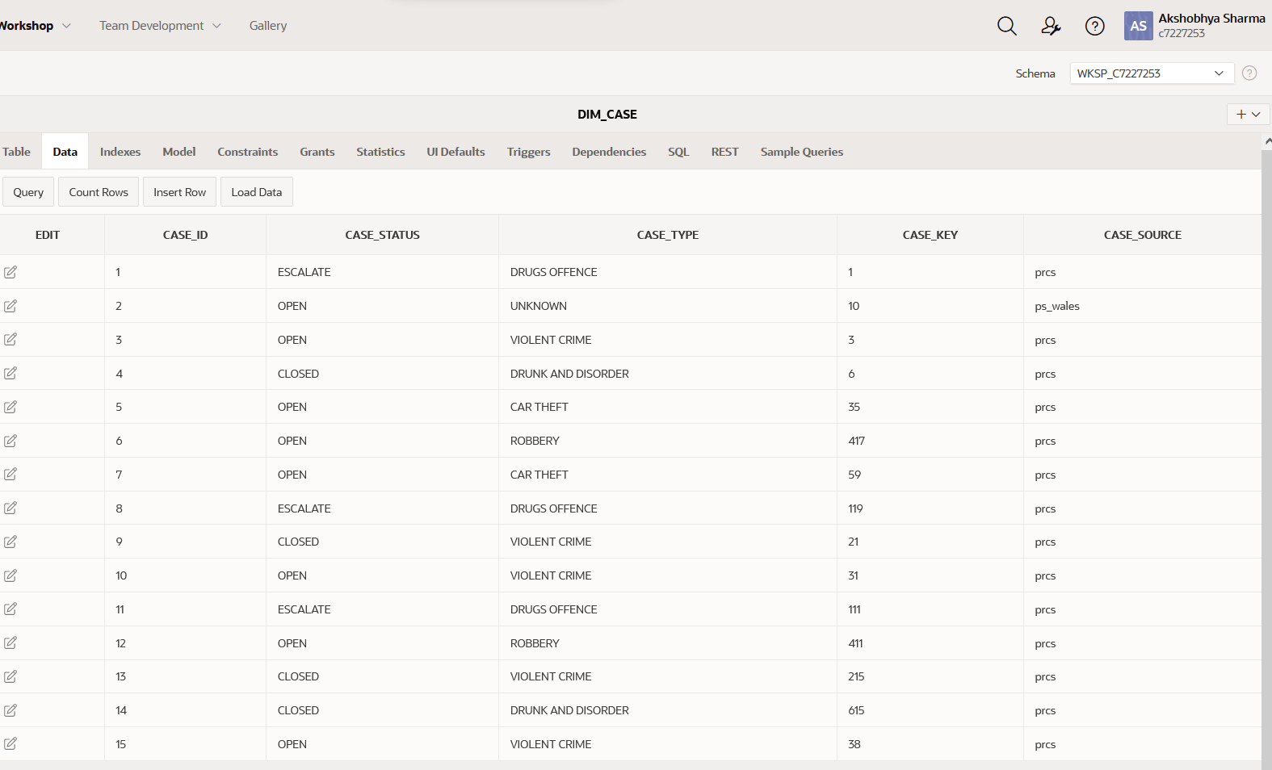

Figure DIM_CASE

**DIM_OFFICER**

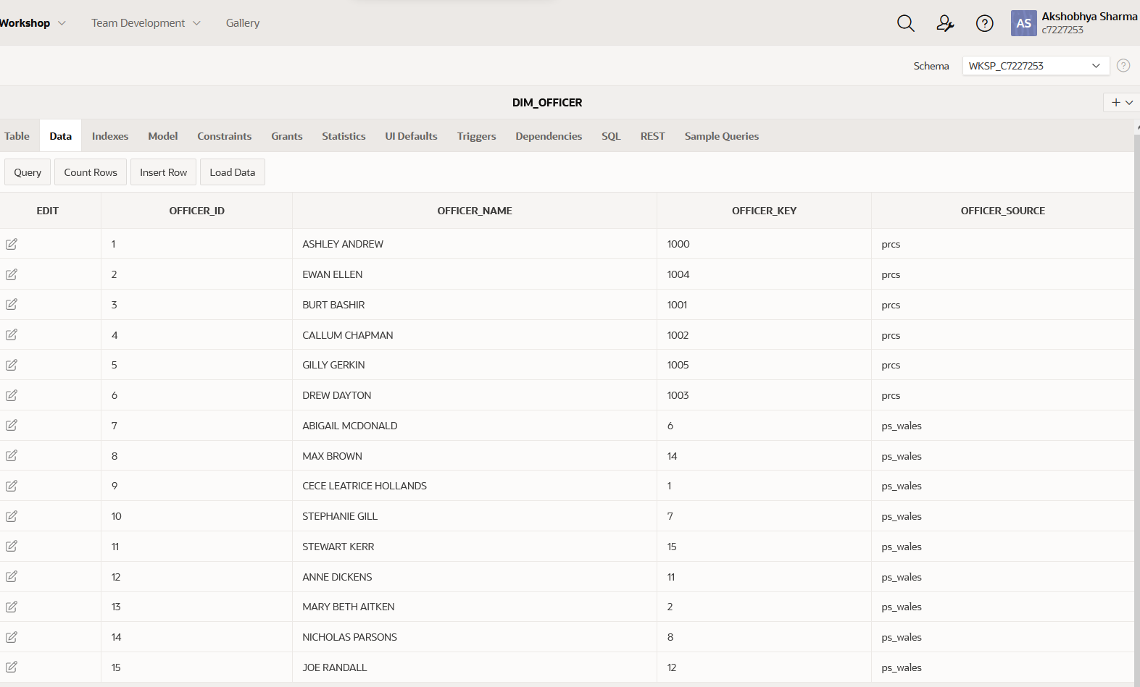

Figure DIM_OFFICER

**DIM_REGION**

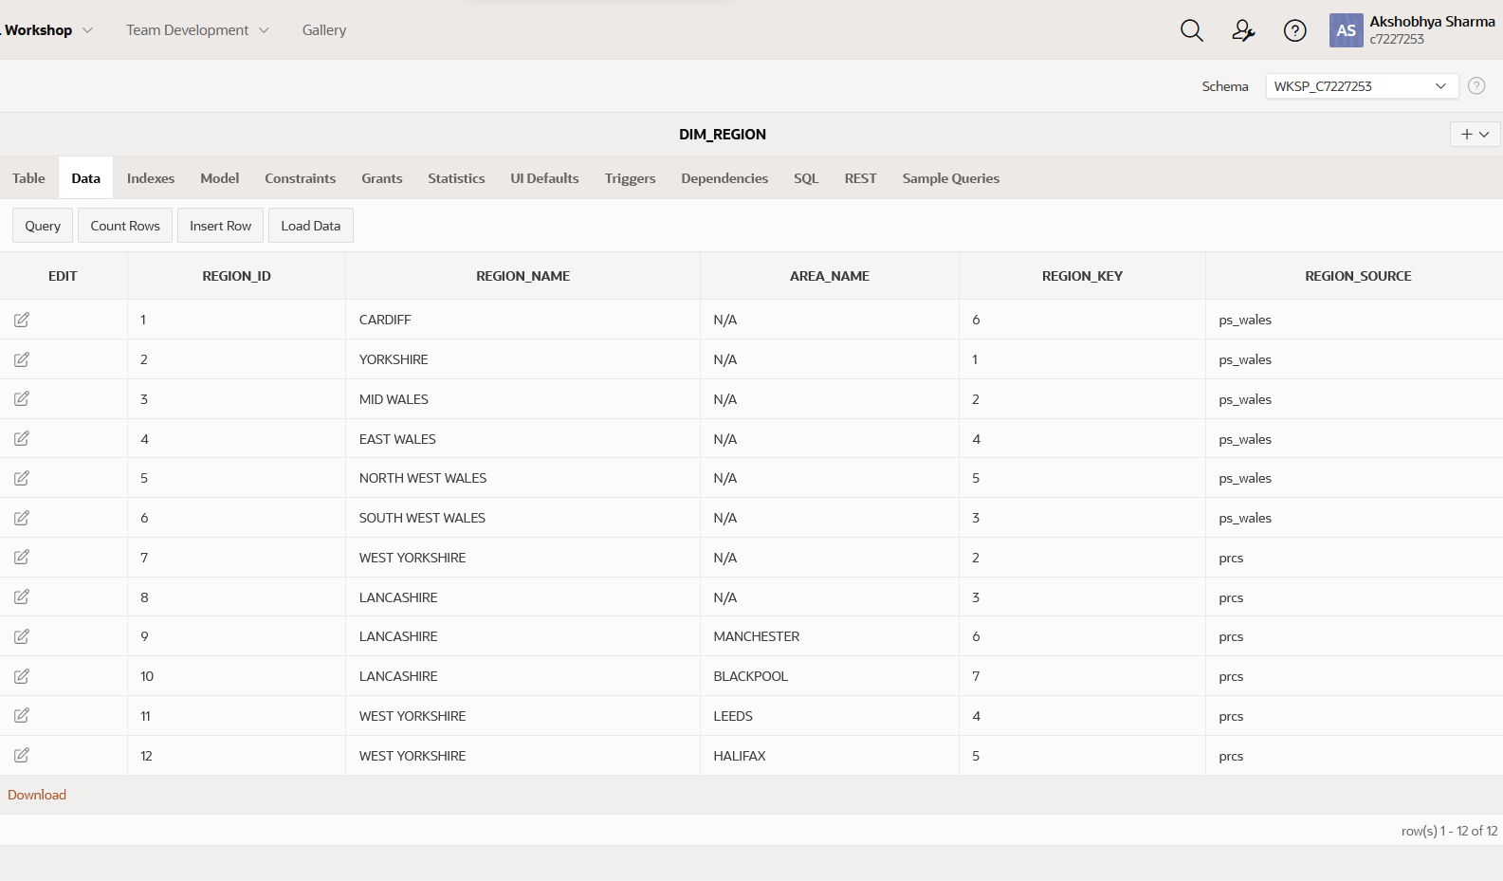

Figure DIM_REGION

**DIM_STATION**

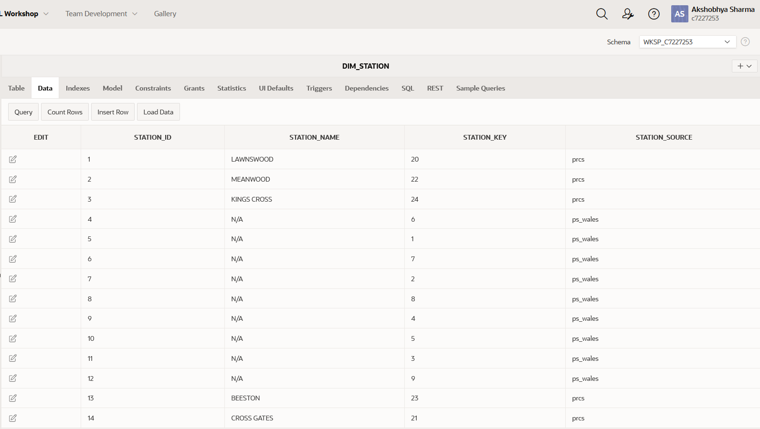

Figure DIM_STATION

**DIM_TIME**

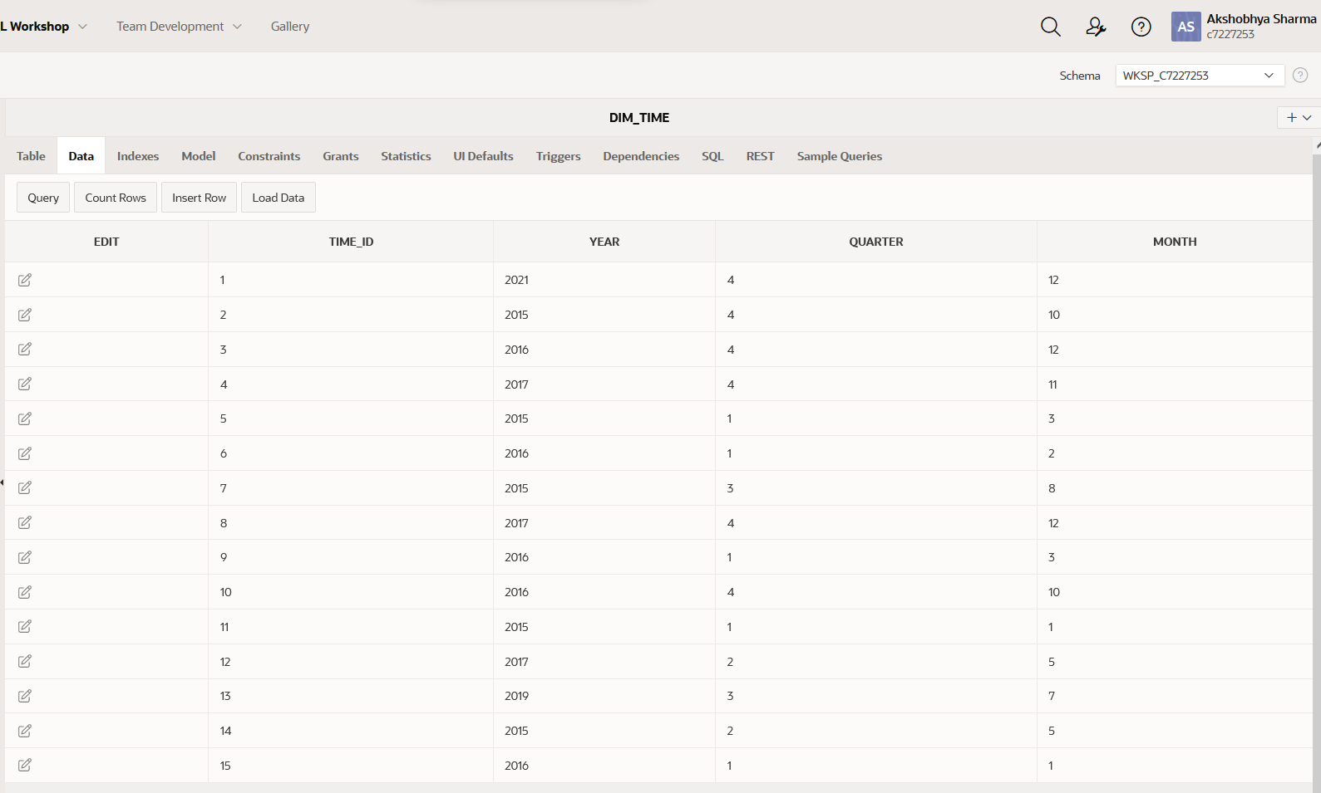

Figure DIM_TIME

**DIM_WITNESS**

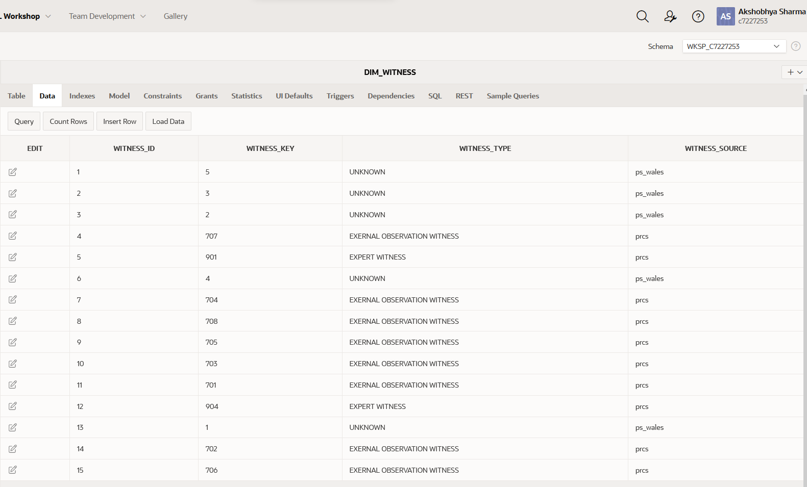

Figure DIM_TIME

**FACT_CRIME**

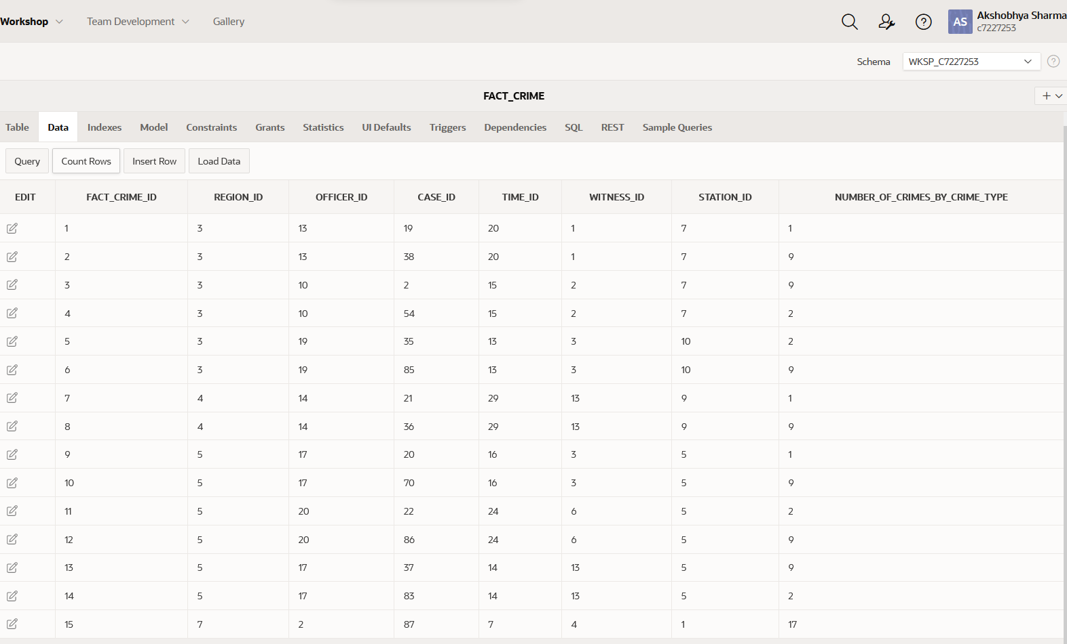

Figure FACT_CRIME

# Appendix

15 scripts in total were used to get the data to fact table. These scripts are listed below:

**Dimension_ddl**

-- Drop tables --

DROP TABLE DIM_TIME cascade constraints;

DROP TABLE DIM_CASE cascade constraints;

DROP TABLE DIM_REGION cascade constraints;

DROP TABLE DIM_OFFICER cascade constraints;

DROP TABLE DIM_STATION cascade constraints;

DROP TABLE FACT_CRIME cascade constraints;

DROP TABLE DIM_WITNESS cascade constraints;

--------------------------------------------------------------

-- End of DDL DROP file auto-generation

--------------------------------------------------------------

--------------------------------------------------------------

-- Database creation Script

-- Auto-Generated by QSEE-SuperLite (c) 2001-2004 QSEE-Technologies Ltd.

-- Verbose generation: ON

-- note: spaces within table/column names have been replaced by underscores (_)

-- Target DB: SQL2

-- Entity Model :Entity Relationship Diagram

-- To drop the tables generated by this script run -

-- 'C:\Users\LENOVO\Desktop\ddl\dimension_ddl_drop.sql'

--------------------------------------------------------------

--------------------------------------------------------------

-- Table Creation --

-- Each entity on the model is represented by a table that needs to be created within the Database.

-- Within SQL new tables are created using the CREATE TABLE command.

-- When a table is created its name and its attributes are defined.

-- The values of which are derived from those specified on the model.

-- Certain constraints are sometimes also specified, such as identification of primary keys.

-- Create a Database table to represent the "DIM_TIME" entity.

CREATE TABLE DIM_TIME(

time_id INTEGER NOT NULL,

year INTEGER,

quarter INTEGER,

month INTEGER,

-- Specify the PRIMARY KEY constraint for table "DIM_TIME".

-- This indicates which attribute(s) uniquely identify each row of data.

CONSTRAINT pk_DIM_TIME PRIMARY KEY (time_id)

);

-- Create a Database table to represent the "DIM_CASE" entity.

CREATE TABLE DIM_CASE(

case_id INTEGER NOT NULL,

case_status VARCHAR(40),

case_type VARCHAR(40),

case_key INTEGER,

case_source VARCHAR(40),

-- Specify the PRIMARY KEY constraint for table "DIM_CASE".

-- This indicates which attribute(s) uniquely identify each row of data.

CONSTRAINT pk_DIM_CASE PRIMARY KEY (case_id)

);

-- Create a Database table to represent the "DIM_REGION" entity.

CREATE TABLE DIM_REGION(

region_id INTEGER NOT NULL,

region_name VARCHAR(40),

area_name VARCHAR(40),

region_key INTEGER,

region_source VARCHAR(40),

-- Specify the PRIMARY KEY constraint for table "DIM_REGION".

-- This indicates which attribute(s) uniquely identify each row of data.

CONSTRAINT pk_DIM_REGION PRIMARY KEY (region_id)

);

-- Create a Database table to represent the "DIM_OFFICER" entity.

CREATE TABLE DIM_OFFICER(

officer_id INTEGER NOT NULL,

officer_name VARCHAR(40),

officer_key INTEGER,

officer_source VARCHAR(40),

-- Specify the PRIMARY KEY constraint for table "DIM_OFFICER".

-- This indicates which attribute(s) uniquely identify each row of data.

CONSTRAINT pk_DIM_OFFICER PRIMARY KEY (officer_id)

);

-- Create a Database table to represent the "DIM_STATION" entity.

CREATE TABLE DIM_STATION(

station_id INTEGER NOT NULL,

station_name VARCHAR(40),

station_key INTEGER,

station_source VARCHAR(40),

-- Specify the PRIMARY KEY constraint for table "DIM_STATION".

-- This indicates which attribute(s) uniquely identify each row of data.

CONSTRAINT pk_DIM_STATION PRIMARY KEY (station_id)

);

-- Create a Database table to represent the "FACT_CRIME" entity.

CREATE TABLE FACT_CRIME(

fact_crime_id INTEGER NOT NULL,

region_id INTEGER NOT NULL,

officer_id INTEGER NOT NULL,

case_id INTEGER NOT NULL,

time_id INTEGER NOT NULL,

witness_id INTEGER NOT NULL,

station_id INTEGER NOT NULL,

number_of_crimes_by_crime_type INTEGER,

-- Specify the PRIMARY KEY constraint for table "FACT_CRIME".

-- This indicates which attribute(s) uniquely identify each row of data.

CONSTRAINT pk_FACT_CRIME PRIMARY KEY (fact_crime_id)

);

-- Create a Database table to represent the "DIM_WITNESS" entity.

CREATE TABLE DIM_WITNESS(

witness_id INTEGER NOT NULL,

witness_key INTEGER,

witness_type VARCHAR(40),

witness_source VARCHAR(40),

-- Specify the PRIMARY KEY constraint for table "DIM_WITNESS".

-- This indicates which attribute(s) uniquely identify each row of data.

CONSTRAINT pk_DIM_WITNESS PRIMARY KEY (witness_id)

);

--------------------------------------------------------------

-- Alter Tables to add fk constraints --

-- Now all the tables have been created the ALTER TABLE command is used to define some additional

-- constraints. These typically constrain values of foreign keys to be associated in some way

-- with the primary keys of related tables. Foreign key constraints can actually be specified

-- when each table is created, but doing so can lead to dependency problems within the script

-- i.e. tables may be referenced before they have been created. This method is therefore safer.

-- Alter table to add new constraints required to implement the "FACT_CRIME_DIM_REGION" relationship

-- This constraint ensures that the foreign key of table "FACT_CRIME"

-- correctly references the primary key of table "DIM_REGION"

ALTER TABLE FACT_CRIME ADD CONSTRAINT fk1_FACT_CRIME_to_DIM_REGION FOREIGN KEY(region_id) REFERENCES DIM_REGION(region_id) ON DELETE cascade;

-- Alter table to add new constraints required to implement the "FACT_CRIME_DIM_CASE" relationship

-- This constraint ensures that the foreign key of table "FACT_CRIME"

-- correctly references the primary key of table "DIM_CASE"

ALTER TABLE FACT_CRIME ADD CONSTRAINT fk2_FACT_CRIME_to_DIM_CASE FOREIGN KEY(case_id) REFERENCES DIM_CASE(case_id) ON DELETE cascade;

-- Alter table to add new constraints required to implement the "FACT_CRIME_DIM_TIME" relationship

-- This constraint ensures that the foreign key of table "FACT_CRIME"

-- correctly references the primary key of table "DIM_TIME"

ALTER TABLE FACT_CRIME ADD CONSTRAINT fk3_FACT_CRIME_to_DIM_TIME FOREIGN KEY(time_id) REFERENCES DIM_TIME(time_id) ON DELETE cascade;

-- Alter table to add new constraints required to implement the "FACT_CRIME_DIM_WITNESS" relationship

-- This constraint ensures that the foreign key of table "FACT_CRIME"

-- correctly references the primary key of table "DIM_WITNESS"

ALTER TABLE FACT_CRIME ADD CONSTRAINT fk4_FACT_CRIME_to_DIM_WITNESS FOREIGN KEY(witness_id) REFERENCES DIM_WITNESS(witness_id) ON DELETE cascade;

-- Alter table to add new constraints required to implement the "FACT_CRIME_DIM_STATION" relationship

-- This constraint ensures that the foreign key of table "FACT_CRIME"

-- correctly references the primary key of table "DIM_STATION"

ALTER TABLE FACT_CRIME ADD CONSTRAINT fk5_FACT_CRIME_to_DIM_STATION FOREIGN KEY(station_id) REFERENCES DIM_STATION(station_id) ON DELETE cascade;

-- Alter table to add new constraints required to implement the "FACT_CRIME_DIM_OFFICER" relationship

-- This constraint ensures that the foreign key of table "FACT_CRIME"

-- correctly references the primary key of table "DIM_OFFICER"

ALTER TABLE FACT_CRIME ADD CONSTRAINT fk6_FACT_CRIME_to_DIM_OFFICER FOREIGN KEY(officer_id) REFERENCES DIM_OFFICER(officer_id) ON DELETE cascade;

--------------------------------------------------------------

-- End of DDL file auto-generation

--------------------------------------------------------------

drop sequence dim_witness_seq;

drop sequence dim_region_seq;

drop sequence dim_officer_seq;

drop sequence dim_case_seq;

drop sequence dim_station_seq;

drop sequence dim_time_seq;

drop sequence fact_crime_seq;

create sequence dim_witness_seq start with 1 increment by 1;

create sequence dim_region_seq start with 1 increment by 1;

create sequence dim_officer_seq start with 1 increment by 1;

create sequence dim_case_seq start with 1 increment by 1;

create sequence dim_station_seq start with 1 increment by 1;

create sequence dim_time_seq start with 1 increment by 1;

create sequence fact_crime_seq start with 1 increment by 1;

create or replace trigger dim_region_pk

before insert on dim_region

for each row

begin

select dim_region_seq.nextval

into :new.region_id

from dual;

end;

/

create or replace trigger dim_officer_pk

before insert on dim_officer

for each row

begin

select dim_officer_seq.nextval

into:new.officer_id

from dual;

end;

/

create or replace trigger dim_witness_pk

before insert on dim_witness

for each row

begin

select dim_witness_seq.nextval

into :new.witness_id

from dual;

end;

/

create or replace trigger dim_station_pk

before insert on dim_station

for each row

begin

select dim_station_seq.nextval

into :new.station_id

from dual;

end;

/

create or replace trigger dim_case_pk

before insert on dim_case

for each row

begin

select dim_case_seq.nextval

into :new.case_id

from dual;

end;

/

create or replace trigger dim_time_pk

before insert on dim_time

for each row

begin

select dim_time_seq.nextval

into:new.time_id

from dual;

end;

/

create or replace trigger fact_crime

before insert on fact_crime

for each row

begin

select fact_crime_seq.nextval

into:new.fact_crime_id

from dual;

end;

/

**Staging_ddl**

--Purpose of this script: For creating staging area required for the data warehouse.

drop table stage_region cascade constraints;

drop table stage_officer cascade constraints;

drop table stage_station cascade constraints;

drop table stage_case cascade constraints;

drop table stage_witness cascade constraints;

drop sequence stage_region_seq;

drop sequence stage_officer_seq;

drop sequence stage_case_seq;

drop sequence stage_witness_seq;

drop sequence stage_station_seq;

--stage_region table stores information from PL_Area and REGION tables

create table stage_region(

region_id integer not null,

region_key integer not null,

region_name varchar2(20),

area_name varchar2(20),

region_source varchar2(20) not null,

constraint pk_stage_region primary key (region_id)

);

--stage_officer table stores information from PL_POLICE_EMPLOYEE and OFFICER table

create table stage_officer(

officer_id integer not null,

officer_key integer not null,

officer_name varchar2(40),

officer_source varchar2(20) not null,

constraint pk_stage_officer primary key (officer_id)

);

--stage_station table stores information from PL_STATION and LOCATION table

create table stage_station(

station_id integer not null,

station_key integer not null,

station_name varchar2(20),

region_id integer not null,

station_source varchar(20) not null,

constraint pk_stage_station primary key(station_id)

);

--stage_witness table stores information from PL_WITNESS and CRIME_REPORTER

create table stage_witness(

witness_id integer not null,

witness_key integer not null,

case_id integer,

witness_type varchar(40),

witness_source varchar(20) not null,

constraint pk_stage_witness primary key(witness_id)

);

--stage_case table stores information from PL_REPORTED_CRIME and CRIME_REGISTER table

create table stage_case(

case_id integer not null,

case_key integer not null,

officer_id integer,

station_id integer not null,

case_status varchar2(10),

reported_date date,

case_type varchar2(20),

case_source varchar2(20) not null,

constraint pk_stage_case primary key(case_id)

);

--one sequence for every staging table above

create sequence stage_region_seq start with 1 increment by 1;

create sequence stage_officer_seq start with 1 increment by 1;

create sequence stage_case_seq start with 1 increment by 1;

create sequence stage_witness_seq start with 1 increment by 1;

create sequence stage_station_seq start with 1 increment by 1;

--Triggers for inserting sequence value in the id coloumns of the stage table.

create or replace trigger trigger_stage_region_pk

before insert on stage_region

for each row

begin

select stage_region_seq.nextval

into :new.region_id

from dual;

end;

/

create or replace trigger trigger_stage_officer_pk

before insert on stage_officer

for each row

begin

select stage_officer_seq.nextval

into:new.officer_id

from dual;

end;

/

create or replace trigger trigger_stage_witness_pk

before insert on stage_witness

for each row

begin

select stage_witness_seq.nextval

into :new.witness_id

from dual;

end;

/

create or replace trigger trigger_stage_station_pk

before insert on stage_station

for each row

begin

select stage_station_seq.nextval

into :new.station_id

from dual;

end;

/

create or replace trigger trigger_stage_case_pk

before insert on stage_case

for each row

begin

select stage_case_seq.nextval

into :new.case_id

from dual;

end;

**Stage_insert_procedure**

--Package with the procedures to bring required data to the staging tables--

create or replace package staging_procedure_package is

procedure insert_to_stage_region;

procedure insert_to_stage_station;

procedure insert_to_stage_officer;

procedure insert_to_stage_witness;

procedure insert_to_stage_case;

end staging_procedure_package;

/

create or replace package body staging_procedure_package is

--this procedure brings data into stage_region from multiple data source--

procedure insert_to_stage_region is

begin

--merge statement to bring data from region table--

merge into stage_region s

using (select region_id, region_name from region) r

on (s.region_key = r.region_id and s.region_source = 'region')

when matched then

update set

s.region_name = r.region_name

when not matched then

insert (s.region_key,s.region_name,s.region_source)

values (r.region_id,r.region_name,'region');

--merge statement to bring data from stage table--

merge into stage_region s

using ( select area2.area_id as area_id, area1.area_name as region,area2.area_name as area

from pl_area area1, pl_area area2

where

area1.area_id = area2.parent_area

and area1.parent_area is not null

union

select area1.area_id as area_id, area1.area_name as region, null as area

from pl_area area1

where

area1.parent_area<2

and area1.parent_area is not null)r

on(s.region_key = r.area_id and s.region_source='pl_area')

when matched then

update set

s.region_name = r.region,

s.area_name = r.area

when not matched then

insert (s.region_key,s.region_name,s.area_name,s.region_source)

values (r.area_id, r.region, r.area, 'pl_area');

end insert_to_stage_region;

--procedure to bring data into stage_station--

procedure insert_to_stage_station is

begin

--merges data from pl_station table--

merge into stage_station s

using (select station_id, station_name, fk1_area_id as area_id from pl_station) os

on (s.station_key = os.station_id and station_source='pl_station')

when matched then

update set

s.station_name = os.station_name,

s.region_id = os.area_id

when not matched then

insert(s.station_key,s.station_name,s.region_id,s.station_source)

values(os.station_id,os.station_name,os.area_id,'pl_station');

--merges data from location table--

merge into stage_station s

using (select location_id, null as station_name, region_id from location) os

on (s.station_key = os.location_id and station_source = 'location')

when matched then

update set

s.station_name = os.station_name,

s.region_id = os.region_id

when not matched then

insert(s.station_key, s.station_name, s.region_id, s.station_source)

values(os.location_id, os.station_name, os.region_id, 'location');

end insert_to_stage_station;

--procedure to insert data into stage_officer table--

procedure insert_to_stage_officer is

begin

--merges data from pl_polic_employee--

merge into stage_officer s

using (select emp_id, emp_name from pl_police_employee) o

on(s.officer_key = o.emp_id and s.officer_source='pl_police_employee')

when matched then

update set

s.officer_name = o.emp_name

when not matched then

insert(s.officer_key, s.officer_name, s.officer_source)

values(o.emp_id, o.emp_name, 'pl_police_employee');

--merges data from officer table--

merge into stage_officer s

using (select officer_id, first_name||' '||middle_name||' '||last_name as officer_name from officer) o

on(s.officer_key = o.officer_id and s.officer_source='officer')

when matched then

update set

s.officer_name = o.officer_name

when not matched then

insert(s.officer_key, s.officer_name, s.officer_source)

values(o.officer_id, o.officer_name, 'officer');

end insert_to_stage_officer;

--procedure to insert data to stage_witness--

procedure insert_to_stage_witness is

begin

--merges data from crime_register--

merge into stage_witness w

using (select crime_id as case_id, reporter_id as witness_id, null as witness_type from crime_register)cr

on ((cr.witness_id = w.witness_key and cr.case_id = w.case_id) and w.witness_source = 'crime_register')

when matched then

update set

w.witness_type = cr.witness_type

when not matched then

insert(w.witness_key, w.case_id, w.witness_type, w.witness_source)

values(cr.witness_id, cr.case_id, cr.witness_type, 'crime_register');

--merges data from pl_witness table--

merge into stage_witness w

using(select witness_id, witness_type_desc as witness_type, s.s_reported_crime_id as case_id

from

(select w.witness_id, wt.witness_type_desc

from

pl_witness w

left outer join pl_witness_type wt

on w.witness_type_id = wt.witness_type_id)nw

left outer join pl_statement s on nw.witness_id=s.d_witness_id)cr

on (((w.witness_key = cr.witness_id and cr.case_id = w.case_id)or(w.witness_key = cr.witness_id and w.case_id IS null)) and w.witness_source='pl_witness')

when matched then

update set

w.witness_type = cr.witness_type

when not matched then

insert(w.witness_key, w.case_id, w.witness_type, w.witness_source)

values (cr.witness_id, cr.case_id, cr.witness_type, 'pl_witness');

end insert_to_stage_witness;

--procedure to insert data into stage_case--

procedure insert_to_stage_case is

begin

--merges data from pl_reported_crime--

merge into stage_case c

using (select reported_crime_id, crime_status, date_reported, crime_type_desc, fk2_station_id, d_emp_id

from pl_reported_crime rc

left outer join pl_work_allocation p on

rc.reported_crime_id = p.s_reported_crime_id

inner join pl_crime_type cr on

rc.fk1_crime_type_id = cr.crime_type_id

)cc

on (((cc.reported_crime_id=c.case_key and cc.d_emp_id=c.officer_id )or(cc.reported_crime_id=c.case_key and cc.d_emp_id is null)) and case_source='pl_reported_crime')

when matched then

update set

c.case_status = cc.crime_status,

c.station_id = cc.fk2_station_id,

c.case_type = cc.crime_type_desc,

c.reported_date = cc.date_reported

when not matched then

insert(c.case_key,c.officer_id,c.station_id,c.case_status,c.case_type,c.case_source,c.reported_date)

values(cc.reported_crime_id, cc.d_emp_id, cc.fk2_station_id, cc.crime_status, cc.crime_type_desc, 'pl_reported_crime',cc.date_reported);

--merges data from stage_case--

merge into stage_case c

using (select crime_id, location_id as station_id, crime_name as case_type, police_id, crime_status, reported_date from crime_register)cc

on(c.case_id =cc.crime_id and case_source = 'crime_register')

when matched then

update set

c.officer_id = cc.police_id,

c.station_id = cc.station_id,

c.case_status = cc.crime_status,

c.case_type = cc.case_type,

c.reported_date = cc.reported_date

when not matched then

insert(c.case_key,c.officer_id,c.station_id,c.case_status,c.case_type,c.case_source,c.reported_date)

values(cc.crime_id,cc.police_id, cc.station_id, cc.crime_status, cc.case_type, 'crime_register', cc.reported_date);

end insert_to_stage_case;

end staging_procedure_package;

/

**Run_stage_insertion_procedure**

--script to execute the staging procedures--

begin

staging_procedure_package.insert_to_stage_case;

staging_procedure_package.insert_to_stage_officer;

staging_procedure_package.insert_to_stage_region;

staging_procedure_package.insert_to_stage_witness;

staging_procedure_package.insert_to_stage_station;

end;

**Cleand_and_bad_ddl**

--drop all the clean and bad tables--

drop table clean_witness cascade constraints;

drop table clean_station cascade constraints;

drop table clean_officer cascade constraints;

drop table clean_region cascade constraints;

drop table clean_case cascade constraints;

drop table bad_witness cascade constraints;

drop table bad_station cascade constraints;

drop table bad_officer cascade constraints;

drop table bad_region cascade constraints;

drop table bad_case cascade constraints;

--drop all of the sequences for the clean and bad tables

drop sequence clean_witness_seq;

drop sequence clean_region_seq;

drop sequence clean_officer_seq;

drop sequence clean_case_seq;

drop sequence clean_station_seq;

drop sequence bad_witness_seq;

drop sequence bad_region_seq;

drop sequence bad_officer_seq;

drop sequence bad_case_seq;

drop sequence bad_station_seq;

--creation of clean table structures

create table clean_region(

region_id integer not null,

region_key integer not null,

region_name varchar2(20),

area_name varchar2(20),

region_source varchar2(20) not null,

constraint pk_clean_region primary key (region_id)

);

create table clean_officer(

officer_id integer not null,

officer_key integer not null,

officer_name varchar2(40),

officer_source varchar2(20) not null,

constraint pk_clean_officer primary key (officer_id)

);

create table clean_station(

station_id integer not null,

station_key integer not null,

station_name varchar2(20),

region_id integer not null,

station_source varchar(20) not null,

constraint pk_clean_station primary key(station_id)

);

create table clean_witness(

witness_id integer not null,

witness_key integer not null,

case_id integer,

witness_type varchar(40),

witness_source varchar(20) not null,

constraint pk_clean_witness primary key(witness_id)

);

create table clean_case(

case_id integer not null,

case_key integer not null,

officer_id integer,

station_id integer not null,

case_status varchar2(10),

reported_date date,

case_type varchar2(20),

case_source varchar2(20) not null,

constraint pk_clean_case primary key(case_id)

);

--creation of bad table structures

create table bad_region(

region_id integer not null,

region_key integer not null,

region_name varchar2(20),

area_name varchar2(20),

region_source varchar2(20) not null,

data_status varchar(15) not null,

constraint pk_bad_region primary key (region_id)

);

create table bad_officer(

officer_id integer not null,

officer_key integer not null,

officer_name varchar2(40),

officer_source varchar2(20) not null,

data_status varchar(15) not null,

constraint pk_bad_officer primary key (officer_id)

);

create table bad_station(

station_id integer not null,

station_key integer not null,

station_name varchar2(20),

region_id integer not null,

station_source varchar(20) not null,

data_status varchar(15) not null,

constraint pk_bad_station primary key(station_id)

);

create table bad_witness(

witness_id integer not null,

witness_key integer not null,

case_id integer,

witness_type varchar(40),

witness_source varchar(20) not null,

data_status varchar(15) not null,

constraint pk_bad_witness primary key(witness_id)

);

create table bad_case(

case_id integer not null,

case_key integer not null,

officer_id integer,

station_id integer not null,

case_status varchar2(10),

reported_date date,

case_type varchar2(20),

case_source varchar2(20) not null,

data_status varchar(15) not null,

constraint pk_bad_case primary key(case_id)

);

--creation of sequences for clean tables

create sequence clean_witness_seq start with 1 increment by 1;

create sequence clean_region_seq start with 1 increment by 1;

create sequence clean_officer_seq start with 1 increment by 1;

create sequence clean_case_seq start with 1 increment by 1;

create sequence clean_station_seq start with 1 increment by 1;

--creation of sequences for bad tables

create sequence bad_witness_seq start with 1 increment by 1;

create sequence bad_region_seq start with 1 increment by 1;

create sequence bad_officer_seq start with 1 increment by 1;

create sequence bad_case_seq start with 1 increment by 1;

create sequence bad_station_seq start with 1 increment by 1;

--creation of triggers for inserting sequences into clean and bad tables

create or replace trigger trigger_clean_region_pk

before insert on clean_region

for each row

begin

select clean_region_seq.nextval

into :new.region_id

from dual;

end;

/

create or replace trigger trigger_clean_officer_pk

before insert on clean_officer

for each row

begin

select clean_officer_seq.nextval

into:new.officer_id

from dual;

end;

/

create or replace trigger trigger_clean_witness_pk

before insert on clean_witness

for each row

begin

select clean_witness_seq.nextval

into :new.witness_id

from dual;

end;

/

create or replace trigger trigger_clean_station_pk

before insert on clean_station

for each row

begin

select clean_station_seq.nextval

into :new.station_id

from dual;

end;

/

create or replace trigger trigger_clean_case_pk

before insert on clean_case

for each row

begin

select clean_case_seq.nextval

into :new.case_id

from dual;

end;

/

create or replace trigger trigger_bad_region_pk

before insert on bad_region

for each row

begin

select bad_region_seq.nextval

into :new.region_id

from dual;

end;

/

create or replace trigger trigger_bad_officer_pk

before insert on bad_officer

for each row

begin

select bad_officer_seq.nextval

into:new.officer_id

from dual;

end;

/

create or replace trigger trigger_bad_witness_pk

before insert on bad_witness

for each row

begin

select bad_witness_seq.nextval

into :new.witness_id

from dual;

end;

/

create or replace trigger trigger_bad_station_pk

before insert on bad_station

for each row

begin

select bad_station_seq.nextval

into :new.station_id

from dual;

end;

/

create or replace trigger trigger_bad_case_pk

before insert on bad_case

for each row

begin

select bad_case_seq.nextval

into :new.case_id

from dual;

end;

/

**Create_bad_data_procedure**

--Package for procedures to alter staging data

create or replace package create_bad_data_package is

procedure change_data_case(c_id in number, rep_date in date, d_source varchar);

procedure change_data_officer(o_id in number, o_name in varchar,d_source varchar);

procedure change_data_witness(w_id in number, w_type in varchar,d_source varchar);

end create_bad_data_package;

/

create or replace package body create_bad_data_package is

--Changes date of the given case from the given source

procedure change_data_case(c_id in number, rep_date in date, d_source varchar) IS

begin

update stage_case

set

reported_date = to_date(rep_date,'mm-dd-yyyy')

where case_key = c_id and case_source=d_source;

end;

--Changes officer name of the given officer_id from the given source

procedure change_data_officer(o_id in number, o_name in varchar, d_source varchar)IS

begin

update stage_officer

set

officer_name = o_name

where officer_key = o_id and officer_source=d_source;

end;

--Changes witness type of the given witness_id from the given source

procedure change_data_witness(w_id in number, w_type in varchar, d_source varchar)IS

begin

update stage_witness

set

witness_type = w_type

where witness_key = w_id and witness_source=d_source;

end;

end create_bad_data_package;

**Insert_bad_data**

--inserting invalid values into the stage_case table

insert all

into stage_case(case_key, officer_id, station_id, case_status, reported_date, case_type, case_source)

values(1001, 1005,22,'closed', to_date('01/25/2025','mm/dd/yyyy'),'v1olent crime','pl_reported_crime')

into stage_case(case_key, officer_id, station_id, case_status, reported_date, case_type, case_source)

values(1002, 1005,22,'open', to_date('01/25/2025','mm/dd/yyyy'),'drugs offence','pl_reported_crime')

select 1 from dual;

begin

--modifying values with change_data_case procedure

create_bad_data_package.change_data_case(1,'01/25/2024','pl_reported_crime');

create_bad_data_package.change_data_case(2,'01/25/2030','pl_reported_crime');

--modifying values with change_data_officer procedure

create_bad_data_package.change_data_officer(1000,'Ash1ley','pl_police_employee');

create_bad_data_package.change_data_officer(1004,NULL,'pl_police_employee');

--modifying values with change_data_witness procedure

create_bad_data_package.change_data_witness(702,NULL,'pl_witness');

create_bad_data_package.change_data_witness(703,'Exp3rt W1tness','pl_witness');

end;

**filter_procedure_package**

--Collection of procedures to filter data into clean and bad table

create or replace package filter_procedure_package is

procedure filter_stage_officer;

procedure filter_stage_region;

procedure filter_stage_station;

procedure filter_stage_witness;

procedure filter_stage_case;

end filter_procedure_package;

/

create or replace package body filter_procedure_package is

--This procedure filters data from stage_officer

procedure filter_stage_officer

is

--cursor to select data from stage_officer

cursor c_officer is select * from stage_officer;

--cursor to check if data is already in bad table

cursor b_checker(off_key number, off_source varchar) is (select * from bad_officer b where b.officer_key=off_key and b.officer_source=off_source);

--cursor to check if data is already in clean table

cursor c_checker(off_key number, off_source varchar) is (select * from clean_officer cl where cl.officer_key=off_key and cl.officer_source = off_source);

--declaration of pl/sql table types

type table_bad_office is table of b_checker%rowtype index by binary_integer;

type table_good_office is table of c_checker%rowtype index by binary_integer;

--pl/sql tables to store result returned by queires that the above cursor points to

v_tab_office_bad table_bad_office;

v_tab_office_clean table_good_office;

begin

for row_officer in c_officer loop

open b_checker (row_officer.officer_key, row_officer.officer_source);

open c_checker (row_officer.officer_key, row_officer.officer_source);

Fetch b_checker bulk collect into v_tab_office_bad;

Fetch c_checker bulk collect into v_tab_office_clean;

--filtering conditions

if ((row_officer.officer_name is NULL or regexp_like(trim(row_officer.officer_name),'[^a-zA-Z[:space:]]')) and v_tab_office_bad.count<1 and v_tab_office_clean.count<1) then

insert into bad_officer(officer_key, officer_name, officer_source, data_status)

values(row_officer.officer_key, row_officer.officer_name, row_officer.officer_source, 'unresolved');

elsif(v_tab_office_bad.count<1 and v_tab_office_clean.count<1) then

insert into clean_officer(officer_key, officer_name, officer_source)

values(row_officer.officer_key, row_officer.officer_name, row_officer.officer_source);

end if;

close b_checker;

close c_checker;

end loop;

end filter_stage_officer;

--This procedure filters data from stage_region

procedure filter_stage_region

is

--cursor to select data from stage_region

cursor c_region is select * from stage_region;

--cursor to check if the data is in the associated bad table

cursor b_checker(reg_key number, reg_source varchar) is (select * from bad_region b where b.region_key=reg_key and b.region_source = reg_source);

--cursor to check if the data is in the associated clean table

cursor c_checker(reg_key number, reg_source varchar) is (select * from clean_region cl where cl.region_key=reg_key and cl.region_source = reg_source);

--declaration of pl/sql table types

type table_bad_region is table of b_checker%rowtype index by binary_integer;

type table_clean_region is table of c_checker%rowtype index by binary_integer;

--pl/sql tables to store result returned by queires that the above cursor points to

v_tab_region_clean table_clean_region;

v_tab_region_bad table_bad_region;

begin

for row_region in c_region loop

open b_checker(row_region.region_key, row_region.region_source);

open c_checker(row_region.region_key, row_region.region_source);

fetch b_checker bulk collect into v_tab_region_bad;

fetch c_checker bulk collect into v_tab_region_clean;

--filtering conditions

if((row_region.area_name IS null or regexp_like(row_region.region_name,'[^a-zA-Z[:space:]]')) and v_tab_region_bad.count<1 and v_tab_region_clean.count<1)then

insert into bad_region(region_key, region_name,area_name,region_source,data_status)

values (row_region.region_key, row_region.region_name, row_region.area_name, row_region.region_source,'unresolved');

elsif(v_tab_region_bad.count<1 and v_tab_region_clean.count<1) then

insert into clean_region(region_key, region_name,area_name,region_source)

values (row_region.region_key, row_region.region_name, row_region.area_name, row_region.region_source);

end if;

close b_checker;

close c_checker;

end loop;

end filter_stage_region;

--This procedure filters data from stage_station

procedure filter_stage_station

is

cursor c_station is select * from stage_station;

--cursor to check if the data is in the associated bad table

cursor b_checker (stat_key number, stat_source varchar) is (select * from bad_station b where b.station_key=stat_key and b.station_source = stat_source);

--cursor to check if the data is in the associated clean table

cursor c_checker (stat_key number, stat_source varchar) is (select * from clean_station cl where cl.station_key = stat_key and cl.station_source = stat_source);

--cursor to check the repitition of the station name in stage_station

cursor rep_checker(stat_name varchar) is

select station_name from(

select station_name from

(select upper(station_name) as station_name, count(upper(station_name))as station_count

from stage_station

group by upper(station_name))

where station_count >1)s

where station_name = upper(stat_name)

;

--declaration of pl/sql table types

type table_bad_station is table of b_checker%rowtype index by binary_integer;

type table_clean_station is table of c_checker%rowtype index by binary_integer;

type table_repeated_station is table of rep_checker%rowtype index by binary_integer;

--pl/sql tables to store result returned by queires that the above cursor points to

v_table_bad_station table_bad_station;

v_table_clean_station table_clean_station;

v_table_repeated_station table_repeated_station;

begin

for row_station in c_station loop

open b_checker(row_station.station_key, row_station.station_source);

open c_checker(row_station.station_key, row_station.station_source);

open rep_checker (row_station.station_name);

fetch b_checker bulk collect into v_table_bad_station;

fetch c_checker bulk collect into v_table_clean_station;

fetch rep_checker bulk collect into v_table_repeated_station;

--filtering conditions

if ((row_station.station_name is null or v_table_repeated_station.count >0) and v_table_bad_station.count<1 and v_table_clean_station.count<1)then

insert into bad_station(station_key,station_name,region_id, station_source, data_status)

values (row_station.station_key, row_station.station_name, row_station.region_id, row_station.station_source, 'unresloved');

elsif(v_table_bad_station.count<1 and v_table_clean_station.count<1)then

insert into clean_station(station_key, station_name, region_id, station_source)

values (row_station.station_key, row_station.station_name, row_station.region_id, row_station.station_source);

end if;

close b_checker;

close c_checker;

close rep_checker;

end loop;

end filter_stage_station;

--This procedure filters data from stage_witness

procedure filter_stage_witness

is

cursor c_witness is select * from stage_witness;

--cursor to check if the data is in the associated bad table

cursor b_checker(wit_key number, c_id number, wit_source varchar) is

(select * from bad_witness b

where ((b.witness_key=wit_key and b.case_id=c_id)or(b.witness_key=wit_key and b.case_id is null))and b.witness_source=wit_source);

--cursor to check if the data is in the associated clean table

cursor c_checker(wit_key number, c_id number, wit_source varchar) is

(select * from clean_witness cl

where ((cl.witness_key=wit_key and cl.case_id=c_id)or(cl.witness_key=wit_key and cl.case_id is null))and cl.witness_source=wit_source);

--declaration of pl/sql table types

type table_bad_witness is table of b_checker%rowtype index by binary_integer;

type table_clean_witness is table of c_checker%rowtype index by binary_integer;

--pl/sql tables to store result returned by queires that the above cursor points to

v_table_bad_witness table_bad_witness;

v_table_clean_witness table_clean_witness;

begin

for row_witness in c_witness loop

open b_checker (row_witness.witness_key, row_witness.case_id, row_witness.witness_source);

open c_checker (row_witness.witness_key, row_witness.case_id, row_witness.witness_source);

fetch b_checker bulk collect into v_table_bad_witness;

fetch c_checker bulk collect into v_table_clean_witness;

--filtering conditions

if((row_witness.witness_type is null or regexp_like(row_witness.witness_type,'[^a-zA-Z[:space:]]')) and v_table_bad_witness.count<1 and v_table_clean_witness.count<1) then

insert into bad_witness(witness_key, case_id, witness_type, witness_source, data_status)

values (row_witness.witness_key, row_witness.case_id, row_witness.witness_type, row_witness.witness_source, 'unresolved');

elsif(v_table_bad_witness.count<1 and v_table_clean_witness.count<1) then

insert into clean_witness(witness_key, case_id, witness_type, witness_source)

values (row_witness.witness_key, row_witness.case_id, row_witness.witness_type, row_witness.witness_source);

end if;

close b_checker;

close c_checker;

end loop;

end filter_stage_witness;

--This procedure filters data from stage_case

procedure filter_stage_case

is

cursor c_case is select * from stage_case;

--cursor to check if the data is in the associated bad table

cursor b_checker (c_key number, emp_id number, c_source varchar) is

(select * from bad_case b

where((b.case_key = c_key and b.officer_id = emp_id)or(b.case_key = c_key and b.officer_id is null)) and b.case_source = c_source);

--cursor to check if the data is in the associated clean table

cursor c_checker (c_key number, emp_id number, c_source varchar) is

(select * from clean_case cl

where((cl.case_key = c_key and cl.officer_id = emp_id)or(cl.case_key = c_key and cl.officer_id is null)) and cl.case_source = c_source);

--declaration of pl/sql table types

type table_bad_case is table of b_checker%rowtype index by binary_integer;

type table_clean_case is table of c_checker%rowtype index by binary_integer;

--pl/sql tables to store result returned by queires that the above cursor points to

v_table_bad_case table_bad_case;

v_table_clean_case table_clean_case;

begin

for row_case in c_case loop

open b_checker(row_case.case_key, row_case.officer_id, row_case.case_source);

open c_checker(row_case.case_key, row_case.officer_id, row_case.case_source);

fetch b_checker bulk collect into v_table_bad_case;

fetch c_checker bulk collect into v_table_clean_case;

--filtering conditions

if((row_case.case_type is null or regexp_like(row_case.case_type,'[^a-zA-Z[:space:]]') or row_case.reported_date>trunc(sysdate))and v_table_bad_case.count<1 and v_table_clean_case.count<1) then

insert into bad_case(case_key, officer_id, station_id, case_status, reported_date, case_type, case_source, data_status)

values (row_case.case_key, row_case.officer_id, row_case.station_id, row_case.case_status, row_case.reported_date, row_case.case_type, row_case.case_source, 'unresolved');

elsif(v_table_bad_case.count<1 and v_table_clean_case.count<1) then

insert into clean_case(case_key, officer_id, station_id, case_status, reported_date, case_type, case_source)

values (row_case.case_key, row_case.officer_id, row_case.station_id, row_case.case_status, row_case.reported_date, row_case.case_type, row_case.case_source);

end if;

close b_checker;

close c_checker;

end loop;

end filter_stage_case;

end filter_procedure_package;

/

**Run_filter_procedure**

--execute all the filter procedures to seperate the data in good and bad table

begin

filter_procedure_package.filter_stage_officer;

filter_procedure_package.filter_stage_region;

filter_procedure_package.filter_stage_case;

filter_procedure_package.filter_stage_witness;

filter_procedure_package.filter_stage_station;

end;

**cleaning_procedure_package**

--this package contains the procedures that cleans bad data to good data

create or replace package cleaning_procedure_package is

procedure clean_bad_station;

procedure clean_bad_region;

procedure clean_bad_officer;

procedure clean_bad_witness;

procedure clean_bad_case;

end cleaning_procedure_package;

/

create or replace package body cleaning_procedure_package is

--procedure to clean bad officer

procedure clean_bad_officer

is

--cursor to read bad table

cursor b_officer is (select * from bad_officer);

--cursor to check if the data is already inserted in clean table

cursor c_checker(off_key number, off_source varchar) is (select * from clean_officer cl where cl.officer_key=off_key and cl.officer_source = off_source);

--pl/sql table to store query value pointed by above cursor

type table_clean_officer is table of c_checker%rowtype index by binary_integer;

v_table_clean_officer table_clean_officer;

--variable to store clean value

org_officer_name varchar2(100);

begin

for row_officer in b_officer loop

open c_checker (row_officer.officer_key, row_officer.officer_source);

fetch c_checker bulk collect into v_table_clean_officer;

--using implicit cursor to retrieve original data based on table

if(row_officer.officer_source = 'pl_police_employee') then

select emp_name into org_officer_name from pl_police_employee where emp_id = row_officer.officer_key;

elsif(row_officer.officer_source = 'officer') then

select first_name||' '||middle_name||' '||last_name as officer_name into org_officer_name from officer where officer_id = row_officer.officer_key;

end if;

--various conditions are checked before inserting the value in clean table

if((row_officer.officer_name is null or regexp_like(row_officer.officer_name,'[^a-zA-Z[:space:]]')) and (org_officer_name is not null) and

(not regexp_like(org_officer_name,'[^a-zA-Z[:space:]]')) and v_table_clean_officer.count<1) then

insert into clean_officer(officer_key, officer_name, officer_source)

values(row_officer.officer_key, org_officer_name, row_officer.officer_source);

update bad_officer set data_status = 'resolved' where bad_officer.officer_key = row_officer.officer_key;

elsif(v_table_clean_officer.count<1) then

insert into clean_officer(officer_key, officer_name, officer_source)

values(row_officer.officer_key, 'N/A', row_officer.officer_source);

update bad_officer set data_status = 'resolved' where bad_officer.officer_key = row_officer.officer_key;

end if;

close c_checker;

end loop;

end clean_bad_officer;

--procedure to clean bad region

procedure clean_bad_region

is

--cursor to read bad table

cursor b_region is (select * from bad_region);

--cursor to check if the data is already inserted in clean table

cursor c_checker(reg_key number, reg_source varchar) is (select * from clean_region cl where cl.region_key=reg_key and cl.region_source = reg_source);

--pl/sql table to store query value pointed by above cursor

type table_clean_region is table of c_checker%rowtype index by binary_integer;

v_table_clean_region table_clean_region;

new_region varchar2(50);

new_area varchar2(50);

begin

for row_region in b_region loop

open c_checker(row_region.region_key, row_region.region_source);

fetch c_checker bulk collect into v_table_clean_region;

new_region := row_region.region_name;

new_area := row_region.area_name;

--multiple ifs assigns to check each of the data inconsistencies

if(row_region.area_name is null) then

new_area:='N/A';

end if;

if(regexp_like(row_region.region_name,'[^a-zA-Z[:space:]]'))then

new_region := replace(row_region.region_name,', ',' ');

end if;

if(v_table_clean_region.count<1) then

insert into clean_region(region_key, region_name,area_name,region_source)

values (row_region.region_key, new_region, new_area, row_region.region_source);

update bad_region set data_status = 'resolved' where bad_region.region_key = row_region.region_key;

end if;

close c_checker;

end loop;

end clean_bad_region;

--procedure to clean bad station

procedure clean_bad_station

is

--cursor to read bad table

cursor b_station is (select * from bad_station);

--cursor to check if the data is already inserted in clean table

cursor c_checker (stat_key number, stat_source varchar) is (select * from clean_station cl where cl.station_key = stat_key and cl.station_source = stat_source);

--pl/sql table to store query value pointed by above cursor

type table_clean_station is table of c_checker%rowtype;

type station_id_type is table of integer(4);

station_id station_id_type;

v_table_clean_station table_clean_station;

begin

station_id := station_id_type(20,22,24);

for row_station in b_station loop

open c_checker(row_station.station_key, row_station.station_source);

fetch c_checker bulk collect into v_table_clean_station;

--purifying values from pl_station

if(row_station.station_source = 'pl_station' and row_station.station_key member of station_id and v_table_clean_station.count<1) then

insert into clean_station(station_key, station_name, region_id, station_source)

values (row_station.station_key, row_station.station_name, row_station.region_id, row_station.station_source);

update bad_station set data_status='resolved' where station_key = row_station.station_key;

elsif(row_station.station_source = 'pl_station') then

update bad_station set data_status='resolved' where station_key = row_station.station_key;

end if;

--purifying values from location

if(row_station.station_source = 'location' and row_station.station_name is null and v_table_clean_station.count<1) then

insert into clean_station(station_key, station_name, region_id, station_source)

values (row_station.station_key, 'N/A', row_station.region_id, row_station.station_source);

update bad_station set data_status='resolved' where station_key = row_station.station_key;

end if;

close c_checker;

end loop;

end clean_bad_station;

--procedure to clean bad witness

procedure clean_bad_witness

is

--cursor to read bad table

cursor b_witness is (select * from bad_witness);

--cursor to check if the data is already inserted in clean table

cursor c_checker(wit_key number, c_id number, wit_source varchar) is

(select * from clean_witness cl

where ((cl.witness_key=wit_key and cl.case_id=c_id)or(cl.witness_key=wit_key and cl.case_id is null))and cl.witness_source=wit_source);

--cursor to check original witness description

cursor original_checker(wit_id number) is

(select distinct witness_type_desc from pl_witness p, pl_witness_type pl where p.witness_id = wit_id and p.witness_type_id = pl.witness_type_id);

--pl/sql table to store query value pointed by above cursor

type table_clean_witness is table of c_checker%rowtype index by binary_integer;

v_table_clean_witness table_clean_witness;

org_witness_type varchar2(40);

begin

for row_witness in b_witness loop

open c_checker(row_witness.witness_key, row_witness.case_id, row_witness.witness_source);

fetch c_checker bulk collect into v_table_clean_witness;

--only pl_witness table is checked because crime_register lacks the data

if(row_witness.witness_source = 'pl_witness') then

open original_checker(row_witness.witness_key);

fetch original_checker into org_witness_type;

close original_checker;

elsif(row_witness.witness_source = 'crime_register') then

org_witness_type := 'unknown';

end if;

--further condition checks before inserting the data

if((row_witness.witness_type is null or regexp_like(row_witness.witness_type,'[^a-zA-Z[:space:]]')) and (org_witness_type is not null) and

(not regexp_like(org_witness_type,'[^a-zA-Z[:space:]]'))and v_table_clean_witness.count<1) then

insert into clean_witness(witness_key, case_id, witness_type, witness_source)

values (row_witness.witness_key, row_witness.case_id, org_witness_type, row_witness.witness_source);

update bad_witness set data_status ='resolved' where ((bad_witness.witness_key = row_witness.witness_key and bad_witness.case_id = row_witness.case_id)or

(bad_witness.witness_key = row_witness.witness_key)) and bad_witness.witness_source=row_witness.witness_source;

elsif(v_table_clean_witness.count<1) then

insert into clean_witness(witness_key, case_id, witness_type, witness_source)

values (row_witness.witness_key, row_witness.case_id, 'unknown', row_witness.witness_source);

update bad_witness set data_status ='resolved' where ((bad_witness.witness_key = row_witness.witness_key and bad_witness.case_id = row_witness.case_id)or

(bad_witness.witness_key = row_witness.witness_key)) and bad_witness.witness_source=row_witness.witness_source;

end if;

close c_checker;

end loop;

end clean_bad_witness;

--procedure to clean bad case

procedure clean_bad_case

is

--cursor to read bad table

cursor b_case is (select * from bad_case);

--cursor to check if the data is already inserted in clean table

cursor c_checker (c_key number, emp_id number, c_source varchar) is

(select * from clean_case cl

where((cl.case_key = c_key and cl.officer_id = emp_id)or(cl.case_key = c_key and cl.officer_id is null)) and cl.case_source = c_source);

--cursor to check original date and crime type

cursor original_checker(c_id number) is

(select date_reported,crime_type_desc from pl_reported_crime p, pl_crime_type c where p.reported_crime_id = c_id and p.fk1_crime_type_id=c.crime_type_id);

--pl/sql table to store query value pointed by above cursor

type clean_case_table is table of c_checker%rowtype index by binary_integer;

v_clean_case_table clean_case_table;

original_date date;

original_case_type varchar2(30);

begin

for row_case in b_case loop

open c_checker(row_case.case_key, row_case.officer_id, row_case.case_source);

fetch c_checker bulk collect into v_clean_case_table;

--checking values based on original tables

if(row_case.case_source='pl_reported_crime') then

open original_checker (row_case.case_key);

fetch original_checker into original_date, original_case_type;

close original_checker;

elsif(row_case.case_source='crime_register') then

original_date :=row_case.reported_date;

original_case_type :='unknown';

end if;

--checking for bad case_type

if(row_case.case_type is null or regexp_like(row_case.case_type,'[^a-zA-Z[:space:]]')) then

if(original_case_type is null or regexp_like(original_case_type,'[^a-zA-Z[:space:]]'))then

original_case_type := 'unknown';

end if;

end if;

--checking for bad reported_date

if(row_case.reported_date>trunc(sysdate))then

if(original_date>trunc(sysdate) or original_date is null)then

original_date := to_char(sysdate, 'mm-dd-yyyy');

end if;

end if;

--inserting into clean after checking

if (v_clean_case_table.count <1) then

insert into clean_case(case_key, officer_id, station_id, case_status, reported_date, case_type, case_source)

values (row_case.case_key, row_case.officer_id, row_case.station_id, row_case.case_status, original_date, original_case_type, row_case.case_source);

update bad_case set data_status='resolved'

where (((bad_case.case_key=row_case.case_key and bad_case.officer_id=row_case.officer_id )or(bad_case.case_key=row_case.case_key and bad_case.officer_id is null))

and case_source=row_case.case_source);

end if;

close c_checker;

end loop;

end clean_bad_case;

end cleaning_procedure_package;

/

**Run_cleaning_procedure**

--runs all the cleaning procedures

begin

cleaning_procedure_package.clean_bad_station;

cleaning_procedure_package.clean_bad_region;

cleaning_procedure_package.clean_bad_officer;

cleaning_procedure_package.clean_bad_witness;

cleaning_procedure_package.clean_bad_case;

end;

**Transformation_ddl**

--drop all the transformation tables

drop table transformation_witness cascade constraints;

drop table transformation_station cascade constraints;

drop table transformation_officer cascade constraints;

drop table transformation_region cascade constraints;

drop table transformation_case cascade constraints;

--drop all the transformation sequences

drop sequence transformation_witness_seq;

drop sequence transformation_region_seq;

drop sequence transformation_officer_seq;

drop sequence transformation_case_seq;

drop sequence transformation_station_seq;

--create all the transformation tables

create table transformation_region(

region_id integer not null,

region_key integer not null,

region_name varchar2(20),

area_name varchar2(20),

region_source varchar2(20) not null,

constraint pk_transform_region primary key (region_id)

);

create table transformation_officer(

officer_id integer not null,

officer_key integer not null,

officer_name varchar2(40),

officer_source varchar2(20) not null,

constraint pk_transform_officer primary key (officer_id)

);

create table transformation_station(

station_id integer not null,

station_key integer not null,

station_name varchar2(20),

region_id integer not null,

station_source varchar(20) not null,

constraint pk_transform_station primary key(station_id)

);

create table transformation_witness(

witness_id integer not null,

witness_key integer not null,

case_id integer,

witness_type varchar(40),

witness_source varchar(20) not null,

constraint pk_transform_witness primary key(witness_id)

);

create table transformation_case(

case_id integer not null,

case_key integer not null,

officer_id integer,

station_id integer not null,

case_status varchar2(10),

reported_date date,

case_type varchar2(20),

case_source varchar2(20) not null,

constraint pk_transform_case primary key(case_id)

);

--create all the transformation sequences

create sequence transformation_witness_seq start with 1 increment by 1;

create sequence transformation_region_seq start with 1 increment by 1;

create sequence transformation_officer_seq start with 1 increment by 1;

create sequence transformation_case_seq start with 1 increment by 1;

create sequence transformation_station_seq start with 1 increment by 1;

--create all the transformation triggers

create or replace trigger transformation_region_pk

before insert on transformation_region

for each row

begin

select transformation_region_seq.nextval

into :new.region_id

from dual;

end;

/

create or replace trigger transformation_officer_pk

before insert on transformation_officer

for each row

begin

select transformation_officer_seq.nextval

into:new.officer_id

from dual;

end;

/

create or replace trigger transformation_witness_pk

before insert on transformation_witness

for each row

begin

select transformation_witness_seq.nextval

into :new.witness_id

from dual;

end;

/

create or replace trigger transformation_station_pk

before insert on transformation_station

for each row

begin

select transformation_station_seq.nextval

into :new.station_id

from dual;

end;

/

create or replace trigger transformation_case_pk

before insert on transformation_case

for each row

begin

select transformation_case_seq.nextval

into :new.case_id

from dual;

end;

/

**Transformation_procedure_package**

--transforms data from clean tables

create or replace package transform_procedure_package is

procedure transform_officer;

procedure transform_region;

procedure transform_station;

procedure transform_witness;

procedure transform_case;

end transform_procedure_package;

/

create or replace package body transform_procedure_package is

procedure transform_officer

is

--selects data from clean table

cursor c_officer is (select * from clean_officer);

--checks if the transformation table already has the data

cursor t_checker(off_key number, off_source varchar) is (select * from transformation_officer t where t.officer_key=off_key and t.officer_source=off_source);

type table_transform_officer is table of t_checker%rowtype index by binary_integer;

v_table_transform_officer table_transform_officer;

begin

for row_officer in c_officer loop

open t_checker(row_officer.officer_key, row_officer.officer_source);

fetch t_checker bulk collect into v_table_transform_officer;

--inserts and changes the source value based on source table

if(v_table_transform_officer.count<1 and row_officer.officer_source='officer') then

insert into transformation_officer(officer_key, officer_name, officer_source)

values(row_officer.officer_key, upper(row_officer.officer_name), 'ps_wales');

elsif(v_table_transform_officer.count<1 and row_officer.officer_source='pl_police_employee') then

insert into transformation_officer(officer_key, officer_name, officer_source)

values(row_officer.officer_key, upper(row_officer.officer_name), 'prcs');

end if;

close t_checker;

end loop;

end transform_officer;

procedure transform_region

is

--selects data from clean table

cursor c_region is (select * from clean_region);

--checks if the transformation table already has the data

cursor t_checker(reg_key number, reg_source varchar) is (select * from transformation_region t where t.region_key=reg_key and t.region_source = reg_source);

type table_transform_region is table of t_checker%rowtype;

v_table_transform_region table_transform_region;

begin

for row_region in c_region loop

open t_checker(row_region.region_key, row_region.region_source);

fetch t_checker bulk collect into v_table_transform_region;

--inserts and changes the source value based on source table

if(v_table_transform_region.count<1 and row_region.region_source ='region') then

insert into transformation_region(region_key, region_name,area_name,region_source)

values (row_region.region_key, upper(row_region.region_name), upper(row_region.area_name), 'ps_wales');

elsif(v_table_transform_region.count<1 and row_region.region_source='pl_area') then

insert into transformation_region(region_key, region_name,area_name,region_source)

values (row_region.region_key, upper(row_region.region_name), upper(row_region.area_name), 'prcs');

end if;

close t_checker;

end loop;

end transform_region;

procedure transform_station

is

--selects data from clean table

cursor c_station is (select * from clean_station);

--checks if the transformation table already has the data

cursor t_checker (stat_key number, stat_source varchar) is (select * from transformation_station t where t.station_key = stat_key and t.station_source = stat_source);

type transform_table_station is table of t_checker%rowtype;

v_transform_table_station transform_table_station;

begin

for row_station in c_station loop

open t_checker (row_station.station_key, row_station.station_source);

fetch t_checker bulk collect into v_transform_table_station;

--inserts and changes the source value based on source table

if(v_transform_table_station.count<1 and row_station.station_source='location') then

insert into transformation_station(station_key, station_name, region_id, station_source)

values (row_station.station_key, upper(row_station.station_name), row_station.region_id, 'ps_wales');

elsif(v_transform_table_station.count<1 and row_station.station_source='pl_station') then

insert into transformation_station(station_key, station_name, region_id, station_source)

values (row_station.station_key, upper(row_station.station_name), row_station.region_id, 'prcs');

end if;

close t_checker;

end loop;

end transform_station;

procedure transform_witness

is

--selects data from clean table

cursor c_witness is (select * from clean_witness);

--checks if the transformation table already has the data

cursor t_checker (wit_key number, c_id number, wit_source varchar) is

(select * from transformation_witness cl

where ((cl.witness_key=wit_key and cl.case_id=c_id)or(cl.witness_key=wit_key and cl.case_id is null))and cl.witness_source=wit_source);

type transform_witness_table is table of t_checker%rowtype;

v_transform_witness_table transform_witness_table;

begin

for row_witness in c_witness loop

open t_checker(row_witness.witness_key, row_witness.case_id, row_witness.witness_source);

fetch t_checker bulk collect into v_transform_witness_table;

--inserts and changes the source value based on source table

if(v_transform_witness_table.count<1 and row_witness.witness_source='crime_register') then

insert into transformation_witness(witness_key, case_id, witness_type, witness_source)

values (row_witness.witness_key, row_witness.case_id, upper(row_witness.witness_type), 'ps_wales');

elsif(v_transform_witness_table.count<1 and row_witness.witness_source='pl_witness') then

insert into transformation_witness(witness_key, case_id, witness_type, witness_source)

values (row_witness.witness_key, row_witness.case_id, upper(row_witness.witness_type), 'prcs');

end if;

close t_checker;

end loop;

end transform_witness;

procedure transform_case

is

--selects data from clean table

cursor c_case is (select * from clean_case);

--checks if the transformation table already has the data

cursor t_checker (c_key number, emp_id number, c_source varchar) is

(select * from transformation_case cl

where((cl.case_key = c_key and cl.officer_id = emp_id)or(cl.case_key = c_key and cl.officer_id is null)) and cl.case_source = c_source);

type table_transform_case is table of t_checker%rowtype;

v_table_transform_case table_transform_case;

begin

for row_case in c_case loop

open t_checker(row_case.case_key, row_case.officer_id, row_case.case_source);

fetch t_checker bulk collect into v_table_transform_case;

--inserts and changes the source value based on source table

if(v_table_transform_case.count<1 and row_case.case_source='crime_register') then

insert into transformation_case(case_key, officer_id, station_id, case_status, reported_date, case_type, case_source)

values (row_case.case_key, row_case.officer_id, row_case.station_id, upper(row_case.case_status), row_case.reported_date, upper(row_case.case_type), 'ps_wales');

elsif(v_table_transform_case.count<1 and row_case.case_source='pl_reported_crime') then

insert into transformation_case(case_key, officer_id, station_id, case_status, reported_date, case_type, case_source)

values (row_case.case_key, row_case.officer_id, row_case.station_id, upper(row_case.case_status), row_case.reported_date, upper(row_case.case_type), 'prcs');

end if;

close t_checker;

end loop;

end transform_case;

end transform_procedure_package;

**run_transformation_procedure**

--runs all the transformation procedures

begin

transform_procedure_package.transform_officer;

transform_procedure_package.transform_station;

transform_procedure_package.transform_region;

transform_procedure_package.transform_witness;

transform_procedure_package.transform_case;

end;

**insert_dimension_procedure**

--this package contains the procedures to load dimension tables

create or replace package insert_dimension_procedure is

procedure dimension_officer;

procedure dimension_region;

procedure dimension_station;

procedure dimension_witness;

procedure dimension_case;

procedure dimension_time;

procedure ins_fact_crime;

end insert_dimension_procedure;

/

create or replace package body insert_dimension_procedure is

--this procedure loads the data into dimension_officer

procedure dimension_officer

is

--selecting value from the relevant transformation table

cursor c_officer is (select * from transformation_officer);

begin

--insertion of each rows in the transformation table

for row_officer in c_officer loop

insert into dim_officer(officer_name, officer_key, officer_source)

values(row_officer.officer_name, row_officer.officer_key, row_officer.officer_source);

end loop;

insert into dim_officer(officer_name, officer_key, officer_source) values('UNASSIGNED', null, 'prcs');

insert into dim_officer(officer_name, officer_key, officer_source) values ('UNASSIGNED',null, 'ps_wales');

end dimension_officer;

--this procedure loads the data into dimension_station

procedure dimension_station

is

--selecting value from the relevant transformation table

cursor c_station is (select * from transformation_station);

begin

--insertion of each rows in the transformation table

for row_station in c_station loop

insert into dim_station(station_name, station_key, station_source)

values (row_station.station_name, row_station.station_key, row_station.station_source);

end loop;

end dimension_station;

procedure dimension_region

is

--selecting value from the relevant transformation table

cursor c_region is (select * from transformation_region);

begin

for row_region in c_region loop

insert into dim_region(region_name, area_name, region_key, region_source)

values (row_region.region_name, row_region.area_name, row_region.region_key, row_region.region_source);

end loop;

end dimension_region;

--this procedure loads the data into dimension_witness

procedure dimension_witness

is

--selecting value from the relevant transformation table

cursor c_witness is (select distinct witness_key, witness_type, witness_source from transformation_witness);

begin

--insertion of each rows in the transformation table

for row_witness in c_witness loop

insert into dim_witness(witness_key, witness_type, witness_source)

values (row_witness.witness_key, row_witness.witness_type, row_witness.witness_source);

end loop;

insert into dim_witness(witness_key, witness_type, witness_source) values (null , 'N/A', 'prcs');

insert into dim_witness(witness_key, witness_type, witness_source) values (null, 'N/A','ps_wales');

end dimension_witness;

--this procedure loads the data into dimension_case

procedure dimension_case

is

--selecting value from the relevant transformation table

cursor c_case is (select distinct case_key,case_status,case_type,case_source from transformation_case);

begin

for row_case in c_case loop

insert into dim_case(case_key, case_status, case_type, case_source)

values (row_case.case_key, row_case.case_status, row_case.case_type, row_case.case_source);

end loop;

end dimension_case;

--this procedure loads the data into dimension_time

procedure dimension_time

is

--selecting value from the relevant transformation table

cursor c_time is (select distinct to_char(reported_date,'yyyy') as YEAR , to_char(reported_date,'Q') as QUARTER, to_char(reported_date,'mm')as MONTH from transformation_case);

begin

--insertion of each rows in the transformation table

for row_time in c_time loop

insert into dim_time(year, quarter, month)

values (row_time.year, row_time.quarter, row_time.month);

end loop;

end dimension_time;

--this procedure loads the data into fact_crime

procedure ins_fact_crime

is

--selecting all the required values for the fact table using nested queries

cursor c_fact is(select ca.case_id, d.officer_id, r.region_id, s.station_id, w.witness_id, t.time_id from

(select cs.case_key, cs.station_id, cs.officer_id, cs.reported_date,st.region_id,cs.case_source, wt.witness_key, cs.case_source as cs_source

from transformation_case cs

inner join transformation_station st

on(st.station_key = cs.station_id and st.station_source = cs.case_source)

left outer join transformation_witness wt

on(wt.case_id = cs.case_key and wt.witness_source = cs.case_source))tt , dim_case ca, dim_officer d, dim_region r, dim_station s, dim_witness w, dim_time t

where (tt.case_key = ca.case_key and tt.cs_source = ca.case_source)

and (tt.officer_id = d.officer_key and tt.cs_source=d.officer_source)

and (tt.region_id=r.region_key and tt.cs_source=r.region_source)

and (tt.station_id=s.station_key and tt.cs_source=s.station_source)

and (tt.witness_key = w.witness_key and tt.cs_source = w.witness_source)

and (to_char(tt.reported_date,'yyyy')=t.year and to_char(tt.reported_date,'mm')=t.month));

--cursor for selecting the measure

cursor no_crime(c_id number) is

(select count(case_id) from transformation_case tc,

(select case_type from dim_case dc where dc.case_id = c_id)ss

where ss.case_type =tc.case_type);

var_case_num integer;

begin

--insertion of each rows in the transformation table

for row_fact in c_fact loop

open no_crime(row_fact.case_id);

fetch no_crime into var_case_num;

insert into fact_crime(region_id, officer_id, case_id, time_id, witness_id, station_id, number_of_crimes_by_crime_type)

values (row_fact.region_id, row_fact.officer_id, row_fact.case_id, row_fact.time_id, row_fact.witness_id, row_fact.station_id, var_case_num);

close no_crime;

end loop;

end ins_fact_crime;

end insert_dimension_procedure;

**run_dimension_procedure**

--runs all the dimension procedures

begin

insert_dimension_procedure.dimension_officer;

insert_dimension_procedure.dimension_station;

insert_dimension_procedure.dimension_region;

insert_dimension_procedure.dimension_witness;

insert_dimension_procedure.dimension_case;

insert_dimension_procedure.dimension_time;

insert_dimension_procedure.ins_fact_crime;

end;

# Bibliography

Anon., 2020. *www.geeksforgeeks.org.* [Online]   
Available at: https://www.geeksforgeeks.org/difference-between-kimball-and-inmon/  
[Accessed 6 12 2021].

Cody, T. W. & David, W., 2012. What is known about the effectiveness of police practices in reducing crime and disorder?. *Police Quarterly,* 15(4), pp. 331-357.

Efraim, T., Ramesh, S. & Dursun, D., 2014. *Business Intelligence and Analytics.* 10th ed. s.l.:Pearson.

Inmon, B., 1992. *Building the Data Warehouse.* 3rd ed. s.l.:John Wiley & Sons, Inc..

Naeem, T., 2020. *www.astera.com.* [Online]   
Available at: https://www.astera.com/type/blog/data-warehouse-concepts/  
[Accessed 6 12 2021].

oracle, n.d. *docs.oracle.com.* [Online]   
Available at: https://docs.oracle.com/cd/B10500_01/server.920/a96520/schemas.htm  
[Accessed 6 12 2021].

Ponniah, P., 2001. *Data Warehousing Fundamentals.* 1st ed. s.l.:Jonh Wiley & Sons, Inc..

Ralph, K. & Margy, R., 2002. *The Data Warehouse Toolkit.* 2nd ed. s.l.:John Wiley & Sons, Inc..

Sinha, T., 2021. *www.ibm.com.* [Online]   
Available at: https://www.ibm.com/cloud/blog/olap-vs-oltp  
[Accessed 5 12 2021].

Taylor, D., 2021. *www.guru99.com.* [Online]   
Available at: https://www.guru99.com/oltp-vs-olap.html  
[Accessed 6 12 2021].

Taylor, D., 2021. *www.guru99.com.* [Online]   
Available at: https://www.guru99.com/star-snowflake-data-warehousing.html  
[Accessed 7 12 2021].